Learning Journey Plan for a Cross Curricular Topic
6) Music- Listen to and interpret great composers – Holst The planets, focusing on ‘Mars’.

We will listen to The Planets by Holst and think about why each piece has been composed to represent each planet. We will then take a closer look at ‘Mars’ and produce our own piece of movement to the music, thinking about the beats, crescendos and tempo to inspire our movements.
Our essay will be about our feelings created by the music, it will discuss the different tempos used throughout the piece of music and how we interpreted it and used it to inspire our movement piece.

MFL- Spanish Where I live ¿Donde Vives? And ¡A comer! Food
-saying your nationality –saying which country you live in and which language you speak

-saying some food words and that you want to have some of these foods –saying you or someone else is hungry, hot and cold –giving opinions about singular and plural foods and joining opinions using conjunctions –giving someone else’s opinion about singular and plural foods and joining using conjunctions.

Geography Focus- Time Travel ‘We are Geographers, exploring the world around us’
3) RE-
Explore the Holy Trinity and explain its significance to Christians.
Compare the trinity with other religions (such as Hinduism where Hindus believe Brahman is everywhere and in everything?)
-Explore the Holy trinity and explain the significance to Christians that God is a Father, Son and Holy Spirit. The Father creates; he sends the Son who saves his people and the Son sends the Holy Spirit to his followers. Explore the idea of a Holly spirit in other cultures studied during Geography Topic?
Explore through the Christmas Story, how Christians believe that Jesus is God’s son and the birth of Jesus was God’s gift of a messiah and saviour for mankind

Fiction: ‘How to catch the sun’ and ‘The Hero Twins’ will be our fiction books of study, we will then write our own Mayan adventure based on these ideas and the ancient goings-on of the Mayan Civilisation.
Non Fiction: ‘The Ancient Mayan Civilisation’ will be our non-fiction book of study.
Research article- Formal writing, writing a research article about the discovery of a Mayan city. Focus will be on the formal writing and using appropriate language for a research article. Children will learn to differentiate between formal and informal writing.
Instructions- We will be writing instructions for creating an ecosystem in a jar, using imperative verbs and formal writing.
Poetry/Rhymes: Christmas poems and songs



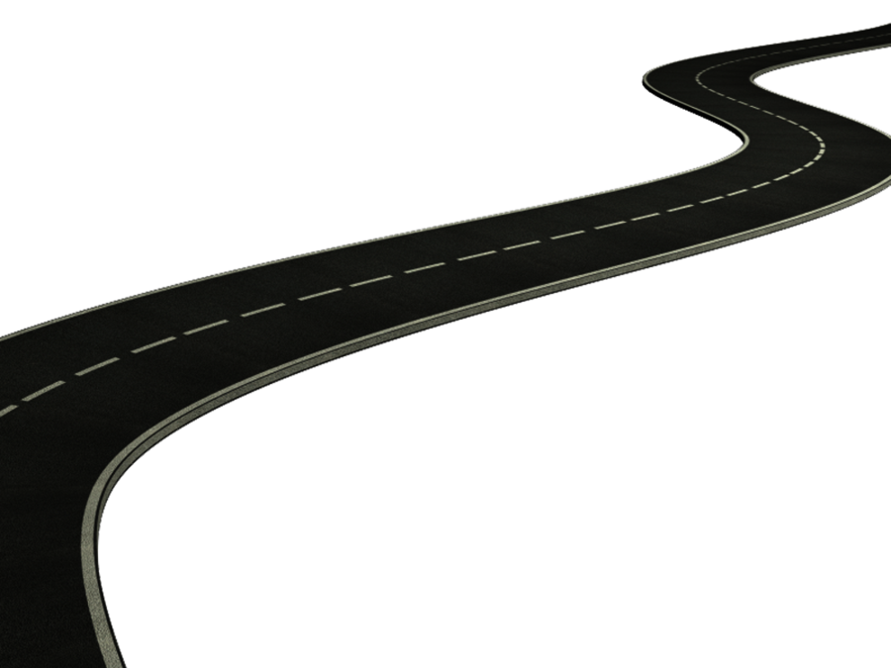
PHSE Forest School
This Term, KS2 are completing their PSHE curriculum through Forest School
This Term we are ‘Valuing Difference’, learning;

-That rules are important
-About taking turns and working as a team
-Thinking about is it ‘only for boys?’
-About our multicultural world

PE / The Way I Move
This terms PE will be taught through swimming and PE skills on a Friday at Port Regis.
We will also be exploring dance through our music and creating our own movement pieces to music

British Values-
Mutual Respect and Individual Liberty

Maths continued
Year 5-
Place Value
Rounding to the nearest 10, 100 and 1000
Numbers up to 1 million
Negative numbers
Roman numerals
Addition and Subtraction
Adding and subtracting 4 digit numbers including borrowing and carrying
Rounding and approximating
Statistics
Comparison, sum and difference
Drawing, reading and interpreting line graphs
Reading and interpreting tables
Multiplication and division
Multiplication up to 1000
Square, prime and cube numbers
Multiples, factors and common factors
Perimeter and area
Calculating perimeter
Area of rectangles, compound shapes and irregular shapes
Year 6-
Place Value
Numbers to 1 million
Rounding numbers to 10,100 and 1000
Negative numbers
Addition, subtraction, multiplication and division
Recapping column addition and subtraction
Recapping column multiplication
Short division and Long division
Common factors and common multiples
Primes to 100
Squares and cubes
Estimation
Fractions
Denominator and numerator
Ordering fractions
Mixed number fractions
Multiplying and dividing fractions
Adding and subtracting fractions
Position and Direction
Quadrants
Translations
Reflections
4) Design – Planet lamps.
We will be creating solar system rotating displays, including a motor and pulley system too with batteries to make it move. Each person will create 8 planets, thinking about how to make that planet look aesthetically pleasing and then we will create out very own solar systems to display.
-To investigate the use of electrical mechanisms such as electrical systems, switches, bulbs, buzzers, motors to light up/make a model/element/ aspect/artefact of history studied.
–I understand and use electrical systems in their products [for example, series circuits incorporating switches, bulbs, buzzers and motors]
Our essay will be in the form of an instructional text detailing how we created our solar system displays

5) Science: Earth and Space
We will be exploring our solar system and how it works, we will be investigating how the seasons are created and how night and day are created. Our essay will explain how this happens and we will use our planet lamps (created in DT) and other items and games to demonstrate practically how the rotation of our planet and the revolutions of our planet allow life to inhabit Earth.
We will also learn the order of the planets in our solar system and look in detail at other planets and why life is unable to survive on these planets.
Yr 3/4 I can explain how the moon and earth move in rotation around the sun and can explain night and day.
Yr 5/6 I can explain the movement of the planets around the sun and can explain how the earth’s seasons are created by the earths spherical orbit
-I know about and explain the movement of the Earth and other planets relative to the Sun.
-I know about and explain the movement of the Moon relative to the Earth.
-I know and demonstrate how night and day are created.
-I describe the Sun, Earth and Moon (using the term spherical).
Our essay will explain how our solar system works, how the seasons are created, how night and day are created and why our planet is able to sustain life and other are not
2) History – The Mayan/Aztec Civilisation
We will be exploring the Mayan Civilisation, using primary and secondary sources to investigate the past and explore the ancient ways of the Mayans. We will look primarily at how the Mayan calendar was created, how they built observatories and followed and mapped the planets. We will understand how this Mayan calendar has influenced the calendar that we use today and how their history has impacted our own.
-Explore an element of Non – European history linked to the Geography topic learning about the Mayan Civilization

Our essay will be in the form of a historical information text, including timelines, first and secondary resources and information about the Mayan Civilisation

1) Geography: Central and South America
-We will be conducting an investigation into physical and human geography. We will be exploring biomes and learning about the different physical and human aspects of geography in Central and Southern America.
The children will explore the water cycle in more detail and create their own miniature ecosystem in a glass jar using seeds and mosses demonstrating the water cycle and showing the children that all water is recycled and is never lost.
-Place knowledge
Understand geographical similarities and differences through the study of human and physical geography of a region of the United Kingdom, a region in a European country, and a region within North or South America
-Physical geography, including: climate zones, biomes and vegetation belts, rivers, mountains, volcanoes and earthquakes, and the water cycle
Our essay will focus mainly on the water cycle and how it works, as well as including information based on the physical and human geography of Central and Southern America.
Maths- Children will be following the White Rose Maths Structure. This term the structure is as follows;
Year 3
Place Value
Numbers to 1000
Number lines to 1000
Compare objects
1,10 or 100 more or less
Counting in 50s
Addition and Subtraction
Adding and subtracting using column method
Adding up to 3 digit numbers crossing 10 and crossing 100
Subtracting 3 digit numbers exchanging and borrowing
Multiplication and Division
2,5 and 10 times-tables
Dividing by 2,5 and 10
Multiplying and dividing by 3,4 and 8
Year 4
Place Value
Rounding to the nearest 10, 100 and 1000
Comparing 4 digit numbers
Counting in 25s
Negative numbers
Roman numerals
Addition and Subtraction
Adding 3 and 4 digit numbers
Adding numbers crossing 10 or 100
Subtracting numbers up to 4 digits including exchanging (borrowing)
Length and Perimeter
Equivalent lengths
Adding and subtracting lengths
Measuring perimeter
Perimeter of rectangles and rectilinear shapes
Multiplication and Division
Multiplying by 0,1,10 and 100
Multiplying and dividing by 3,6,7 and 9

