Learning Journey Plan for a Cross Curricular Topic
4) Computing- Digital Literacy
I use technology respectfully and responsibly.
I know different ways I can get help if I am concerned.
I discern where it is best to use technology and where it adds little or no value.
I recognise acceptable and unacceptable behaviour using technology.
I understand that you have to make choices when using technology and that not everything is true and/or safe.
I discuss the risks of online use of technology.
I identify how to minimise risks.

7) MFL- Spanish Así Soy Yo
-Introducing yourself and describing yourself in Spanish
-Saying your age in Spanish
-Months of the Year in Spanish
-Saying the month of your birthday
-Saying your name, age and birthday in Spanish

Geography Focus- Climb Every Mountain- ‘We are Geographers, exploring the world around us’
Fiction: Romulus and Remus- writing the Roman Myth of Romulus and Remus and exploring character development and speech in our writing.
Non Fiction: Newspaper articles about the eruption or Pompeii focusing on features of a newspaper and writing in the past tense.
Information texts about Roman history. Focusing on features of an information text, including layout and factual writing.
Poetry/Rhymes: Autumn Poems- Getting ready for our Harvest festival, the children will be creating their own Harvest Poems to read aloud in the church.
Christmas poetry- writing some Christmas poetry or songs to include in our Christmas production.

6) RE- Gospel stories, morals and Parables-
We will be exploring the miracles and parables from the Bible and leaning about how Christians believe these will help them lead a better life.

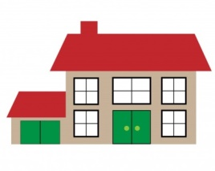


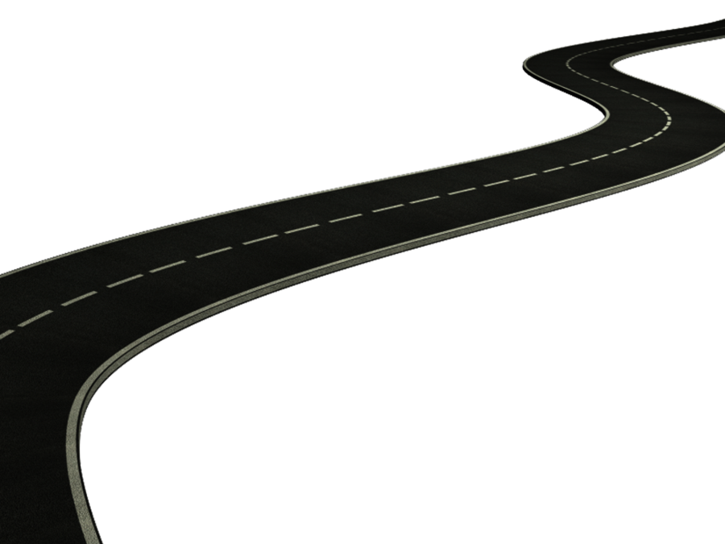
3) History – Looking at the History of Rome and how it was built. We will be comparing it to our lives today and exploring how our modern day existence has been heavily influenced by the Roman Period.
-Roman roads, Gladiators, Hadrian’s Wall, Roman Baths, clothing, religion, democracy, money, pottery.
- I know about at least three things that the Romans did for our country.
- I know why the Romans needed to build forts in this country.
- I know that Rome was a very important place and many decisions were made there.
- I know about the lives of at least two famous Romans.

PE / Games
Play competitive games, modified where appropriate football, hockey, and apply basic principles suitable for attacking and defending
Sequences of movement
Team Work
5) Design – Food technology
We will be exploring Roman food and experimenting with different recipes. Thinking about healthy eating, foraging and food safety and hygiene.
- I describe the ingredients I am using.
- I cut food safely.
- I describe how food ingredients come together.
- I know how to be both hygienic and safe when using food.
- I show that I can be both hygienic and safe in the kitchen

1) Geography:
Volcanoes, tectonic plates and earthquakes
-We will be looking at Mount Vesuvius and exploring the eruption which entombed the Roman city of Pompeii
-The children will learn about tectonic plates and how these can cause volcanoes, mountain ranges and earthquakes.
We will be learning about how the Earth is divided
-We will be exploring the inside of a volcano and learning about how they work
- I know about, locate and name some of the world’s most famous volcanoes.
- I know about and describe the key aspects of earthquakes.
- I know about and describe the key aspects of volcanoes.
- I locate the Tropic of Cancer, the Tropic of Capricorn and the Greenwich meridian on a map.
- I know whether a country is located in the Southern or Northern hemisphere
- I know the name of a number of countries in the northern hemisphere.

British Values
Rule of Law- Looking at our laws and rules and how these are enforced. We will be looking at the rules of games and how important they are to follow.
Democracy- We will also be looking at democracy and how we live in a democratic country.

Maths continued
Year 5-
Place Value
Rounding to the nearest 10, 100 and 1000
Numbers up to 1 million
Negative numbers
Roman numerals
Addition and Subtraction
Adding and subtracting 4 digit numbers including borrowing and carrying
Rounding and approximating
Statistics
Comparison, sum and difference
Drawing, reading and interpreting line graphs
Reading and interpreting tables
Multiplication and division
Multiplication up to 1000
Square, prime and cube numbers
Multiples, factors and common factors
Perimeter and area
Calculating perimeter
Area of rectangles, compound shapes and irregular shapes
Year 6-
Place Value
Numbers to 1 million
Rounding numbers to 10,100 and 1000
Negative numbers
Addition, subtraction, multiplication and division
Recapping column addition and subtraction
Recapping column multiplication
Short division and Long division
Common factors and common multiples
Primes to 100
Squares and cubes
Estimation
Fractions
Denominator and numerator
Ordering fractions
Mixed number fractions
Multiplying and dividing fractions
Adding and subtracting fractions
Position and Direction
Quadrants
Translations
Reflections
2) Science: We will be exploring rocks and how they are formed. We will be collecting and sorting rocks based on their properties and learning about the different layers of the Earth. We will be creating some edible rocks in our science.

Rocks
- I compare and group rocks based on their appearance and physical properties, giving a reason.
- I know how fossils are formed.
- I know how soil is made.
- I know about and explain the difference between sedimentary, metamorphic and igneous rock.

Maths- Children will be following the White Rose Maths Structure. This term the structure is as follows;
Year 3
Place Value
Numbers to 1000
Number lines to 1000
Compare objects
1,10 or 100 more or less
Counting in 50s
Addition and Subtraction
Adding and subtracting using column method
Adding up to 3 digit numbers crossing 10 and crossing 100
Subtracting 3 digit numbers exchanging and borrowing
Multiplication and Division
2,5 and 10 times-tables
Dividing by 2,5 and 10
Multiplying and dividing by 3,4 and 8
Year 4
Place Value
Rounding to the nearest 10, 100 and 1000
Comparing 4 digit numbers
Counting in 25s
Negative numbers
Roman numerals
Addition and Subtraction
Adding 3 and 4 digit numbers
Adding numbers crossing 10 or 100
Subtracting numbers up to 4 digits including exchanging (borrowing)
Length and Perimeter
Equivalent lengths
Adding and subtracting lengths
Measuring perimeter
Perimeter of rectangles and rectilinear shapes
Multiplication and Division
Multiplying by 0,1,10 and 100
Multiplying and dividing by 3,6,7 and 9

PHSE Forest School
This Term, KS2 are completing their PSHE curriculum through Forest School
This Term we are ‘Valuing Difference’, learning;

-That rules are important
-About taking turns and working as a team
-Thinking about is it ‘only for boys?’
-About our multicultural world

