Mutual Respect Learning Journey Plan for a Cross Curricular Topic
Art: 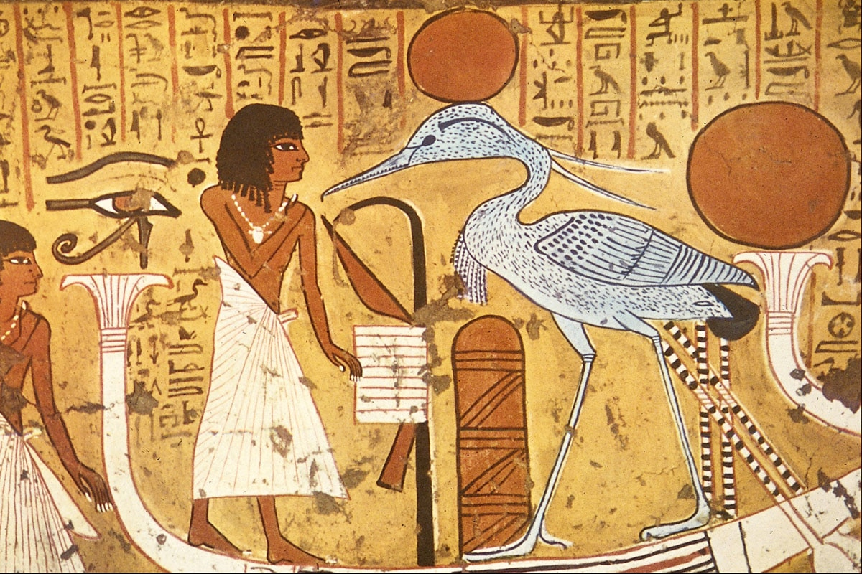
Re-creating ancient Egyptian artwork; we will be studying the different artworks of the ancient Egyptians focusing on their particular style of drawing. We will be looking at shading and the importance of the people within the artwork (they are usually Gods). We will look at how we can recreate the style and apply these techniques to our own sketches.
Year 3&4- I know how to show facial expressions in my art.
-I know how to use sketches to produce a final piece of art.
-I know how to use different grades of pencil to shade and to show different tones and textures.
Year 5&6 -I know how to successfully use shading to create mood and feeling.
-I know how to organise line, tone, shape and colour to represent figures and forms in movement.
-I know how to use shading to create mood and feeling.
-I know how to express emotion in my art.
Essay-
Year 3&4- I can discuss the different drawing techniques and how I have used them to produce a replica of an ancient Egyptian drawing.
Year 5&6-I can write about the different techniques of sketching and compare an ancient Egyptian drawing of a person to that of a modern day artist.

At the end of this topic, we will……Understand the journey of a river from source to sea. Understand the different stages of a river.
British Values
Democracy- Looking at dictatorship in Egypt and the rule of a Pharaoh compared to Britain and our parliament.
Geography Focus – Footsteps in the sand- We are Geographers
exploring the Nile and the surround desert The Sahara
History:
Egypt and the history of the Nile; we will also be looking at mummification, pyramids, Shaduf, and hieroglyphics.
- I know that many of the early civilizations gave much to the world.
- I know how the lives of wealthy people were different from the lives of poorer people.
- I describe events from the past using dates when things happened.
- I know how an event or events from the past has shaped our life today.
Essay-
Year 3&4-I can write about how past events have shaped our lives today and explain how the ancient Egyptians contributed much to the modern world today
Year 5&6- I can write an essay about the main events from a period of history, explaining the order of events and what happened and demonstrating that many of the early civilizations gave much to the world

Geography: Rivers; we will be looking at different rivers around the world, recapping on the Yangtze River from last topic and moving forward to looking at The River Nile. We will be looking at the course of a river and how meanders are made, linking to science using centrifugal force.
- I know why most cities as situated by rivers.
- I know about the course of a river.
- I name and locate many of the world’s most famous rivers.
Vocabulary- centrifugal force, Shaduf, meander, middle course, upper course, lower course, drainage basin, source, oxbow lake, watershed, river channel, erosion and deposition
Essay-
Year 3&4- I can write an essay about the features of a river and the impact of the river Nile on Egypt.
Year 5&6- I can write about the river Nile and how it has affected the population of Egypt. I can discuss how man has changed the landscape of Egypt for the better or worse according to my opinion.





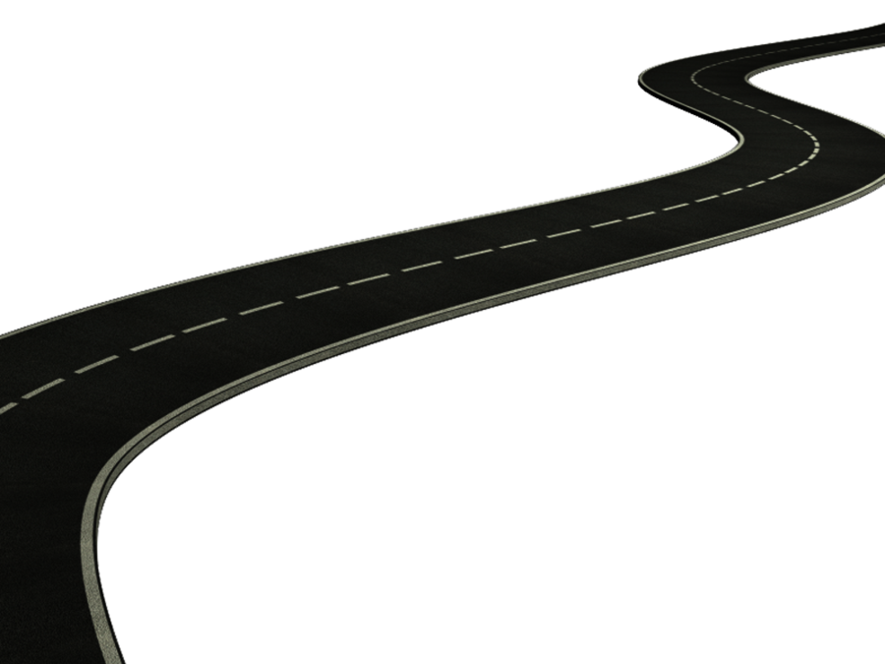
Maths- Children will be following the White Rose Maths Structure. This term the structure is as follows;
Year 3- Number- Place Value
Number- Addition and Subtraction
Number- Multiplication and Division

Year 4- Number- Place Value
Number- Addition and Subtraction
Measurement- length and perimeter
Number- Multiplication and Division

Year 5- Number- Place Value
Number- Addition and subtraction
Statistics
Number- Multiplication and Division
Measurement- Perimeter and Area

Year 6- Number- Place Value
Number- Addition and Subtraction
Number- Fractions
Geometry- Position and Direction

Year 6 will also be carrying out SATS papers and we will be focusing on the gaps in their learning rather than covering things they are very confident/secure in.

Design – designing and building a Shaduf. – Cross curricular links with Science
- Strengthen, stiffen and reinforce more complex structures
I can make a simple plan before making.
I can choose tools and materials and explain why I have chosen them.
I can join materials and components in different ways.
I can explain what went well with my work.
I can explain why I have chosen specific textiles.

Music
Christmas Production
I can use my voice expressively and creatively by singing songs and speaking chants and rhymes

I can listen with concentration and understanding to a range of high-quality live and recorded music – Children will be listening and responding to the music of the modern composer Hanz Zimmer. Hanz Zimmer wrote the score to ‘The Prince of Egypt’ and the children will be learning about some of his works
Year 3&4-.
- I know how to use musical words to describe a piece of music and compositions.
- I know how to use musical words to describe what I like and do not like about a piece of music.
- I know how to recognise the work of at least one famous composer.
Year 5&6-
- I know how to analyse features within different pieces of music.
- I know how to compare and contrast the impact that different composers from different times have had on people of that time.
Essay-
Year 3&4-I can respond to a piece of music written by Hanz Zimmer, a modern day famous composer.
Year 5&6- I can write about different types of music through time by comparing Hanz Zimmer to traditional Egyptian music.

PHSE
We will be looking at our ‘Health and Wellbeing’ covering topics such as;
- Our mental health and how to take care of it.
- How TO keep our bodies clean and healthy.
- How to eat a balanced diet.
- Staying safe on the internet and how to protect yourself online.
- About how our bodies are our bodies, and no one has the right to touch any part if it without our permission.

English
Non-fiction- Information texts and newspaper reports; Children will be writing their own newspaper report about the finding of Tutankhamen’s tomb and an information text about Egyptians.

Fiction- Story writing; Children will be looking at ‘Cinderella of the Nile’ and comparing it to the traditional tale of ‘Cinderella’.

Poetry- Children will be writing poetry about the course of a river and performing them to music/ the sound of a river.

RE- The Story of Moses and ‘Exodus’ (Leading the Jewish slaves out of Egypt)
Bible stories liked to dictatorship and democracy, individual liberty. links to modern day troubles in Afghanistan and links to PSHE- human rights and slavery.

Science: Forces- we will be looking at different forces, including centrifugal force which occurs in rivers and creates turns and meanders as well as looking at the Shaduf and how their pulley system works.
- I know what gravity is and its impact on our lives.
- I identify and know the effect of air resistance.
- I identify and know the effect of water resistance.
- I identify and know the effect of friction.
- I explain how levers, pulleys and gears allow a smaller force to have a greater effect.

MFL- Spanish
- I can count to 12 in Spanish
- I can say the months of the year in Spanish
- I can introduce myself in Spanish
- I can say my birthday in Spanish
- I can respond to questions about myself in Spanish
- I can say where I am from in Spanish

Computing
We will be using Google Earth to search for different rivers and information about them, using PowerPoint to present information about Mummification and using Word to type up essays or writing.
- I use a range of software for similar purposes.
- I collect information.
- I design and create content.
- I present information.
- I search for information on the web in different ways.

PE / Games
Play competitive games, modified where appropriate football, hockey, and apply basic principles suitable for attacking and defending

Dance
I improvise freely and translate ideas from a stimulus Water/Rivers into movement.

Swimming

