Mutual Respect Learning Journey Plan for a Cross Curricular Topic
British Values
Mutual Respect
At the end of this topic, we will……Understand the journey of a river from source to sea. Understand the different stages of a river. Identify animals that rely on the river to survive. Know how humans use a river today and in the past. Know the symbolism of water and rivers and how it is reproduced in Art
Art: Monet Water
I know how to identify the techniques used by different artists.

I experiment with the styles used by other artists.
I research the work of an artist and use their work to replicate a style.

I know how to show reflections in my art.

I can explain the style of my work and how it has been influenced by a famous artist.

Visits/ Visitors
Stourhead – The source of the River Stour
Hengistbury Head –Where the Stour meets the sea.
Langford Lakes – River bank studies
Geography Focus – From the River to the Sea
History:
A local history study – Britain’s Canals
I can select appropriate information from different sources to find out about the past,
I can use the correct historical vocabulary in my writing and discussions about the past

I can describe the ways of life of ordinary people who lived in this country

I can explain when an important event or development happened, why it happened and the consequence it had.

Geography: Rivers.. The River Stour
Locational knowledge
I can… Name and locate key topographical features (including hills, mountains, coasts and rivers),
Place knowledge
I can….
Understand geographical similarities and differences through the study of human and physical geography of a region of the United Kingdom – The River Stour
Human and physical geography
I can…
Describe and understand key aspects of:
  - Physical geography, including: rivers and the water cycle

Human geography – water and river use

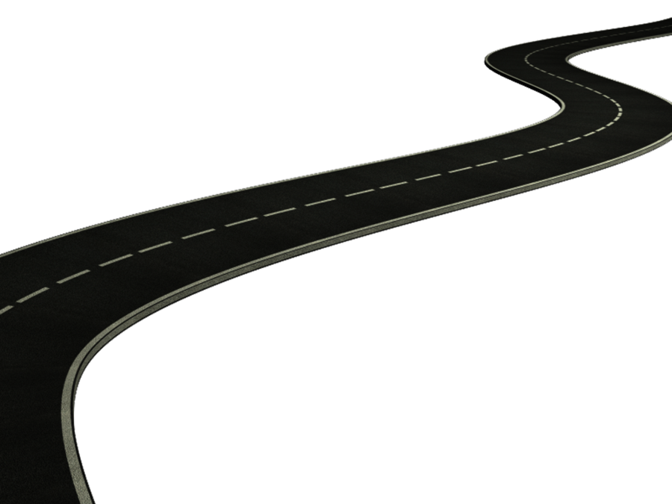




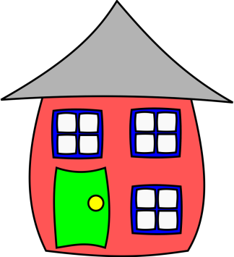


Computing
- I collect information.
- I design and create content.
- I present information.
- I search for information on the web in different ways.
Internet Safety week Nov 11th

PE / Games
Play competitive games, modified where appropriate football, hockey, and apply basic principles suitable for attacking and defending

Dance
I improvise freely and translate ideas from a stimulus Water/Rivers into movement.

Swimming
Science: River habitats

LIVING THINGS AND THEIR HABITATS
I can recognise that living things can be grouped in a variety of ways
I can explore and use classification keys to help group, identify and name a variety of living things in my local and wider environment
I can recognise that environments can change and that this can sometimes pose dangers to living things.

RE
I can describe important events and ceremonies in my life and in the lives of people from different religions (rites of passage) that include water

I can describe some symbols like light, colour or water and say why they are important in different religions.

What can Christians learn from the Creation Story – Creation

Music
Christmas Production:
I can sing and play musically with increasing confidence and control.
I can play and perform in solo and ensemble contexts, using my voice and playing musical instruments with increasing accuracy, fluency, control and expression
I can appreciate and understand a wide range of high-quality live and recorded music drawn from different traditions and from great composers and musicians

Design
I understand seasonality, and know where and how a variety of ingredients are grown, and processed – Local ingredients from Autumn harvest. Blackberries and apple cakes.
I can understand and use mechanical systems in my products, such as levers and linkages – River bank animal pop up toy

Maths Link - M
Measuring water ml
Measure weight grms
Measure lengths mm
MFL
- I name and describe a place.- along the river bank.

PHSE
Our Happy School
(New Beginnings)
Out and About
(Getting On & Falling Out / Say No to Bullying) Anti bullying Day Nov 11th

English Link
Fiction
- Wind in the Willows – Riverbank animals Story making project
Character profiles
Speech
Description
Argument and point of view
- River Boy – Ghost Story, Emotions
Poetry – Water
Non – Fiction – Chronological reports

