
Science-
Year 1 & Year 2
-Animals and their babies
Looking in detail at how animas adapt to their habitats, how their babies survive in such extreme conditions and learning about food chains.
We will use vocabulary such as;
Omnivore, herbivore and carnivore, consumer, producer, secondary consumer, prey, predator

-living and non-living things
We will explore what it means to be living and how we classify something as being alive, through ‘Mrs Gren’. We will explore how we classify living things and decide what objects used to be living, and others that have never been alive.

English
Fiction- The Great Explorer by Chris Judge
This story follows a young boy who sets about to find his father, an explorer who appears to have gone missing in the North Pole
Little Polar Bear by Hans De Beer
The story of a little polar bear that gets separated from his father one night and his journey to find him again
The Polar Bear Son: An Inuit Tale by Lydia Dabcovich
This enchanting story is based on a traditional story from the Inuit people. An old woman finds a polar bear cub all alone in the ice and snow

Non-Fiction- Shackleton's Journey by William Grill
An information text about Henry Shackleton the arctic explorer, who lead 3 British expeditions to the Antarctic
The Emperor’s Egg by Jane Chapman and Martin Jenkins
An information book about the life of a male emperor penguin
Polar Animals (Ready to Read) by Wade Cooper
An information text about animals living in the Arctic and how they are adapted to living in extreme conditions
Amazing Adventures
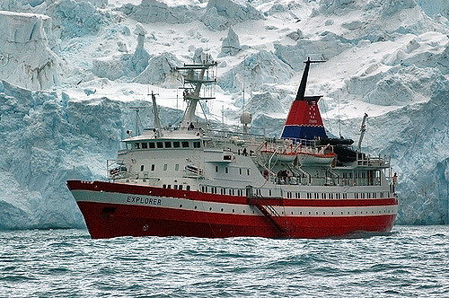
RE

Special places- The Church
Easter celebrations and the Easter Story

ICT
Using and applying computer skills, creating documents in word and inserting pictures to accompany our writing

Children will begin to do their Big Write on computers, in rotation, between hand written and typed.
History/Geography
6 weeks Geography-
Looking at the geographical location of Antarctic and the Arctic and also the differences between the two. Exploring temperatures and weather conditions compared to England. Comparing different animals and their diets in the arctic.

6 Weeks History- We will be learning about the Antarctica explorer Henry Shackleton and his adventures to the Antarctica.
PSHE
Safety online, talking to strangers, keeping our personal information, personal online
We will look at online bullying and the affect it has on people.
Music
Use their voices expressively and creatively by singing songs and speaking chants and rhymes, exploring the music of the Lion King and re-creating different songs from the show.
-play tuned and un-tuned instruments musically
-listen with concentration and understanding to a range of high-quality live and recorded music
-experiment with, create, select and combine sounds using the inter-related dimensions of music
-We are very lucky to have Mr Walker who comes to teach us music every Wednesday morning. We will be playing the recorder.

Phonics-
Sounds covered for the next 12 weeks will be ;
u-e,oa, oe, oy, oi, ow (blow the snow), ow (how now brown cow?), air, ear, wh, ph, e-e

Design
Design and build your own shelter to help you survive in the arctic.
Design and build an igloo for the corner of our classroom.
Maths
Year 1
Addition and subtraction within 20- Using concrete objects, number lines and counting on and back
Place value within 50 including multiples of 2, 5 and 10- Using cubes, HTU and Dienes to help
Length and height- Calculating height and length of animals both real and toys
Weight and volume- looking at the weight of fossils and rocks as well as rainfall for volume
Year 2
Multiplication and division 2, 5 and 10-
Statistics- Using tally charts and bar graphs to find out information about animals
Properties of shape- 2d and 3d shapes, using these to create objects and creations
Fractions-
Length and height- Calculating height and length of animals both real and toy

Art
Drawing and sketching- looking at different sketching techniques and using these to sketch animals from the arctic.

