English:
Fiction- Beowulf –Character descriptions and creating our own characters.
The Saga of Ragnar- Creating our own Viking epic story
Non-Fiction- Persuasive text- Writing a persuasive letter to encourage other Vikings to come to England too settle
Poetry- ‘The Godless’ Viking Poem – writing a poem about the Viking Raids.

Learning Journey Plan for a Cross Curricular Topic
Vikings From Across the Sea
Let’s Explore- We are Geographers Exploring the Present

British Values- Mutual Respect Individual Liberty
3) Science: Materials
To know why materials are used for specific purposes and can relate these to materials used by the Vikings
Investigate a range of liquids, Solids, Gasses.
Explore how particles are grouped to make a liquid, solid, gas and how materials can be compared within each group.
Create investigations into why certain materials are used for a specific purpose – waterproof material for an umbrella.
Create investigations into materials and their properties.
Investigate a range of liquids, Solids, Gasses.
Explore how particles are grouped to make a liquid, solid, gas and how materials can be compared within each group.
Create investigations into why certain materials are used for a specific purpose – waterproof material for an umbrella.
Create investigations into materials and their properties.

Essay-

RE- Sikhism- Prayer and Worship- What is the best way for a Sikh to show commitment to God?
Pupils will be taught to:
- Investigate if all religious beliefs influence people to behave well towards others
- Explore if participating in worship helps people to feel closer to God or their faith or community
Explore how Sikhs show their commitment to God and evaluate if there is a best way.
- I know about the 5Ks of Sikhism (Kangha – comb, Kirpan – sword, Kara – bracelet, Kachera – shorts and Kesh – uncut hair)
- I know that Sewa means helping others.
I know that the law has changed to allow Sikhs to wear turbans instead of crash helmets.

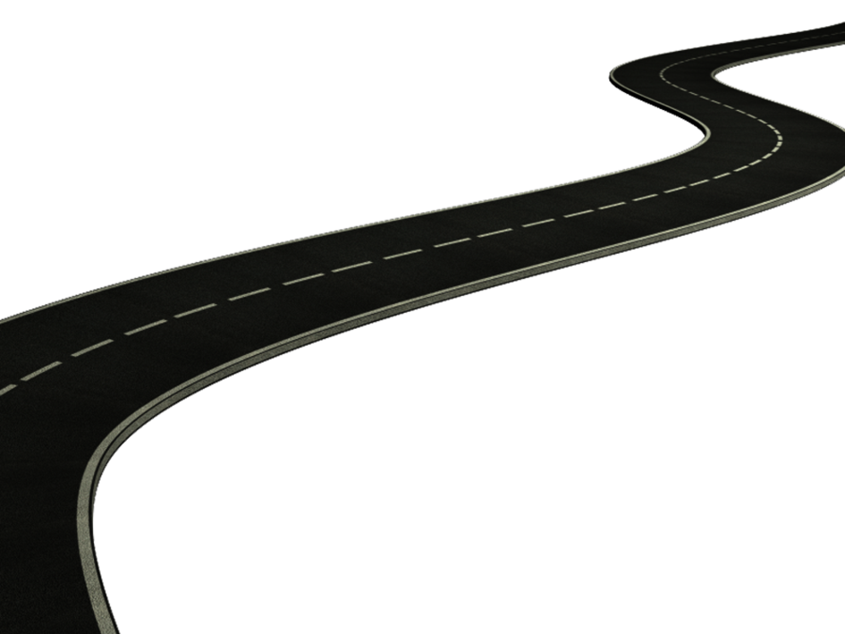
MFL- Spanish-
Spanish – All about me
-Lo Basico
-Todo Sobre mi
-Esta es mi familia
-Como me siento
-El tiempo
- Los Numeros hasta 100

Information Technology- Viking Saga
To design and create a range of programs, systems and content that accomplish given goals, including collecting, analysing, evaluating and presenting data and information
Investigate what a Podcast is and why people make them
Explore a range of Podcasts
Create a Podcast based on the Vikings
PSHE- Forest School
Term1 Term 2

Who helps us stay healthy and safe?
It’s your right
How do we make a difference?
In the news!
Safety in numbers
Logo quiz
Harold’s expenses
Why pay taxes?
Charity Fundraiser

Danger, risk or hazard?
Picture wise
How dare you!
Medicines; check the label
Know the norms (formerly Tell Mark II)
Keeping ourselves safe
Raisin Challenge (2)
Basic First Aid

DT) Design: Building a structure – Viking Longboats

To create a something new by exploring and considering how natural and man- made materials keep their shape and by using this knowledge, to design and make a product that uses shape and/ or material to mould, strengthen, stiffen, reinforce or join materials.

Investigate the purpose and design of a sail
Explore the structure of a Viking longboat and map out its size
Create- become sailmakers ourselves, and learn how to evaluate and improve designs by testing and making alterations.

Essay- Product review

1) History – The Last Kingdom
To know why there was conflict between Anglo Saxons and Vikings in Britain

Investigate the world around us for clues to the past.ie Alfred’s Tower, Egberts Stone. Visit Ancient Technology Centre
Explore key features, events linked to the Viking invasion of Britain and local battles with the Danes
Create information to build up a picture of the past and choose relevant material to present information creatively.

- The Viking and Anglo-Saxon struggle for the Kingdom of England to the time of Edward the Confessor
- I can create a timeline of Viking history (AD700 to 1100.)
- I know that The Vikings were Norse people who came from an area called Scandinavia (countries such as Norway, Sweden and Denmark).
- I know that during this period, many Vikings left their homelands in Scandinavia and travelled by longboat to other countries, like Britain and Ireland.
- I know that Vikings were pagans and worshiped many gods including Odin who was the King of the Gods.
- I know that Vikings believed that when you died you would go to Valhalla.
- I know that Vikings invaded Britain to farm the land and settled in Scotland before moving south.
- I know the Vikings invaded Lindisfarne in 793 AD
Essay- Historical recount

4) Art- Drawing and Printing
Viking Art- Lino Prints
- I know how to create an accurate print design following criteria.
- I know how to overprint to create different patterns.
- I know how to create an accurate print design following criteria.
- I can explain features of Art from an historical period or event.
- I can replicate Art from a period in history that I am studying.
Create- A final Lino print

2) Geography: Human and Physical Geography
Viking Settlements
To investigate the elements of physical and human Geography that has influenced or has been influenced by events in British History
Investigate the origins of place names in Britain from Viking influence.
Explore how the Vikings moved inland from the coast and locate Viking settlements that have remained in Britain
Create a map of Viking influence/remains in Britain

- I know some places in Britain that have Viking names (York – Yorvik)
- I can investigate the construction of Viking settlements.
- I can compare the Geographical features of Norway with the Geographical features of England and explain why The Vikings wanted to settle in England.
- I can research Viking villages and settlements and compare them to towns and villages in Britain during the time of their invasion.
Essay- Explanation text
Maths continued
Year 5-
Multiplication and division
Multiply by 2,3 and 4 digits
Divide by 2,3 and 4 digits
Divide with remainders
Fractions
Equivalent fractions
Improper fractions to mixed number fractions
Number sequences
Compare and order fractions
Add and subtract fractions
Multiply fractions by integers
Fractions of an amount
Fraction problem solving
Decimals and percentages
Decimals as fractions
Understanding thousandths
Rounding decimals
Understanding percentages
Equivalent fractions, decimals and percentages
Year 6-
Decimals
Multiply decimals by 10,100 and 1000
Multiply by integers
Divide by fractions
Fractions as decimals
Percentages
Understanding percentages
Fractions to percentages
Ordering FDP
Equivalent FDP
Percentages of amounts
Algebra
Find a rule
Substitution
Formulae
Solving ine-0step equations
Finding pairs of values
Converting units
Converting metric measurements
Miles and kilometres
Imperial measures
Perimeter area and volume
Area and perimeter
Area of a triangle
Area of a parallelogram
Volume
Counting cubes
Ratio
Maths- Children will be following the White Rose Maths Structure. This term the structure is as follows;
Year 3
Multiplication and Division
Multiply by 1 and 2 digits with and without exchanges
Divide 100 by 2,4,5 and 10
Divide with remainders
Money
Pounds and pence
Convert pounds to pence
Add and subtract money
Give change
Statistics
Pictograms
Draw bar charts
Tables
Length and Perimeter
Equivalent lengths
Comparing lengths
Adding and subtracting lengths
Measuring and calculating perimeter
Year 4
Multiplication and division
1,2 and 3digit multiplication
Dividing by 1 2 and 3 digit numbers
Area
What us area?
Calculating area
Counting area squares
Comparing area
Fractions
Counting in tenths
Equivalent fractions
Counting in fractions
Adding and subtracting fractions
Fractions of a quantity
Decimals
Recognising tenths and hundredths
Dividing by 10 and 100
Tenths on a number line
Hundredths as decimals

