Learning Journey Plan for a Cross Curricular Topic
MFL- Spanish – Describo un monstruo

-We will be learning how to describe someone else’s size and colour
-Naming parts of the head and face
-describing parts of the head with colours and sizes
-Describing a monster’s face and head joining descriptions with conjunctions
-Making monster description better using intensifiers

Art- Sketching and painting
We will be creating mythical creatures from Greek Mythology focusing on sketching and shading using charcoal and pencil.
- I know how to show facial expressions in my art.
- I know how to use sketches to produce a final piece of art.
- I know how to use different grades of pencil to shade and to show different tones and textures.
- I recognise when art is from different cultures.
- I recognise when art is from different historical periods.

Art and Design Focus- - ‘We are Creators and Makers, Creating the Future. Grand Designs
RE- Creation- How can we preserve God’s creation?
Bible story- Creation

Fiction: Theseus and the Minotaur story- writing our own myth, creative writing
Myths- Hercules and Jason and the Argonauts
Non Fiction: Information PowerPoint including a contents page with hyperlinks to the correct slide, glossary with links in the text to the meanings of the words at the end.
Non-Fiction- persuasive writing. We will be writing a persuasive leaflet to advertise a zoo or a museum.

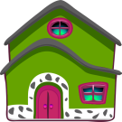


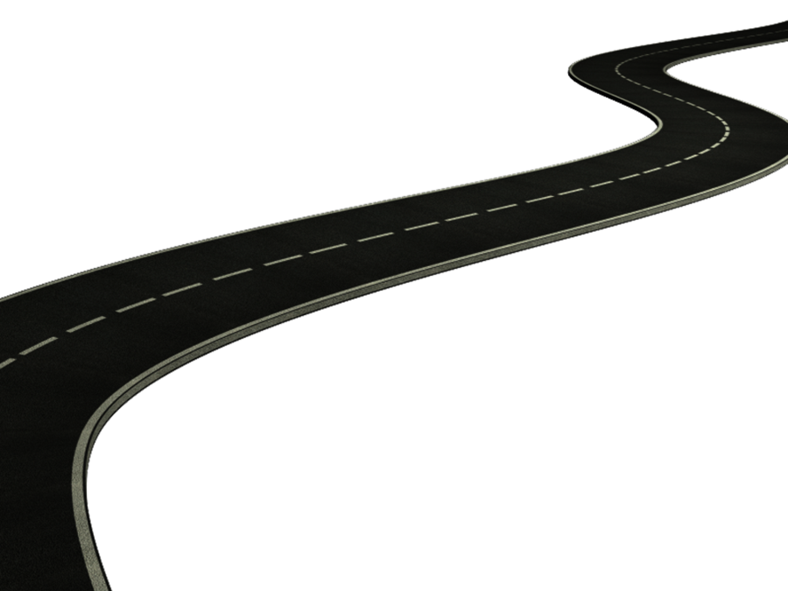
British Values
Rule of Law- How did the Ancient Greeks punish people who broke the laws? How has the rule of law changed today?

PHSE Forest School
This Term, KS2 are completing their PSHE curriculum through Forest School
This Term we are ‘Valuing Difference’, learning;

-That rules are important
-About taking turns and working as a team
-Thinking about is it ‘only for boys?’
-About our multicultural world

History – Greek History
- I know about and can talk about the struggle between the Athenians and the Spartans.
- I know about some of the things that the Greeks gave the world.
- I know that the Greeks were responsible for the birth of the Olympics.
- I know that the Greek Gods were an important part of Greek culture.
- I know how to locate Greece on a map.
We will explore the history of Greece. Learning about Greek Gods and Greek myths and legends. We will have our own Greek Olympics and research where The Olympic games began.

PE / Games- Outdoor games including Quick Cricket in preparation for our tournament. We will be exploring the outdoors through orienteering games and activities.
Outdoor and adventurous
Year 3-
- I follow a map in a familiar context.
- I use clues to follow a route.
- I follow a route safely.
Year 4-
- I follow a map in a (more demanding) familiar context.
- I follow a route within a time limit.
Year 5-
- I follow a map into an unknown location.
- I use clues and a compass to navigate a route.
- I change my route to overcome a problem.
I use new information to change my route
Year 6-
- I plan a route and a series of clues for someone else.
- I plan with others, taking account of safety and danger.

Science: Living things in their habitats.
Year 3 Year 4
- I group living things in different ways.
- I use classification keys to group, identify and name living things.
- I create classification keys to group, identify and name living things (for others to use).
- I know how changes to an environment could endanger living things.
Year 5
- I know the life cycle of different living things, e.g. mammal, amphibian, insect bird.
- I know the differences between different life cycles.
- I know the process of reproduction in plants.
- I know the process of reproduction in animals.
Year 6-
- I classify living things into broad groups according to observable characteristics and based on similarities & differences.
- I know how living things have been classified.
- I give reasons for classifying plants and animals in a specific way.

We will be exploring animals and their habitats. We will follow on from our work last term where we learned about how animals adapt to their habitats. We will be grouping animals together based on how they are classified (mammal, amphibian, insect, bird).
We will be dissecting lilies to explore how plants reproduce and compare this to how animals reproduce. We will be looking at how we classify something as living using MRS GREN

Design – Greek food- we will be sampling and exploring Greek food. The children will be trying baklava, Greek yogurt and honey, Pastitsio, Keftedes, Souvlaki and Gyros.
- Understand and apply the principles of a healthy and varied diet
- Prepare and cook a variety of predominantly savoury dishes using a range of cooking techniques
- Understand seasonality, and know where and how a variety of ingredients are grown, reared, caught and processed.
- I describe how food ingredients come together.
- I know how to be both hygienic and safe when using food.
- I show that I can be both hygienic and safe in the kitchen.
I use market research to inform my plans and ideas.
Children will survey the class, researching the Greek food that the children like most. Then they will design and make a Greek meal for us all to eat, including a menu.

Maths continued
Year 5-
Decimals
Adding and subtracting decimals within 1
Adding decimals, crossing the whole
Multiplying and dividing decimals by 10, 100 and 1,000
Properties of shape
Identify, compare and order angles
Measuring angles in degrees
Measuring with a protractor
Drawing and calculating angles
Calculating angles
Position and Direction
Position in the first quadrant
Translation
translation with coordinates
reflection
reflection with coordinates
Converting units
Kilograms and kilometres
Millimetres and millilitres
Metric units
Imperial units
Converting units of time
Timetables
Volume
Compare volume
Estimate volume
Estimate capacity
Year 6-
SATS revision
Statistics
Read and interpret line graphs
Draw line graphs
Circles
Pie charts with percentages
Draw pie charts
The mean
Properties of Shape
Measure with a protractor
Angles around a point
Angles of a straight line
Calculating angles
Vertically opposite angles
Angles in a triangle
Angles in regular polygons
Angles in quadrilaterals

Maths- Children will be following the White Rose Maths Structure. This term the structure is as follows;
Year 3
Fractions
-making the whole
-tenths as decimals
-equivalent fractions
-ordering fractions
-Adding and subtracting fractions
Time-
-Months and Years
-hours in a day
-telling the time to 5 minutes
-comparing durations
-problem solving with time
Properties of Shape-
Right angles
Comparing angles
Parallel and perpendicular angles
Horizontal and vertical
Mass and Capacity
Measure and compare mass
Add and subtract mass
Measure capacity
Add and subtract capacity
Temperature
Year 4
Money
Pounds and pence
Estimating money
Adding and subtracting money
Giving change
Time
Telling the time in hours minutes and seconds
Years, months, days and weeks
Analogue to digital time 12 and 24 hour
Statistics
Interpret charts
Line graphs
Comparison, sum and difference
Properties of Shape
Turns and angles
Identify and compare angles
Triangles and quadrilaterals
Lines of symmetry
Horizontal and vertical

