Learning Journey Plan for a Cross Curricular Topic
6) Computing- Digital Literacy
I use technology respectfully and responsibly.
I know different ways I can get help if I am concerned.
I discern where it is best to use technology and where it adds little or no value.
I recognise acceptable and unacceptable behaviour using technology.
I understand that you have to make choices when using technology and that not everything is true and/or safe.
I discuss the risks of online use of technology.
I identify how to minimise risks.

7) MFL- Spanish – Describo un monstruo

-We will be learning how to describe someone else’s size and colour
-Naming parts of the head and face
-describing parts of the head with colours and sizes
-Describing a monster’s face and head joining descriptions with conjunctions
-Making monster description better using intensifiers

Art and Design Focus – Another World- ‘We are Artists creating the future’
Fiction: Adventure stories.
For the first part of the Summer term, we will be looking at ‘The Hobbit’ by J.R.R.Tolkien. The Children will create their own Adventure story involving mythical creatures and magic.
For the second half term we will be looking at ‘The Princess Bride’ by William Goldman and the children will be adapting the story to write their own.
Non Fiction: In the first part of the Summer term, we will be looking at bearded dragons, crocodiles, iguanas and other animals that resemble real-life dragons. We will be writing information texts about these animals.
For the second part of the half term, we will be looking at newspaper articles and writing one about a ‘dragon skeleton’ that has been discovered.
Poetry/Rhymes: Within the Hobbit section of this term, we will be creating our own dwarf songs to include in our stories. These will be rhyming poems.

5) RE- Buddhism
-Buddha
-The four sights
-Special places
-Buddhism symbols
The Monkey King
The Wind and the Moon




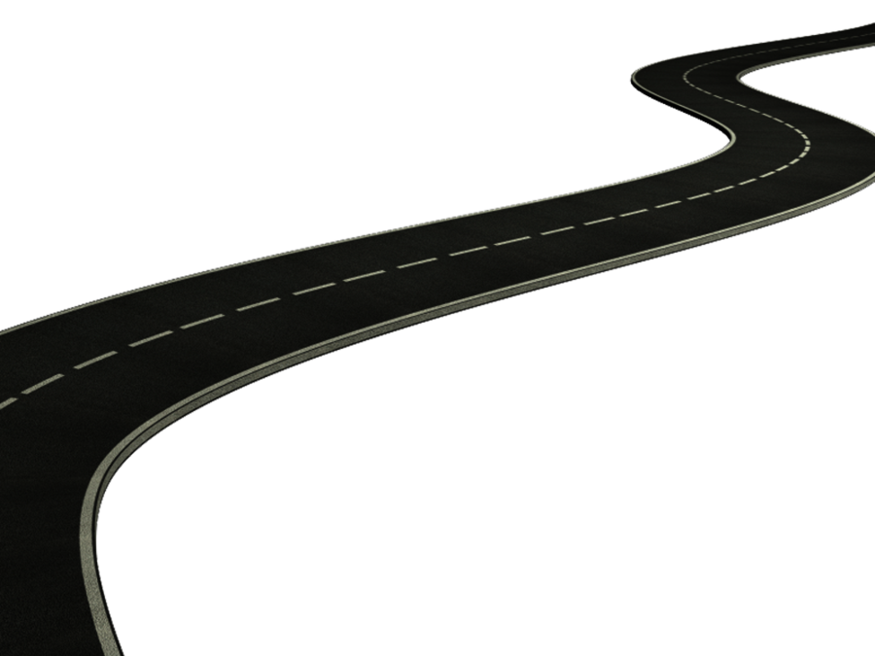
2) Geography:
Locational knowledge
-Locate the world’s countries, using maps to focus on Europe (including the location of Russia) and North and South America
-Name and locate counties and cities of the United Kingdom, geographical regions and their identifying human and physical characteristics, key topographical features (including hills, mountains, coasts and rivers), and land-use patterns; and understand how some of these aspects have changed over time
-Identify the position and significance of latitude, longitude, Equator, Northern Hemisphere, Southern Hemisphere, the Tropics of Cancer and Capricorn, Arctic and Antarctic Circle, the Prime/Greenwich Meridian and time zones (including day and night)
We will be looking at drawing our own maps using map symbols as well as incorporating some of our own made up symbols. We will be looking closely at the map of Middle Earth from The Hobbit.

3) Art: 3d sculpture
We will learn to explore sculpting techniques using different mediums including clay, mod rock and plasticine modelling clay.

We will be making our own dragons to use in our Dungeons and Dragons game and on our game boards created during our DT lessons.

PE / Games
Play competitive games, modified where appropriate football, hockey, and apply basic principles suitable for attacking and defending
Sequences of movement
Team Work
1) Design –
We will be designing and creating our own Dungeons and Dragons board game to play on.
-We will learn how to design our product
-Use market research to help with our designs
-Adapt our designs and make improvements to them
-Create a step-by-step plan to follow when we are building our gaming boards
-Next we will evaluate our process and product by writing our end of unit essay.

British Values
Rule of Law- Looking at our laws and rules and how these are enforced. We will be looking at the rules of games and how important they are to follow

Maths continued
Year 5-
Decimals
Adding and subtracting decimals within 1
Adding decimals, crossing the whole
Multiplying and dividing decimals by 10, 100 and 1,000
Properties of shape
Identify, compare and order angles
Measuring angles in degrees
Measuring with a protractor
Drawing and calculating angles
Calculating angles
Position and Direction
Position in the first quadrant
Translation
translation with coordinates
reflection
reflection with coordinates
Converting units
Kilograms and kilometres
Millimetres and millilitres
Metric units
Imperial units
Converting units of time
Timetables
Volume
Compare volume
Estimate volume
Estimate capacity
Year 6-
SATS revision
Statistics
Read and interpret line graphs
Draw line graphs
Circles
Pie charts with percentages
Draw pie charts
The mean
Properties of Shape

4) Science: Properties and changes of materials
Reversible and irreversible changes

-Comparing materials
- dissolving materials
-reversible and irreversible changes

We will be melting ice, evaporating water, cooking an egg, baking a cake, melting chocolate, all to explore reversible and irreversible changes.
Maths- Children will be following the White Rose Maths Structure. This term the structure is as follows;
Year 3&4-
Decimals
Dividing 1 and 2 digits by 10 and 100
Making a whole and writing decimals
Money
Converting pounds and pence
Ordering money
Estimating money
Adding and subtracting money
Working out change
Time
Months and years
Hours in a day
Weeks and days
Telling the time
AM and PM
24 hour clocks
Analogue to digital 12 and 24 hour
Statistics
Pictograms
Bar charts
Comparison, sum and difference
Line graphs
Position and direction
Comparing angles
2d and 3d shapes and their properties
Horizontal and vertical
Parallel and perpendicular
Triangles
Lines of symmetry
Movement on a grid

8) PHSE- working alongside forest school
This Term, KS2 are working on their own individual PSHE lessons due to Forest School being postponed.
-Relationships, being kind, friendships
-Keeping my body safe, respecting people’s boundaries
-Different family units- divorce- LGBQT families

