English-
Fiction: Adventure story- planning and writing an interactive adventure story about Mulan, thinking about setting, story arches and characters. Including speech and dialogue.
Non Fiction: Biography on Qin Shi Huang. We will be learning about the first emperor of China and writing a biography all about him.
Instruction text- We will be writing a recipe and instructions for our wonderful Chinese feast at the end of term so all of our families can enjoy our wonderful spring rolls.

3) RE- Buddhism- The 8 Fold Path- What is the best way for a Buddhist to lead a good life?
We will explore how Buddha’s teachings make a different to how Buddhists choose to live. We will make links between Buddha’s teachings about causing no harm and the 8 fold path and can explain what the world might look like if many people tried to do this.
.Our Key knowledge-
- I know that Buddhists follow the 8 fold path which guides them in leading a good life.
- I know that the 8 steps are split into three groups:
-Wisdom (thinking and understanding)
-Morality (doing the right thing)
-Meditation (calming the mind
- I know that the 8 fold path is still followed by millions of Buddhists today.
- I know that a wise man called Buddha taught the 8 fold path over 2,500 years ago

Learning Journey Plan for a Cross Curricular Topic
Art Focus ‘We are Creators and Makers Creating the future’
Let’s Explore

PHSE Forest School

Mrs Wilson will continue to follow the SCARF PSHE program of study through Forest School. All children will be completing their age appropriate learning objectives for PSHE both inside and outside of the classroom.
This year, Year 6 children will also be working on strategies to help them when they move on to secondary school.
4) Art- Silk Painting
This term we will be painting silk using specialist paints and ancient Chinese techniques. We will study the type of painting that is traditionally seen in ancient China and can still be found today.
•I know that Gongbi is a special style of painting that started in China a long time ago.
•I know that Gongbi paintings are very neat and detailed, using tiny brushes and fine lines.
•I know that Gongbi artists often paint things from nature, like birds, flowers, and animals.
•I know that gutta is a special kind of liquid used in silk painting to draw outlines
•I know that huāgào means a flower sketch, and it is the first drawing an artist makes before starting a traditional Chinese painting.

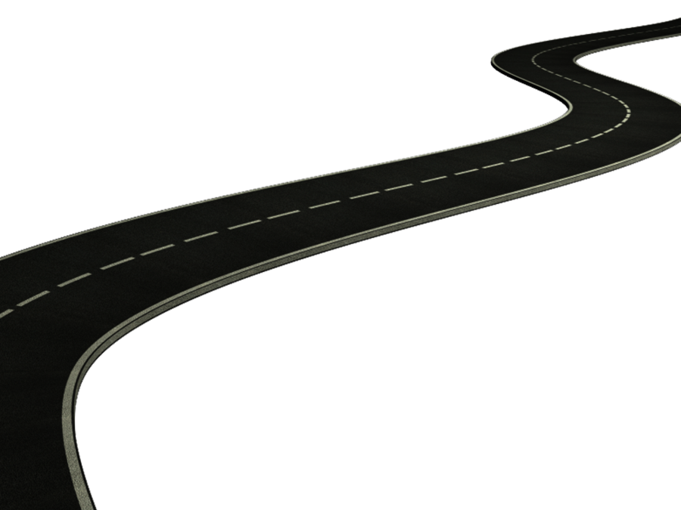
British Values-
Individual Liberty:
Individuals have the freedom to live their lives as they choose, within the bounds of the law, including freedom of speech, religion, and assembly.
Mutual Respect:
Treating others with respect, regardless of their background, beliefs, or circumstances.
PE – Athletics Term 1
Running, jumping and throwing.
- Children will be working on pace and endurance, long jump and triple jump and discus-style throwing in preparation for our Sports Day.

PE – Ball Skills Term 2
- Children will be working on their ball control skills using their feet, passing, dribbling, shooting as well as running with agility and coordination.

- Science: Sound
We will be investigating sounds and how they are created and travel through objects.
- I know that sounds are made when something vibrates
- I know that vibrations from sounds travel through a medium to the ear
- I know that sounds get fainter as the distance from the sound source increases.
- I know that sound waves travel in waves, not straight lines
- I know that sounds can be high or low and this is called pitch
- I know that if you have a bigger pinnae, you can hear sounds louder.

ICT- We will be creating an interactive story.
- I design a solution by breaking a problem up.
- I recognise that different solutions can exist for the same problem.
- I select, use and combine software on a range of digital devices.
- I use a range of technology for a specific project.

- DT- Chinese Feast
We will be exploring Chinese food and cooking our own Chinese feast to celebrate the end of the school year. All parents will be invited to try our fantastic spring rolls and other Chinese delicacies.
Design:
I use market research to inform my plans and ideas.
I justify my plans in a convincing way.
I show that I consider culture and society in my plans and designs.
Make:
I work within a budget.
I describe how food ingredients come together.
I persevere and adapt my work when my original ideas do not work.
Evaluate:
I evaluate my product against clear criteria.
Technical Skill:
I show that I can be both hygienic and safe in the kitchen
I understand and apply the principles of a healthy and varied diet
Prepare and cook a variety of predominantly savoury dishes using a range of cooking techniques

2) History – Qin Shi Huang Dynasty
We will be exploring the Qin Shi Huang Dynasty and learning about some of the key changes Qin Shi Huang made to China.

Investigate the discovery of the Warriors and The Great Wall of China
Explore key features of the Qin Shi Huang Dynasty and how the Terracotta Warriors and The Great Wall of China provide evidence of Chinese history.
Create information related to the Warriors and present information creatively

- I know where the Qin Shi Huang Dynasty is located on a timeline of Chinese history including the commission of The Great Wall of China and The Terracotta Warriors.
- I know that China created and traded silk using The Silk Road
- I know that Qin Shi Huang was known to be the first emperor to unite China.
- I know that Qin Shi Huang began the Great Wall of China.
- I know that China wanted to live forever and so built the Terracotta warriors to help him keep his power in the afterlife.
- I know that China consisted of waring states Han, Wu, Zhao, Chu, Qi and Yan before they were united by Qin Shi Huang.

MFL- Spanish- Sport - Hago deporte
I can name common sports
I can use conjunctions to join lists of sports
I can give an opinion about sport – I like, I don’t like
I can name port clothing
I can describe sport, clothing

Maths continued
Year 5-
Decimals
Adding and subtracting decimals within 1
Adding decimals, crossing the whole
Multiplying and dividing decimals by 10, 100 and 1,000
Properties of shape
Identify, compare and order angles
Measuring angles in degrees
Measuring with a protractor
Drawing and calculating angles
Calculating angles
Position and Direction
Position in the first quadrant
Translation
translation with coordinates
reflection
reflection with coordinates
Converting units
Kilograms and kilometres
Millimetres and millilitres
Metric units
Imperial units
Converting units of time
Timetables
Volume
Compare volume
Estimate volume
Estimate capacity
Year 6-
SATS revision
Statistics
Read and interpret line graphs
Draw line graphs
Circles
Pie charts with percentages
Draw pie charts
The mean
Properties of Shape
Measure with a protractor
Angles around a point
Angles of a straight line
Calculating angles
Vertically opposite angles
Angles in a triangle
Angles in regular polygons
Angles in quadrilaterals

Maths- Children will be following the White Rose Maths Structure. This term the structure is as follows;
Year 3
Fractions
-making the whole
-tenths as decimals
-equivalent fractions
-ordering fractions
-Adding and subtracting fractions
Time-
-Months and Years
-hours in a day
-telling the time to 5 minutes
-comparing durations
-problem solving with time
Properties of Shape-
Right angles
Comparing angles
Parallel and perpendicular angles
Horizontal and vertical
Mass and Capacity
Measure and compare mass
Add and subtract mass
Measure capacity
Add and subtract capacity
Temperature
Year 4
Money
Pounds and pence
Estimating money
Adding and subtracting money
Giving change
Time
Telling the time in hours minutes and seconds
Years, months, days and weeks
Analogue to digital time 12 and 24 hour
Statistics
Interpret charts
Line graphs
Comparison, sum and difference
Properties of Shape
Turns and angles
Identify and compare angles
Triangles and quadrilaterals
Lines of symmetry
Horizontal and vertical

