Learning Journey Plan for a Cross Curricular Topic
Tales from the Harvest
We are historians investigating the past

British Values:
Democracy- Term 1 The Rule of Law- Term 2

English:
Autumn:
Spellings:
I spell unknown words using my phonemes (sounds). (phonetically plausible attempts: yoo, rayn- rain, sed- said frend for friend)
Composition:
I say a sentence out loud before I write it down. (Hold a sentence)
Grammar:
I use the personal pronoun ‘I’
Punctuation:
I leave spaces between words.
I use a capital letter for the start of a sentence.

Science: Animals & Farming
• I can name and identify different animals found on farms and in the wild.
• I can sort animals into groups such as mammals, birds, fish, amphibians, and reptiles.
• I know about what animals eat and can describe simple food chains.
• I can explain how humans get food from animals and plants.
• I know how farmers take care of animals and the food they provide.
• I know how crops are grown, harvested, and cared for on farms.
• I can compare how animals and crops were cared for in the past with today.
• I can use simple observations and information to answer questions about animals and farming.
• I know how farmers help animals and crops stay healthy.
• I understand how science helps us produce food safely and sustainably.
I can create my own fact file of a farm animal

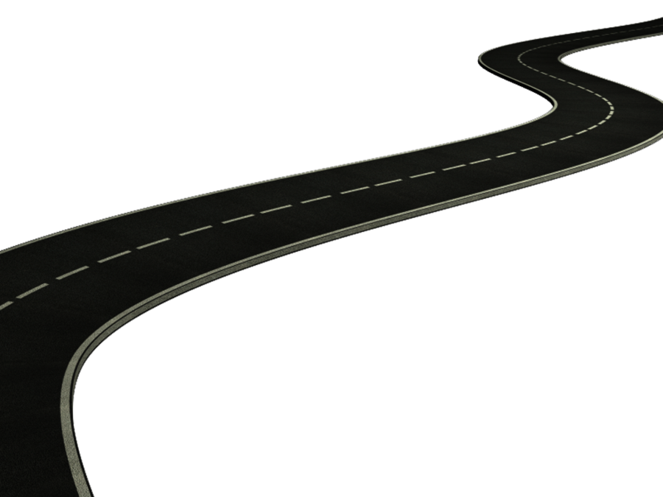
DT
Harvest Lunch & Felted Seasonal Crown
• I can plan and prepare simple harvest-themed food safely.
• I can use tools and equipment carefully.
• I can follow a simple recipe and choose ingredients.
• I can evaluate my food and suggest improvements.
• I can design and make a felt crown using seasonal ideas.
• I can join materials and explain my choices.
• I can compare my finished crown to my design.

Art: Harvest & Seasonal Art
• I can explore colours, shapes, and textures linked to harvest and seasons.
• I can use different materials and tools to create pictures or models.
• I can draw or paint objects from nature and farming.
• I can mix colours and choose materials for effect.
• I can talk about my artwork and explain my choices.
• I can look at other artists’ work and say what I like or notice.
I can create a final piece of seasonal art.

RE
Term 1: Judaism – Shabbat: Is Shabbat important to Jewish children?
- Empathise with Jewish children by understanding what they do during Shabbat and why it is important to them.
- Explain why a particular day is my favourite day and explain why.
- Talk about food I would like to share in a special meal.
- Use the right name for things that are special to Jewish people during Shabbat and explain why.
- Start to make connections between being Jewish and decisions about behaviour.
- I can tell you about something on the special Shabbat table.

Term 2: Judaism – Rosh Hashanah and Yom Kippur: Are Rosh Hashanah and Yom Kippur important to Jewish children?
- Empathise with Jewish children by understanding what Rosh Hashanah and Yom Kipper mean to them.
- Say how it feels to forgive someone.
- Tell you something that either Rosh Hashanah or Yom Kipper is about.
- Choose a picture and give my thinking on why this might be important to Jewish children at Rosh Hashanah and Yom Kippur.

History- Farming & Harvest: Past and Present
• I use words and phrases like then, now, long ago, before, and after.
• I know how to ask and answer questions about farming and harvests in the past and today.
• I can spot differences between old and new farming tools and techniques.
• I know what certain farming tools and machines from the past were used for.
• I recount how people used to plant, grow, and gather crops in the past.
• I know about festivals and celebrations related to harvests and how they have changed over time.
• I know about farmers and inventors who have helped improve farming in the past.
• I know how farming has shaped the way people live today.
• I know how to use books, pictures, and the internet to find out about farming in the past.
• I understand how harvests and food production have changed since my grandparents were young.

I can create a timeline of farming over the years

Maths- Children will be following the White Rose Maths Structure. This term the structure is as follows;
Place Value- 6 weeks
Addition & Subtraction- 5 weeks
Geometry- 1 week

Geography: Seasons, Weather & Food Origins
• I can observe and describe daily weather using words like sunny, rainy, windy, and snowy.
• I can identify seasonal changes and explain how they affect plants, animals, and people.
• I know about different types of weather in the UK throughout the year.
• I can describe the climate in hot and cold countries and compare it with the UK.
• I know where our food comes from and which foods grow in the UK and in other countries.
• I can explain how seasons and weather affect farming and harvests.
• I can use maps, atlases, and the internet to find out where food is grown.
• I understand how food travels from farms to our shops and homes.
• I can compare how food was produced in the past with today.
• I can talk about why weather, climate, and seasons are important to our daily lives and to farming.

I can create a harvest calendar

PSHE- CORAM Life Education: SCARF scheme
In our SCARF sessions. Children meet Harold, our giraffe puppet mascot (‘Healthy Harold’). They have discussions and learn about healthy eating, keeping safe, valuing differences, the body and how it works, and friendships and their influence. They begin to understand the impact of their choices and behaviours on every aspect of their health and wellbeing – and learn the skills and information needed to make positive, informed health choices.
Term 1- Me and my relationships
Why we have classroom rules
Thinking about feelings
Our feelings
Feelings and bodies
Our special people balloons
Good friends
How are you listening?
Term 2- Valuing Differences
Same or different?
Unkind, tease or bully?
Harold’s school rules
Who are our special people?
It’s not fair!

