English:
Spring:
Spellings:
I can start to spell words containing some alternative phase 5 phonemes already taught- spray, day, boy, toy, enjoy
I can spell my phase 5 tricky words words
Writing:
I can say out loud what I am going to write about
I can compose a sentence orally before writing it
I can sequence sentences to form short narratives
I can re-read what I have written to check that it makes sense
Grammar:
I can join words and joining clauses using ‘and’
Punctuation:
I leave spaces between words.
I can use a capital letter for names of people, places, the days of the week, and the personal pronoun ‘I’
I can punctuate sentences using a capital letter and a full stop, question mark or exclamation mark

Spring 2- Science: Plants
• I can name and identify a variety of common wild and garden plants, including British flowers such as tulip, rose, dandelion, daisy, sunflower and bean plants.
• I can say whether different plants grow from a seed or a bulb.
• I can name and label the basic parts of a plant, including the roots, stem, leaves and petals.
• I can name and label the main parts of a tree, including the roots, trunk, branches and leaves.
• I can plant seeds and bulbs and observe how they grow over time.
• I can monitor and compare plant growth in different conditions, such as light and dark places.
• I know that plants need water, light and a suitable temperature to grow and stay healthy.
• I know that plants will die if they do not have water.
• I understand that plants in dark places may still grow if they can find a source of light.
• I can use simple observations to answer questions about how plants grow and what they need to survive.
I can create a simple experiment record to show what plants need to grow.

Year 1
Learning Journey Plan for a Cross Curricular Topic
The Land of Dinosaurs- Spring 1
Spring has Sprung- Spring 2
British Values:
Mutual Respect- Spring 1 Individual Liberty- Spring 2

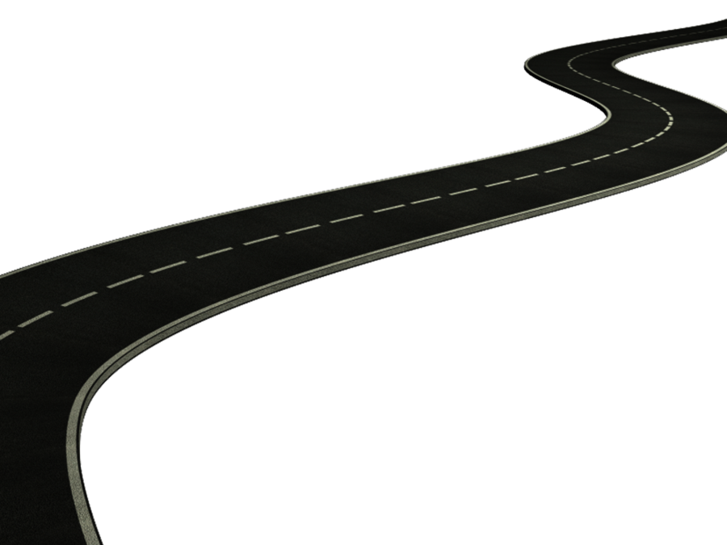
Spring 2- Art: Artist study- Van Gogh & Frida Kahlo
- I know that artists look closely at the world around them to help them create their artwork.
- I know that Vincent van Gogh painted flowers and nature using bold colours and visible brushstrokes.
- I know that Frida Kahlo painted many self-portraits and often included flowers and bright colours.
- I know that observational drawing means looking carefully at something real, like a flower, and drawing what I see.
- I know that artists can use different materials such as paint, collage and tissue paper to create texture in their artwork.
- I know that artists can combine different ideas and materials to create a final piece of artwork inspired by other artists.
- I can create a final piece inspired by Van Gogh & Frida Kahlo

RE
Term 1:

Spring 1- History: Dinosaurs (Significant Individual – Mary Anning)

• I know that dinosaurs lived in the past, a very long time ago.
• I can use words such as past, before, now and long ago to talk about history.
• I know that there are different ways to find out about the past, including fossils and pictures.
• I understand that fossils help us learn about animals that lived long ago.
• I can identify similarities and differences between life in the past and life today.
• I know that Mary Anning was a significant person from the past.
• I can explain why Mary Anning is remembered for her discoveries of fossils and dinosaurs and she became famous for her discoveries, which helped us to learn more about prehistoric life.
- I can describe the main events and achievements in Mary Anning’s life.
- I can describe the Ichthyosaurus and other important fossil discoveries Mary Anning made.
- I can create a dinosaur museum to show what I know about dinosaurs and fossils.

Spring 1- Geography: Dinosaurs Around the World

• I can learn that dinosaurs lived all around the world.
• I can use a map or globe to find different places where dinosaur fossils have been found.
• I can name and locate the seven continents.
• I can describe hot and cold places using simple geographical words.
• I can learn that the Earth’s climate was different when dinosaurs lived.
• I can identify land and sea on maps.
• I can compare places in the past with places today.

I can create a dinosaur world map showing where fossils have been found.

Maths- Children will be following the White Rose Maths Structure. This term the structure is as follows;
Place Value (within 20)- 3 weeks
Addition & Subtraction (within 20)- 3 weeks
Place Value (within 50)- 2 weeks
Length & Height- 2 weeks
Mass & volume- 2 weeks
https://whiteroseeducation.com/parent-pupil-resources/maths/home-learning?year=year-1-new – Home Learning

Spring 1- DT
Dinosaur Skeleton Puppets
I can plan my dinosaur skeleton by deciding which bones I need and drawing them.
I can safely cut out shapes using scissors.
I can join pieces together using split pins or paper fasteners so that they move.
I can add decoration to my dinosaur skeleton to make it look realistic.
I can test my skeleton puppet to make sure the joints move properly.
I can explain how my dinosaur skeleton puppet works and how it links to real dinosaur bones and fossils.
I can work carefully and creatively to make a dinosaur skeleton that could be displayed in a museum.

PSHE- CORAM Life Education: SCARF scheme
In our SCARF sessions. Children meet Harold, our giraffe puppet mascot (‘Healthy Harold’). They have discussions and learn about healthy eating, keeping safe, valuing differences, the body and how it works, and friendships and their influence. They begin to understand the impact of their choices and behaviours on every aspect of their health and wellbeing – and learn the skills and information needed to make positive, informed health choices.
Spring Term 1- Keeping myself safe
Healthy me
Super sleep
Who can help?
Harold loses Geoffrey
What could Harold do?
Good or bad touches?
Sharing pictures
Spring Term 2- Rights & Responsibilities
Harold’s wash and brush up
Around and about the school
Taking care of something
Harold’s money
How should we look after our money?
Basic first aid

