Maths
Children will be following the White Rose Maths Structure. This term the structure is as follows;

Year 2 and Year 3
Place Value
Addition and Subtraction
Multiplication

Children will be practising their 2, 5 and 10 times tables daily.

Please complete any of our optional Home Learning in this order.

When I feel like erupting

Feeling safe

How can we look after our environment?

Harold saves for something special

Harold goes camping

Playing games

Charity fundraiser
Autumn Term 2025
British Values-
Democracy
The Rule of Law

Christian Values-
Friendship
Justice

- History – Investigate the life of a significant person: Florence Nightingale
Why do we think Florence Nightingale is remembered?
Investigate the life of Florence Nightingale
Explore the impact that Florence Nightingale had and still has on life now
Create an information text about why Florence Nightingale is remembered now.
Children will learn about Florence Nightingale as a significant historical figure who helped transform nursing and improve hospital care. They will explore her life, the changes she made during the Crimean War, and how her work has had a lasting impact on healthcare today.
Year 2 SPaG  Year 1 revisit Finger spaces/letter/word/sentence/full stop/capital letter/question mark/exclamation mark/speech bubble/bullet points Singular/plural Adjective/verb/connective Alliteration Simile | Year 3 SPaG  Year 1/2 revisit  Word types  Sentence structure  Punctuation !?"",

Y
English
Non-fiction – Diary Writing, Newspaper report - Florence Nightingale meets Queen Victoria
Fiction – Charlie and The Chocolate Factory, Hansel & Gretel, Elephant’s Guide to Making Friends!
Poetry – Repetitive Rhymes, Acrostic Poems

Weekly Music –
We are Composers
Children will learn to play both tuned and untuned instruments musically as they explore the concept of beat. Through listening and performing, they will begin to understand rhythm and develop their confidence as young composers and musicians.

3) Art and Design - To use sculpture to develop and share their ideas, experiences and imagination.

Investigate images of statues of significant people from the past (Mary Seacole)
Explore making coil pots and joining them together to make a body shape
Create a statue of Florence Nightingale using clay to represent how we remember significant people from the past
Children will investigate images of statues of significant people from the past, such as Mary Seacole, and explore how these figures are remembered. They will learn how to make coil pots and join them to form body shapes, using these skills to create a clay statue of Florence Nightingale, showing how we can remember and honour important people from history through art.
6) RE -
1 – Judaism – Shabbat. Is Shabbat important to Jewish children?
Investigate Shabbat – what is it?
Explore what Jewish people do for Shabbat
Create food that Jewish people might eat from the Shabbat table

2 - Judaism – Rosh Hashanah and Yom Kippur. Are Rosh Hashanah and Yom Kippur important to Jewish children?
Investigate Rosh Hashanah and Yom Kippur – what does it mean?
Explore what Jewish people do to celebrate Rosh Hashanah and Yom Kippur
Create a new snack to eat to celebrate an event in my life

Weekly PE
Half term 1) Ball Skills Half Term 2) Dance
4) Science
Year 3 – Forces
Investigate how many forces there are
Explore cause and effect related to forces concepts
Create an investigation into forces
Year 2 – Animals – Grouping and Classifying
Investigate different animals and sort into groups
Explore different mammals and sort into carnivore, omnivore and herbivore
Create a food chain to show a herbivore can be eaten by a carnivore

Children will learn scientifically by asking questions, making observations, and carrying out simple investigations.
2) Geography
Investigate where Florence travelled throughout her life
Explore Florence Nightingale's journey to Scutari
Create your own map to explain the places Florence visited
Children will learn that Florence Nightingale travelled from Britain to Crimea to help care for wounded soldiers during the Crimean War. They will discover how her journey and work in the hospitals there helped improve conditions and save lives.
PSHE/Wellbeing
Me and My Relationships
Understand that classroom rules help everyone to learn be safe
Understand how others might be feeling by reading body language/facial expressions
Recognise that people’s feelings and bodies can be hurt
Identify simple qualities of friendships
Give and receive positive feedback

Valuing Differences
Identify the differences and similarities between people
empathise with those who are different from them
Explain the difference between being unkind and bullying and that bullying is quite rare
Recognise and explain what is fair and unfair, kind and unkind
5) ICT
Year 2 – 2 Simple 2 Beat
Investigate music with a beat
Explore 2 Simple 2 Beat
Create own tune with different beats

Year 3 – Power Point
Investigate Power Point by identifying key features
Explore how to insert text, pictures and a new slide
Create a Power Point to present to the rest of the class

Learning Journey Plan for a Cross Curricular Topic
We are Historians, learning about the past
Helpful Hands, Kind Hearts
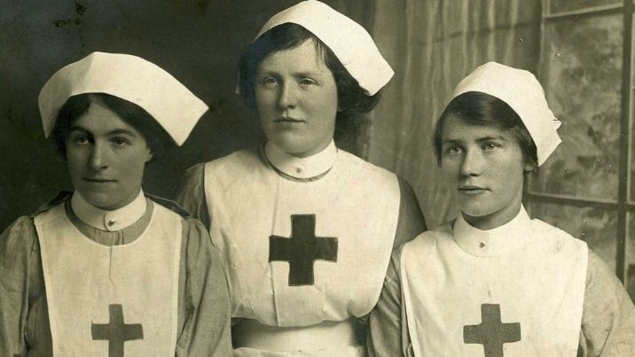
British Values-
Democracy The Rule of Law

