Mastering Number – School Overview at Hindon Primary School
Principles underpinning Mastering Number at our school:
- Developing fluency makes more children better able to access the maths learning in their main lessons.
We do this by making connections between Mastering Number sessions and main lessons.
- Developing children’s mindsets to look for mathematical relationships supports them with being able to make connections.
We do this by drawing pupils’ attention to the relationships between numbers, so that they can also connect them with prior learning where it has taken place.
- Building confidence enables more children to make progress.
We do this by focussing on enabling all pupils to really understand small steps in learning.

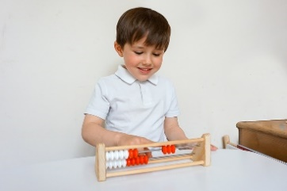
At Hindon Primary School, we are actively participating in the NCETM’s Mastering Number Work Group through our local Wiltshire Maths Hub.
Reception teacher leader: Miss Chloe Gill
Year 1 & 2 teacher leader: Miss Amy Hall


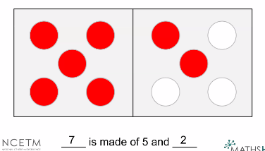

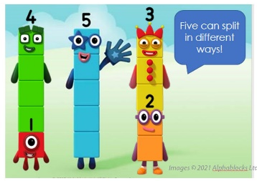
Our Mastering Number sessions are organised with particular impacts in mind:
- A daily input of 10-15 minutes in addition to and to complement daily maths lessons – four times a week – to children in Reception, Year 1 and Year 2.
- Adults drawing children’s attention to intended aspects of learning, including in relation to particular mathematical structures.
This enables us to ensure children think deeply about the mathematics they are using.
- Adults scaffolding learning, including through use of different manipulatives, to help children secure understanding.
This enables pupils to develop a more secure understanding of core mathematical structures. Seeing the same concept alongside different manipulatives and pictorial representations often leads to children making their own connections, thus deepening understanding.
- Conceptual variation – transferring understanding of the same mathematical concept through use of different contexts.
When children transfer their learning through use of well thought out contexts that are varied, they become confident and make connections in learning.
- Linking the action and the thought – manipulatives secure understanding but are then visualised over time.
When children have enough experience of using manipulatives and seeing pictorial representations, they then begin to visualise them.
What you will see in some of our Mastering Number sessions:
- Activities which are accessible and enable all children to become more confident and competent.
- Children being supported to acquire key facts and skills they can use efficiently, including in their other maths learning and/or lessons.
- Quick finishers working on related/connected facts rather than additional ‘challenge’ activities. This does not mean that our children are not challenged! They are focussed on the key learning.
Over time, through participating in Mastering Number sessions, our children will:
- Develop fluency in calculation and a flexibility with number that exemplifies good number sense.
- Be able to clearly communicate their mathematical ideas.
- Make good progress towards the Early Learning Goals and Key Stage 1 year group expectations.
- Demonstrate a willingness to ‘have a go.’

Features of Mastering Number sessions:
Our Mastering Number sessions…
- Are inclusive with all children securing learning linked to the same concepts in an interactive and engaging manner.
- Are about accessible learning which enables all children to have a firm understanding.
- Enable all children to develop number sense and secure core knowledge. This is similar to supporting pupils with phonics knowledge!
For all of our children to develop depth in understanding, we want them to…
- Become mathematically observant.
- Look for relationships between numbers.
- Explain their mathematical thinking.
Don’t count.
Say the amount.

