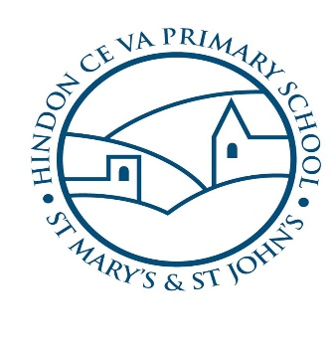
Starting School

My new school is called Hindon Primary School

This is your school, where you will learn, play and make lots of new friends…

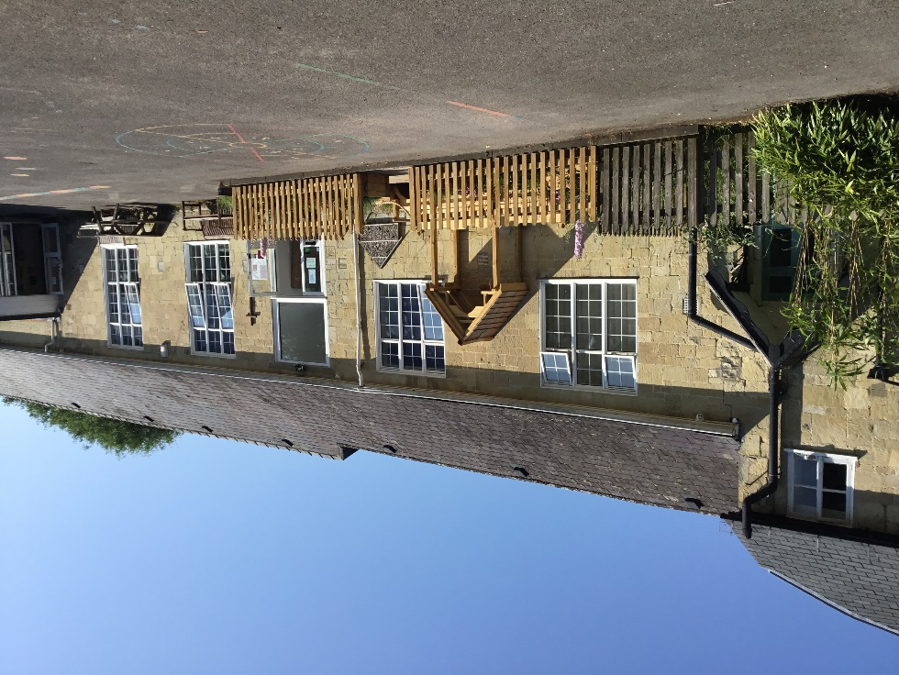

Hello,
I am Miss Gill and this is Mrs Johnson,

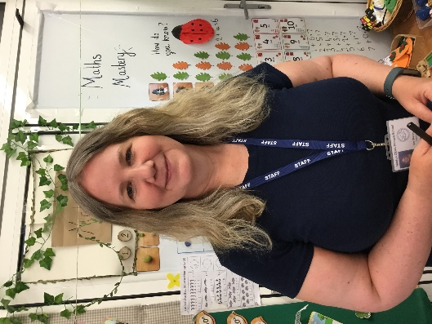
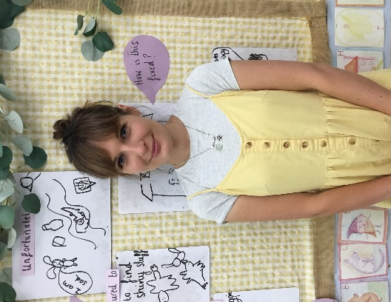

We just heard great news. You are starting school!
Let’s show you around. This is your classroom where we learn and play.
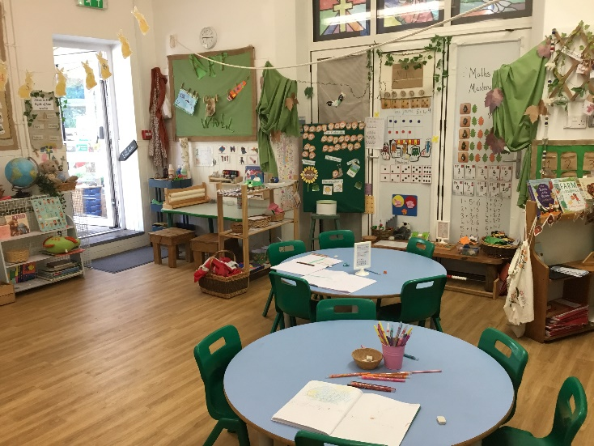

Our morning starts off...
Popping our coats on our pegs
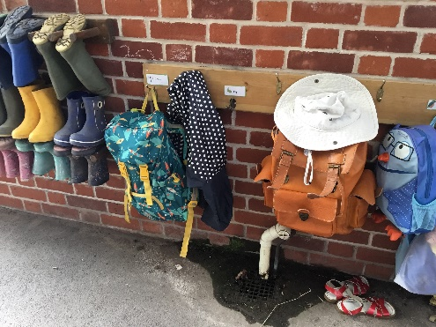
Then we start to explore our new classroom and have a play…

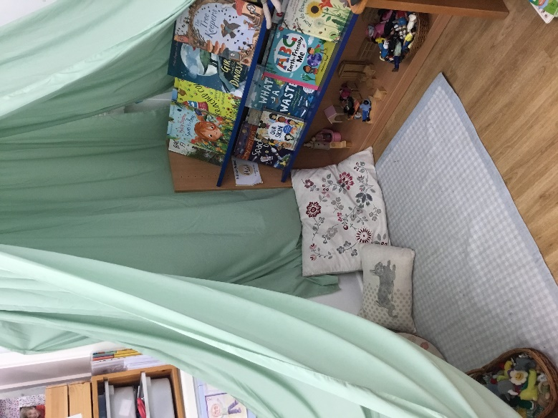

Every morning we do phonics with Phonics Pig. Phonics is where we learn to read and write!
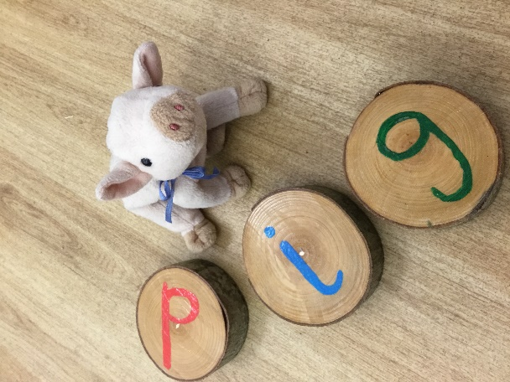
After break time (where we play on the big field) we come back in and do maths with Pete the Badger…he loves to learn all about his numbers.
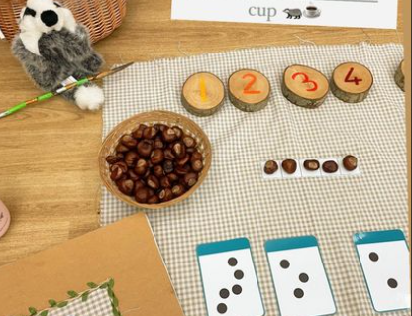

After maths we explore our indoor and outside classroom and play with the new toys!
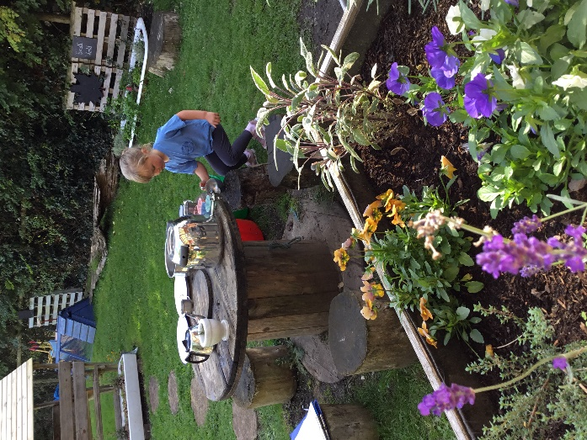
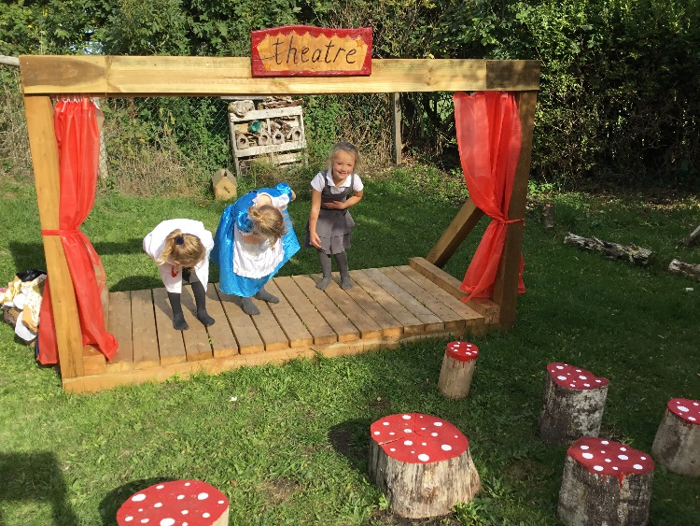

We then settle for a story before we have lunch.
At lunch time Mrs Gray looks after us in the lunch hall.
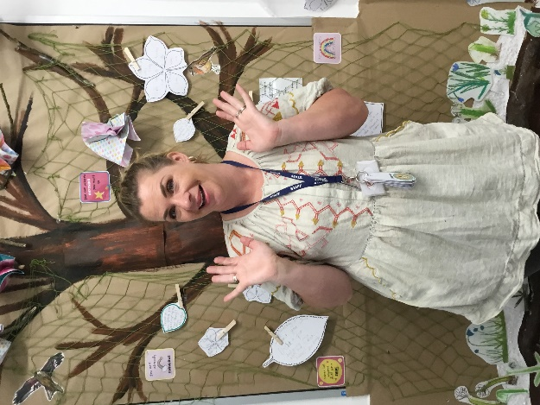
At school I will make lots of new friends, who I can play with at playtime.
My friends will make me feel welcome and help me while I settle in at Hindon School.
If you need the loo you can ask the teachers what to do.
When it is home time we say goodbye to our new friends and our teachers. Someone picks us up and we can talk about all the fun things we’ve done.
We look forward to seeing you soon!

