Building and modelling
IMPORTANT Parent or Carer –
Check that you are happy with any weblinks or use of the internet.

NB New activities are being added at the top of each document.

Activity 12 – Lego or another construction toy
Build objects to retell a traditional tale

What to do  - Tell a traditional tale together which will lend itself to the play: try Goldilocks, or The Three Little Pigs.  - Talk about the story and what objects are important to remember if we want to tell it to someone else (3 different sized bowls, chairs and beds or three houses made from different materials).  - Make the objects together, talking about features that will be important, e.g. chair size.  - When you have made the objects, look at them and talk about how hard or easy it was to make them and what you are pleased about.  - Then retell the story together, using the constructed toys in the play. | What you need  Lego, Duplo, Magnetico, Meccano, blocks or any other construction equipment you have.  Small world figures to act in the stories  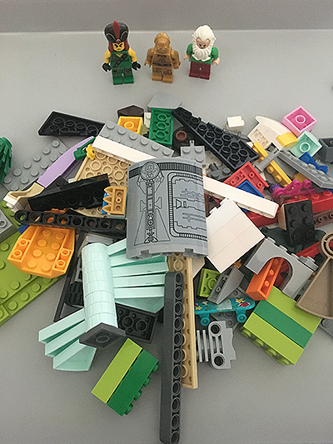
Extension  Explore using different building materials, e.g. twigs or food items (dry spaghetti, brick shaped biscuits, etc.)  Try a different story, Rapunzel, Jack and the Beanstalk, etc.  Photograph the constructions and write instructions together, so that someone else could try making your items. | Questions to ask  What objects are important in the story?  How could we make them?  How many beds will we need? Will they be all the same?  What did we make that chair from?  What was tricky about making the bowls? How would you make them another time?  Can we tell the story using what we have made?

Activity 11 – Mouldable Materials
Make dinosaur fossils

What to do  - Talk about footprints. When do we make footprints? - Walking in sand or snow. This is because the material is soft enough to press into but holds the shape when your foot moves.  - Talk about how fossil footprints were formed, the shape of the dinosaur’s foot being preserved in mud as it hardens.  - Look at the dinosaur toys. Can we guess what shape each dinosaur or part of dinosaur will make if we push it into the salt dough?  - Make fossils together.  - Roll a bit of the dough into a ball and then roll it out to the thickness of 1-2 cm.  - Press a dinosaur (or part of one) into the dough.  - You can keep rolling and pressing to explore lots of ways to make impressions.  - When you have some that you want to keep, place on a baking tray lined with baking parchment.  - Bake at 180˚C for at least 4 hours (the larger and thicker the fossils, the longer the cooking time).  - Allow to cool. You can use watered-down paint to accentuate the imprint. | What you need  Salt dough (see recipe below)  Plastic toy dinosaurs (or any other plastic toys which can make footprints)  Rolling pin  Baking parchment to bake  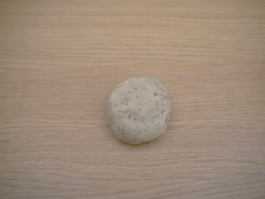  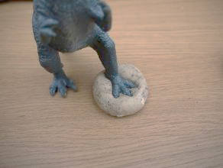  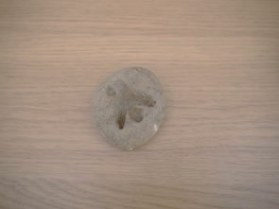
Extension  Challenge children to match the fossil to the original dinosaur, either looking at the toy or real experts might recognise the dinosaur type! | Questions to ask  How do we make footprints? Why do they hold their shape? What shape do you think this dinosaur will make? How can we make the fossil hard?

Salt Dough Instructions
Basic Pale Dough: | Rocky Coloured Salt Dough:
- 1 cup salt  - 2 cups of flour  - ¾ cup of water | - 1 cup salt  - 2 cups of flour  - ¾ cup of stewed cold tea/coffee  - 2 tbsp coffee grounds
Instructions for dough:
- Mix dry ingredients in a bowl.
- Add liquid and mix with a wooden spoon.
- Turn out onto a surface and knead until the dough is smooth.

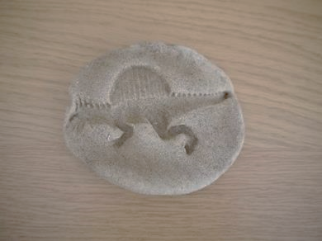

Activity 10 - Lego or another construction toy.
Build a tower as big as you!
What to do  - Talk about building tall structures with construction toys.  - How tall do you think we can build a tower? Up to your knee/tummy/as tall as you are?  - Help your child as they explore building and supporting the structure, while getting it as high as possible.  - Praise your child as the tower reaches different height milestones. Photograph each stage as you go, in case of collapse.  - Celebrate the efforts of your child and their determination to build a tower as tall as they are. | What you need  This can be Duplo, Meccano, blocks, Stickle Bricks or any other construction equipment you have.  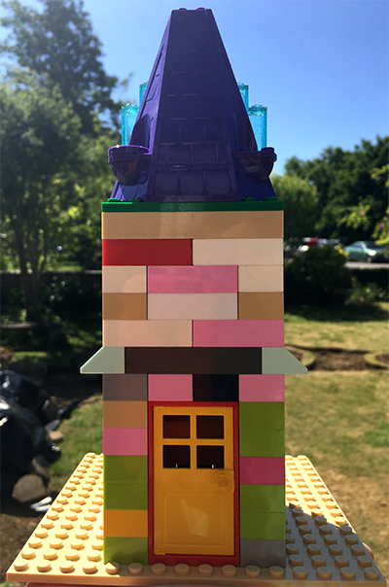
Extension  Try building towers as tall as other household members. Ask a faraway family member how tall they are and build a tower for them.  Try building a tower from junk materials. How will these need fixing together? | Questions to ask  How tall can we build a tower?  How tall are you?  Can we build one the same height as you?  How can we make it sturdy?  How high is it now? Is it tall enough?  What is the difference between your height and the tower?  How many blocks did we need?

Activity 9 – Modelling from found and recycled materials
Build a structure from twigs and tape

What to do  - Collect sticks and twigs together. This could be during a walk.  - Talk about the different colours, textures, shapes and sizes.  - Show the masking tape and how it can be ripped easily and used to make temporary fixings, easily pulled off again in order to reposition it.  - Allow your child to explore the different structures and shapes they can make by fixing the twigs together. If they need help thinking of ideas, suggest they make an animal/building/gadget etc.  - Ask them to tell you about what they have made, what it does and how it works. | What you need  Sticks and twigs  Masking tape  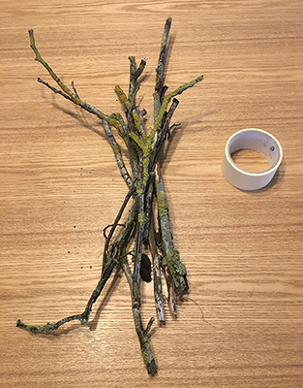
Extension  Encourage your child to make different things. If they want a record of what they have made, offer to photograph anything they feel proud of. They might want to write a label for it or instructions for its use.  Show your child how to make a triangle from three sticks taped together at their ends. Can they make a different triangle/shape? | Questions to ask  What different sticks have we collected? What colours/textures/shapes are they?  What could we make with them?  How could we fix them together?  What have you made? How does it work?  How could you add a handle?  How many sticks have you used? How many more do you need?

Activity 8 - Construction
Make the tallest paper cup pyramid

What to do  - Set up the challenge. How tall can you build a construction using the cups?  - Explore different ways of stacking them. All facing the same way, they nest. Towers of two can be created by stacking two bases or two rims together. Is there another way?  - Allow more exploration before giving a clue, by placing two cups side by side and another on top in a pyramid shape.  - Allow your child to explore and build, experiencing the way the structure will only be sturdy if the triangle structure is kept. | What you need  10-12 paper or plastic cups  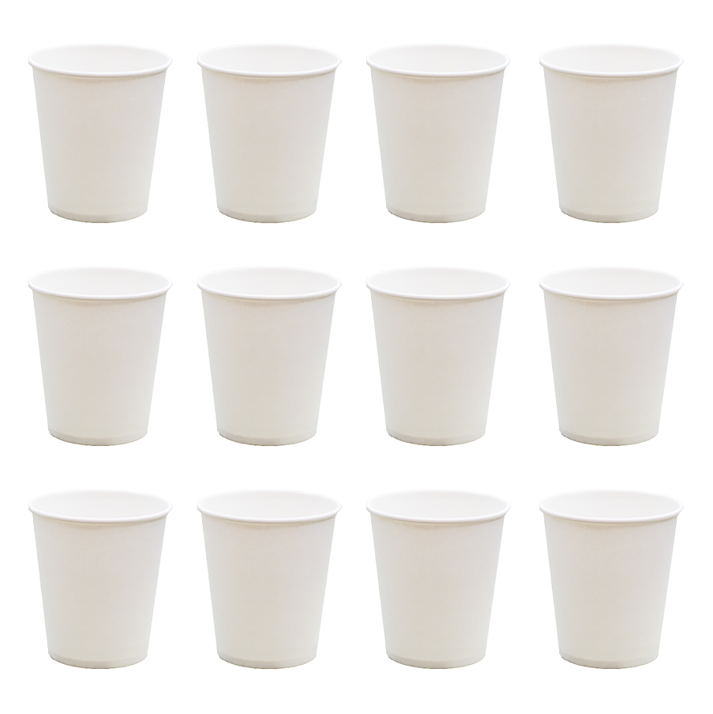
Extension  Try racing (gently) with two people building pyramids at the same time.  Try making walls two cups high.  Try having a wide base (4 in a square) and building up. | Questions to ask  How tall do you think you can make your shape?  How can we stop it wobbling?  Why does it fall down?  How can you make it sturdier?  How tall is it now?  How many cups did you use?  How many cups are on the base?

Activity 7 – Lego or another construction toy.
Build a bridge strong enough to hold a toy

What to do  - Create a river by drawing the shape on paper – you could cut this out or leave drawn on an intact sheet of paper.  - Set up the construction equipment and a character.  - Explain that your character wants to cross the river. Talk about why this might be.  - Ask if your child can help them cross the river. What could they do? Build a bridge. Talk about the fact that it must be sturdy enough to stay standing and strong enough to hold the weight of the character as they cross.  - Let your child explore building the bridge, looking for ways to make it stronger and stay upright. | What you need  River made from paper  Bridge building materials: Lego, Duplo, Magnetico, Meccano, blocks or any other construction equipment you have.  Small world figure to cross the bridge.  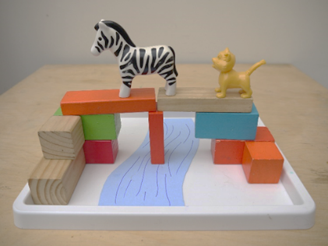
Extension  Explore using different building materials.  Try using more than one toy. Will the bridge be strong enough to hold up two dinosaurs?  Tell stories using the bridge. ‘Who’s that trip-trapping over my bridge?’ | Questions to ask  How will they get across the river? How could we help?  How can we make the bridge strong enough?  How can we stop it falling down?  Is the bridge long enough to cross the river?  What happens when the zebra stands on it?

Activity 1 – Lego or another construction toy.
Build a house for an animal

What to do  - Set up the construction equipment.  - Explain the task clearly. They are to build a home for an animal of their choice. Discuss which animal this might be?  - Talk about what its home looks like.  - Give an incentive for your child to persevere and make something really special. E.g. take a photo and send to a grandparent or other favourite relation. | What you need  This can be Lego, Duplo, Magnetico, Meccano or any other construction equipment you have.  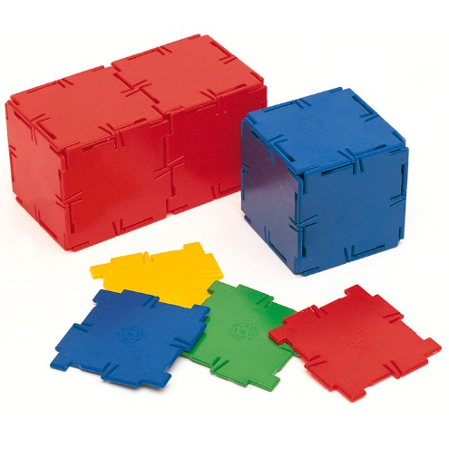
Extension  Set a challenge – e.g. can you create a nest for a bird? Can you create a two-level house for a hamster? What about a split-level cage for a monkey? | Questions to ask  How many pieces have you used – more than 20 or fewer than 20?  What shape are the most useful pieces?  Why is this home good for this animal? Tell me about the animal.

Activity 2 – Junk modelling
Make a spaceship from recycled materials

What to do  - Set up the construction materials.  - Explain the task clearly. They will build a spaceship using the materials collected – look at and handle them. Discuss which parts of the rocket could be made with different materials  - Talk about ways to fix the parts together, without instructing, e.g. masking tape will hold parts together for a while but sticks straightaway, glue takes a while to dry but holds longer  - Give plenty of time for experimenting. The process is more important than the finished product. | What you need  Any clean packaging – cereal boxes, tubes, plastic drinks bottles, cartons, pizza boxes, egg boxes, takeaway containers  Fixing materials – sticky tape, masking tape, PVA glue, elastic bands  Decorative elements: foil, ready mix paints, card, paper  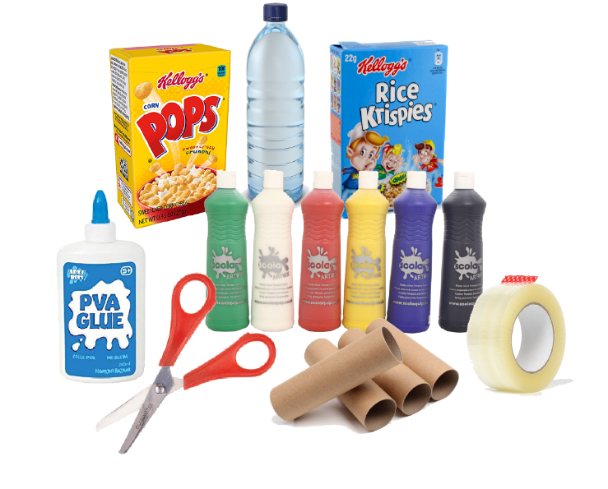  Scissors, felt pens,
Extension  Set a challenge – e.g. can you create a rocket that will deflect rocks? Can you make a rocket that a family can live in?  Take the rocket on its first mission, launching it with a countdown from ten.  Write labels for the different parts of the craft. | Questions to ask  Tell me about your rocket. What does each part do?  Where is your rocket going to go?  What makes your rocket strong?  How did you fix the materials together?

Activity 3 – Modelling from found and recycled materials
Make a bug hotel

What to do  - Explain the task clearly. Insects like to hide in small, dry sheltered places from the weather and predators. This can be gaps in walls, holes in trees, piles of dry leaves. These places are becoming less common so we can help by making a bug hotel.  - Collect the materials – natural materials can be collected during a walk in the park  - Talk about ways to fill the container to make small nooks and crannies for insects to shelter in  - Explore packing the container with the found materials.  - Place or hang up your hotel in an outdoor space ready for the first guests to arrive | What you need  Something to provide the shell of the hotel: a card tube/kitchen roll insert, cut down milk carton, card coffee cup or plant pot  Thin twigs, sticks, dry leaves, pinecones, moss, bark, dead hollow stems  String or thread to suspend the finished hotel from  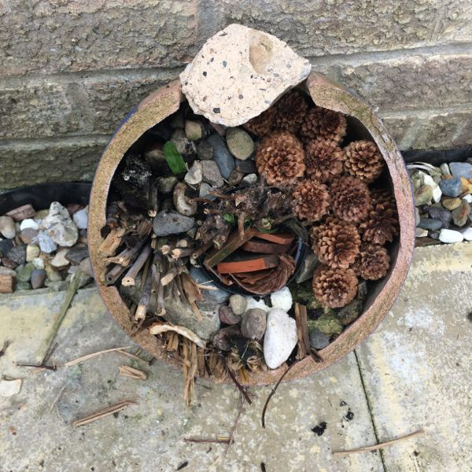
Extension  Set a challenge – e.g. can you create spaces of different sizes for different insects? Can you make a hotel that can hang from a tree/fit in the hedge/be waterproof?  Find out what animals might be taking up residence by looking at this link together: https://www.woodlandtrust.org.uk/blog/2019/09/how-to-build-a-bug-hotel/  Look at larger bug hotels online  http://www.wildwestend.london/stories-feed/2017/4/26/insect-hotel | Questions to ask  How will you stop the parts from falling out?  What will make the hotel waterproof?  Where could we put it? What would be a good place?  How can we keep it light enough to sit on our hedge/stop it blowing away?  How can we design it so it will hang on our fence?

Activity 4 – Modelling using moulding materials
Make ‘food’ for a tea party

What to do  - Set up the activity – pick a guest to make a tea party for (this could be a household member, toy or fictional character e.g. The Tiger Who Came to Tea). Talk about the type of food which would be good to serve them with and how you might shape it  - While you child makes biscuits, cakes, sausage rolls, pizza etc. chat about what they are making.  - Encourage different techniques such as rolling, pressing cutters, pinching and scoring  - Arrange the food on nice plates and welcome your guest/s | What you need  Playdough (bought or made*)  Rolling pin, cutters, board, pastry tools or table knife and a pencil  Plates, platter, cake stand or similar  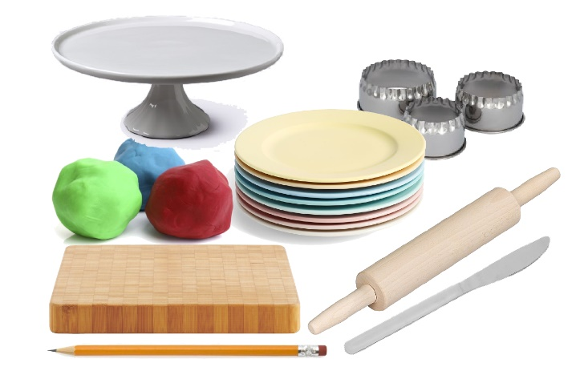
Extension  Count the different foods  Challenge your child to cater for contrasting guests, e.g. a rabbit and a human  Hold your tea party – you could even have a virtual one using Skype (or similar) with distant friends or family members | Questions to ask  What are you making? What flavour is it?  How can you make a really smooth/thin/ biscuit?  How can we put a pattern on your pie top?  How may cherries are there on the top of the cake?  What shape are your biscuits?

*Simple 10 minute playdough recipe: https://www.bbcgoodfood.com/howto/guide/playdough-recipe

Activity 5 – Larger scale building
Build a living room den

What to do  - Set up the challenge.  - Collect building materials from round the home, thinking about what will work well and encouraging your child to share their ideas.  - Test different solutions, again encouraging your child to discover what works and what doesn’t.  - Give open ended prompts to support them and keep their perseverance strong, e.g. ‘Hmm that blanket keeps slipping. How could we stop that happening?’.  - Enjoy the den by bringing in toys, torches, books and cushions. | What you need  Household items for building the structure and then draping over, e.g. dining room chairs, small tables, old fashioned clothes horse, sofa cushions, blankets, sheets, cushions, safe objects to weigh down the blanket (books work well), pegs  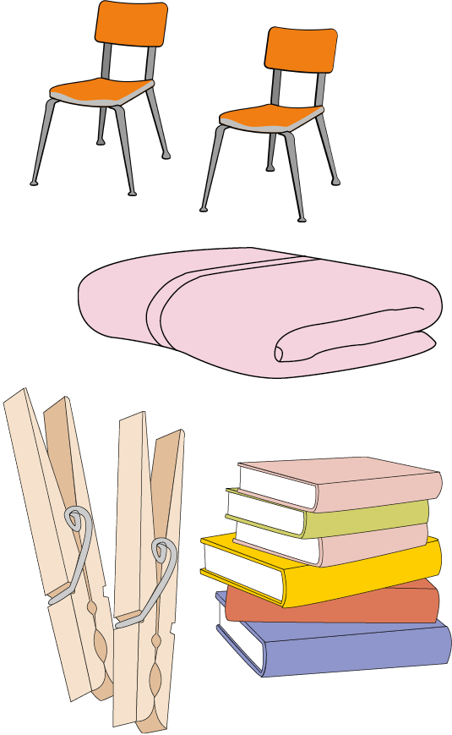
Extension  Try making a den outside.  Make a den for a story character.  Make the den darker for spooky stories or add safe fairy lights. | Questions to ask  What could we use to make a den?  How tall will it need to be?  How many people need to fit inside?  How can we keep the walls standing?  What could be the roof?  How can we keep the blanket in place?

Activity 6 - Construction
Make the tallest tower

What to do  - Set up the challenge. How tall can you build the tower?  - Explore the building blocks and think about ways to use them to build a tower.  - Allow your child to explore and build, experiencing the way the structure will wobble and fall as it gets taller.  - Encourage them to problem-solve, turning the orientation of the blocks and exploring different ways to steady the structure.  - Give plenty of time for experimenting and lots of praise. | What you need  Any regular sized or shaped building pieces, e.g. blocks (not Lego), Jenga pieces, dominoes, mini cereal boxes, Duplo turned with buttons facing out,  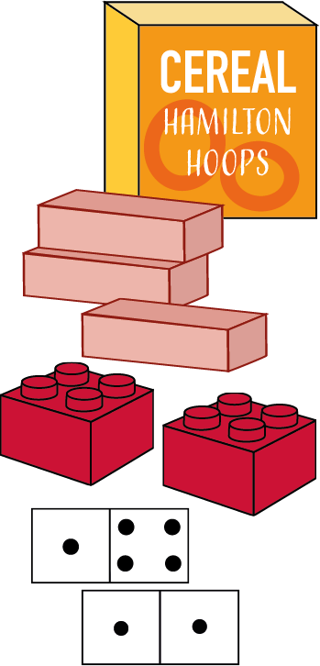
Extension  Encourage your child to compete with themselves. The first tower came up to your knees – can you make the next one taller?  Try different materials to build with.  Make up a story with the tower and some small play figures. | Questions to ask  How tall do you think you can make your tower?  How can we stop it wobbling?  Why does it fall down?  How can you make it sturdier?  How tall is it now?  How many blocks did you use?

