Communicating
IMPORTANT Parent or Carer –
Check that you are happy with any weblinks or use of the internet.

NB New activities are being added at the top of each document.
Activity 12 – Talking and sharing
Play ‘Twenty Questions’

What to do  - Explain that you are thinking of an animal which your child has to guess.  - They can ask some questions to help them, but they have to be questions which you can answer with ‘yes’ or ‘no’.  - Give them some examples of the type of question, e.g. Does the animal have wings? Does it have fur? Does it live under the water? Etc.  - Start the game, helping your child reframe questions that don’t stick to the rules, e.g. How many legs does it have? → Does it have 4 legs?  - Give your child pointers as to how the answers will help them, e.g. ‘Ah. You have found out it doesn’t have feathers, so it can’t be a bird.’  - If your child is not getting close, give them a question which will help them.  - Swap over and ask your child to think of an animal for you to ask questions. | What you need  Nothing needed
Extension  When you get good at the game, add the challenge of having to guess after 20 questions.  Open out the choices to other topics (food, etc.) – keeping to a topic makes this game more manageable for younger players.  Play with a group of guessers. | Questions to ask  Can you guess my animal?  What questions will be helpful?  Can you say it so I can answer yes or no?  What does that answer tell you? What can’t it be?  If it doesn’t have two legs, could there be another number of legs to ask?

Activity 11 – Talking and sharing
Make up a story by playing ‘Over to You’

What to do  - Say you are going to make up a story. Start the story in a traditional way, introducing the characters, place and what is happening, e.g. ‘Once upon a time there was a little girl called Sorcha who found a strange box under her bed. It was covered in sparkling stones and gold shapes. When she opened it, the strangest thing happened…’  - When you have set up a tempting hook (which will not be too difficult to continue) say ‘Over to you’.  - Now it is your child’s turn to continue the story for a few sentences.  - When they reach an interesting point (probably hard to take up!) they then return the story to you to continue with the words, ‘Over to you’.  - Continue passing the story back and forth until you reach a suitable ending. | What you need  Nothing needed
Extension  Make your child the main character.  Tell the story with several storytellers.  Set ground rules to stop the story becoming too silly or themed around toilets or fighting!  Record the story as you tell it and play it back.  Try with remote family over a video call. | Questions to ask  Who will our story be about?  What sort of story might it be?  What will make our story exciting/fun to tell?  What will happen next?  What will they do now?  What will happen in the end?

Activity 10 – Talking and sharing
Make a time capsule
What to do  - Talk about being a child and how you remember different things about what life was like. Explain how different objects can help bring back different memories.  - Explain that this box is going to be a gift for someone special to help them remember what life is like today. It is a gift you are making for your future selves!  - What things might you like to put in to help you remember what life is like right now? Make a list:  - For example:  - Pressed flowers from a walk  - A not too precious toy  - Magazine/comic  - Family photos  - A picture or poem  - A letter  - Takeaway flier  - Rainbow art  - Greetings cards  - Favourite sweet  - Image of favourite picture book  - Seasonal/religious decoration  - Objects to represent special dates, e.g. VE day, Eid, Queen’s Birthday, family events, etc.  - Enjoy building the collection and looking through it. | What you need  A box/container  Paper, pencils, printed photographs  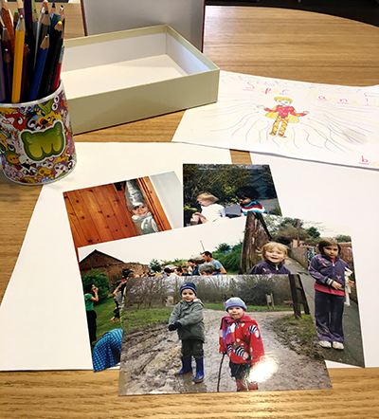
Extension  This could be added to every time you create, are given or find something special.  Decorate the box.  Invite other family members to contribute. | Questions to ask  What would you like to remember?  What objects are special?  What pictures could we include?  What special days have happened recently? How would you like to remember them?

Activity 9 – Giving instructions
Give instructions to draw a picture

What to do  - Before you start, draw a very simple, secret picture. It helps if you do this by drawing shapes, e.g. A house drawn with a triangle roof, rectangle door and four squares for the windows.  - Explain that you have a secret picture that you are going to give instructions for drawing.  - Give simple instructions for your child to follow, so that they can draw a picture like yours.  - When you finish, compare the pictures.  - Swap over and ask your child to draw a secret picture for you to draw. | What you need  Two pieces of paper and pencils  
Extension  Play the game with more than two people; one person instructs while everyone else draws.  Play the game with the drawer hiding their instructed drawing – this is much harder as the instructor cannot adapt or correct their instructions.  Try playing this with distant family and friends over a video call. | Questions to ask  What do you think I have drawn?  How will you be able to listen to my instructions?  Can you guess what it is yet?  How similar do our pictures look?  Which parts were tricky to explain?

Activity 8 – Giving instructions
Create an obstacle course and direct players around it
What to do  - Explain that your child will be making an obstacle course for members of your household. Talk about the different equipment you might use and collect it together.  - Look at what you have collected and talk about how you might use it, where the course will begin and end and what sorts of different obstacles might be fun.  - Work together to set up the course, letting your child take the lead and discussing any safety issues as you go. Encourage your child to test out each obstacle as it is assembled. Encourage them to talk about what users must do.  - Assemble the players and ask your child to introduce the course, instructing them what to do for each part. They will enjoy coaching people through each obstacle. | What you need  Things that can be used to make different obstacles in the course: e.g. hula hoop, cones, chalk drawn shapes on ground, cuddly toys, dress up clothes, furniture, blankets, outdoor toys  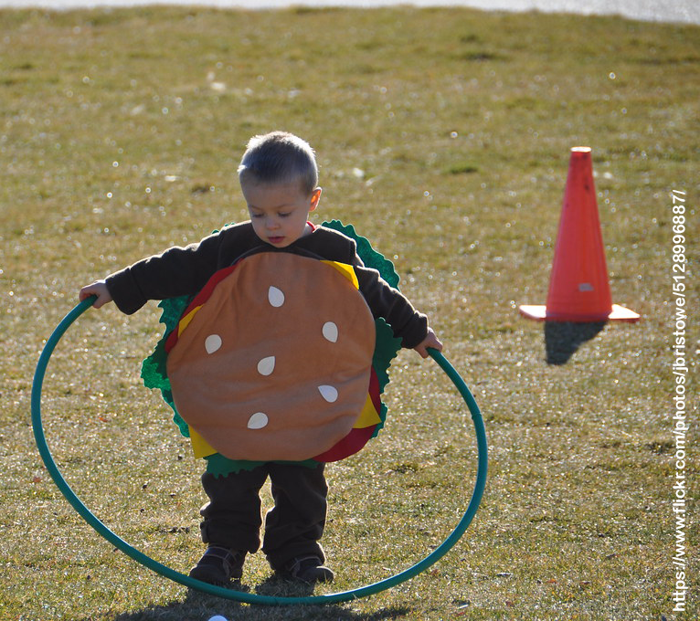
Extension  Take the course through your home and into the garden if possible.  Arm your child with a timer. Who is the fastest?  Name the different obstacles, e.g. Chair Scramble  Create some medals/certificates and award to players showing most skill, best effort, funniest face etc. | Questions to ask  What is an obstacle course? What could we use to make one?  Where will it begin/end?  How will players know what to do?  What will help to encourage the players?

Activity 7 – Giving instructions
Give instructions to a ‘robot’

What to do  - Turn the box into a robot head together. You could so this very simply by drawing a face on it…or you could paint it silver, and add details such as buttons, dials and switched with marker pen.  - Explain that this box turns the wearer into a robot. The robot is very good at following instructions but not so good and thinking for itself. It needs a programmer to give clear instructions.  - Put the box on your head and invite the ‘programmer’ to give some instructions, e.g. walk forward 3 steps, turn one half-turn, etc. You can have lots of fun following less precise instructions (walk forward results in walking into walls until told to stop!).  - Take turns being the robot and giving instructions. | What you need  A box large enough to wear as a robot head,  thick marker pens  (optional) shiny paper or paint  
Extension  Set up obstacles such as cushions for the robot to be directed around.  Make a remote-control box with arrows and numbers to be ‘pressed’ while saying the instructions.  Take the robot around the home and garden. What new instructions can you come up with? | Questions to ask  What instructions could we give to the robot? What things do we need to include?  What happens if you say to go forward 5 steps but there is no room?  What does a whole turn/half turn look like? Can you do one?

Activity 1 – Memorising and performing
Learn and tell jokes

What to do  - Have fun sharing some jokes. Talk about some of the different types of jokes, e.g. Knock Knock, Doctor, Doctor, What do you call…  - Choose some favourites, compiling a top 5 or 10. The emphasis is on preparing these jokes to tell someone else, so it is fine to write these out for your child to help you both to remember them.  - Read these together and choose one or two that you think would go down well with your audience.  - Help your child practise the jokes, saying them clearly, with appropriate timing. They could build in some expression. some actions or find some props.  - Perform the joke/s to an appreciative audience. | What you need  A source of jokes:  Family members, joke books, websites etc.  An audience  A couple to get you started.  Knock Knock.  Who’s there?  Boo.  Boo who?  No need to cry. It’s only a joke.  What do you call a dinosaur that is sleeping?  A dino-snore!
Extension  Help your child build a repertoire of jokes which they can perform to family and friends when they call.  Create a joke book together. It could be illustrated and used in performances or given as a gift to cheer someone up. | Questions to ask  What jokes do you know/like?  What types of jokes do we know?  Who would enjoy hearing some jokes?  What is a good way to tell a joke?  How can we learn a joke so we can tell it to someone else?

A huge database of jokes from the Beano https://www.beano.com/categories/jokes
Activity 2 – Memorising and performing
Learn and perform an action song

What to do  - Talk about the action songs you know already. Explain that it would be fun to learn some new ones.  - Choose an action song to teach your child.  - Ideally, show your child how to do it rather than playing a video clip. This will help your child to feel freer to make up their own style of performance rather than copying one (the clips are for reference).  - Teach one line at a time using a ‘listen and copy me method’, adding in rhythm, intonation and actions as you rehearse.  - Your child can perform their new song for an audience face-to-face or digitally. | What you need  Some action songs*  e.g. Heads, Shoulders, Knees and Toes  There’s a Tiny Caterpillar  The Penguin Song  One Finger One Thumb  Bananas of the World Unite  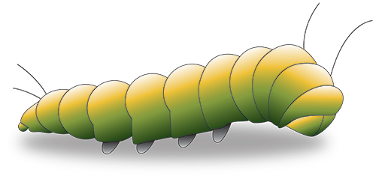
Extension  Encourage your child to teach the song to someone else.  Learn some new songs. Search ‘camp songs’ for a huge selection.  Make a juke box – write the name of each song you learn on a lolly stick. Pull one out randomly and enjoy singing them together. | Questions to ask  What action songs do you know/like?  Which song would be fun to learn?  Who would enjoy hearing this one?  What action could we use for this bit?  How can we sing this line?  Do we know this song by heart?

* Songs to Try
The Penguin Song https://www.youtube.com/watch?v=_FEpPjhVtdc
There’s a Tiny Caterpillar https://www.youtube.com/watch?v=LI2Wo2rRWqM
One Finger One Thumb https://www.youtube.com/watch?v=X5Y586cF0SY
Bananas of the World Unite https://www.youtube.com/watch?v=k93Yunycm28&t=1s

Activity 3 – Conversation
Make a phone or voice call

What to do  - Prepare for the conversation, talking about the person you are about to be speaking with. How do you know them? What sorts of things do you usually talk about with them?  - Talk about why you are calling them. Explain that is nice to receive a call when you cannot visit.  - Have an object or topic ready to talk about. It is easiest to have something to show. Conversations can be a little stilted at first.  - Make the call together, dialling or clicking on the contact details.  - Support your child as they talk, encouraging them and prompting as needed.  - When the call is finished, praise your child for trying hard and brightening someone’s day. | What you need  An organised phone or video call  
Extension  Make plans to contact someone else or the same person again soon. Involve your child in thinking about what that person will enjoy, e.g. some great jokes (see above), a tour round your garden, a story, etc. | Questions to ask  Who could we talk to?  What news could we share? What do they like to hear about?  Will we speak using video or just sound?  What did we do yesterday, can you say?  What did we bake/draw/make?  What questions could we ask them?

Activity 4 – Conversation
Make and use a cup telephone

What to do  - Make a small hole in the base of each cup, small enough to allow the string through.  - Thread the string though each cup and knot it to hold it in place. The knot should sit inside each cup, the cups joined by the string and the drinking rims pointing in opposite directions.  - To speak, gently pull the string taut between the cups. One person speaks into their cup while the other person puts an ear to theirs.  - Have fun holding a conversation at a distance! | What you need  2 paper or plastic cups (tin cans can also be used but take more adult preparation)  String  A pencil/skewer for making holes  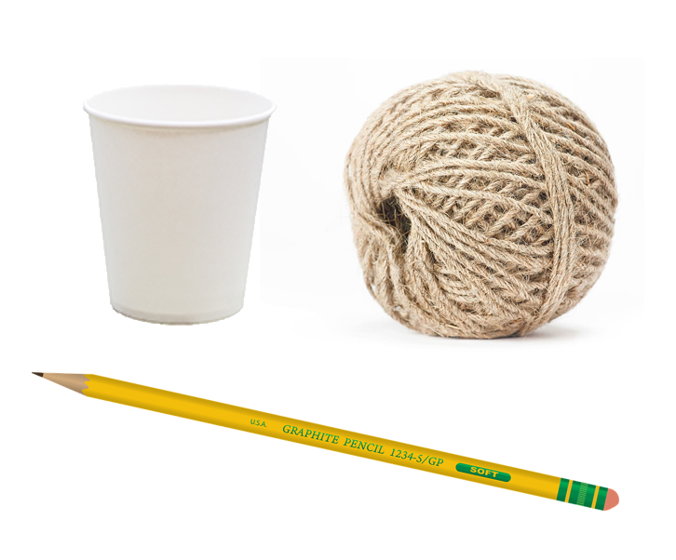
Extension  Tell jokes, give instructions, and ask quiz questions using the cup telephone.  Explore how the sound travels down the string and what happens if the string is limp or someone holds is when you speak.  Try changing the size of the cups or length of the string. | Questions to ask  How could we use these cups to help us have a conversation?  Is your voice louder or quieter when you speak into a cup?  What happens if I speak in this cup and you listen with yours? What can you hear?  What if we both speak/listen at the same time?  Can we use it round a corner?

Activity 5 – Talking and sharing
Make a box of happy things

What to do  - Talk about things that make us happy. Include people, places, food, activities, and experiences.  - Explain that this box is a happy box and we can fill it with things which remind us of happy things.  - Draw and/or write some of these and fold, putting into the box (e.g. picture of Grandma, birthday cake, pet, friends, beach, football, balloons, sun, flowers, etc.)  - At any time, you can put a hand in and pull out a happy thing to talk about. | What you need  A small box/container  Paper cut into foldable notes and a pencil  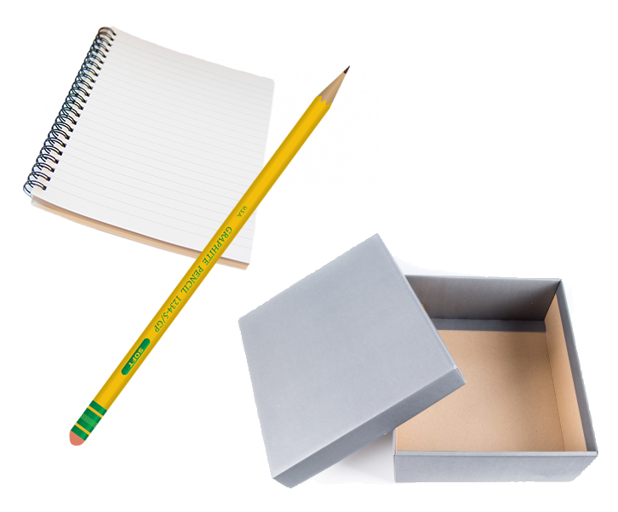
Extension  Decorate the box with happy colours.  Continue to add happy things to the box whenever you like.  Make and post some happy things for someone else. | Questions to ask  What does being happy feel like?  What makes you happy?  Can you draw a picture of your bike?  Why does a kite make you happy?  What does this picture remind you of?  What could make Grandad happy?

Activity 6 – Talking and sharing
Create positive messages for your window

What to do  - Talk about the different windows you have seen on your walks. Have you seen rainbows, bears or eggs, or other things that made you smile?  - Talk about the people who might pass your windows, walkers, delivery workers, neighbours, etc. What things might make them smile?  - Make a positive poster together, using bright colours and a happy message.  - Display in a front window. | What you need  Paper, pens, Blu-Tak  
Extension  Refresh your poster, adding details or new messages.  Photograph and send to distant friends and family who won’t be passing.  Create new posters and rotate to reflect changing seasons and trends. | Questions to ask  What have we seen in people’s windows?  What made us smile?  What might cheer up passers-by?  What colours and pictures are cheerful?  What is a nice message to write?

