Exploring and measuring
IMPORTANT Parent or Carer –
Check that you are happy with any weblinks or use of the internet.

NB New activities are being added at the top of each document.
Activity 12 – Measuring using informal units
Measure bowl capacity and compare

What to do  - Show the bowls and ask your child if this reminds them of a story.  - Talk about the three bowls in Goldilocks and the Three Bears.  - Ask your child which bowl they think could belong to which bear.  - Ask how we can tell which bowl could hold the most porridge (capacity).  - Make predictions and put them into order of their capacity.  - Now measure the capacity by pouring in your measuring objects and counting out how many will fit in each bowl before they start to spill out (larger items here are helpful to keep the number low).  - Help your child record the number on the scrap of paper each time and place next it to the bowl. | What you need  A pencil and three scraps of paper  Three different sized bowls  Regular sized objects which can be ‘poured’ into the bowls and counted, e.g. large pasta shapes, counting cubes, toy cars, Duplo pieces, etc.  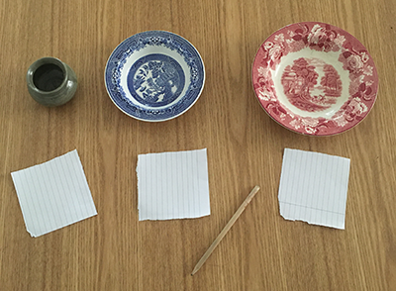
Extension  Compare the number for each bowl. The bowl with the highest number holds the most.  Try comparing the capacity of other containers.  Ask your child to investigate whether tall containers hold more than short containers. | Questions to ask  Who were the bowls for? Why were they different sizes?  Who needs the most/least porridge?  How can we find out which bowl will hold the most porridge?  Can you count the cubes? Can you write that number?  Which is the highest/lowest number?

Activity 11 – Investigating and testing
Find out what happens when materials are mixed

What to do  - Before you start, remind your child that they should never put things in their mouths when they don’t know what they are (both powders are used in cooking, but this is an important Science rule to establish).  - Show your child the different powders. Notice that they are both dry, white, and look very similar.  - Ask your child to spoon out several spoons of each powder into your jug (you need 2 parts of bicarb to 1 part of citric acid - you could do 10:5 for example) counting these out carefully – keep the powder mix dry.  - Pour some water in a bowl and add colour if wanted.  - Ask your child to predict what will happen when you pour the powder mix into the water.  - In an outside space, ask your child to pour the powder into the bowl (this is worth filming if you can).  - Discuss what happened with your child. They have caused a chemical reaction! | What you need  2 cups of bicarbonate of soda  1 cup of citric acid  A bowl, a jug, an outdoor space  Optional: food colouring  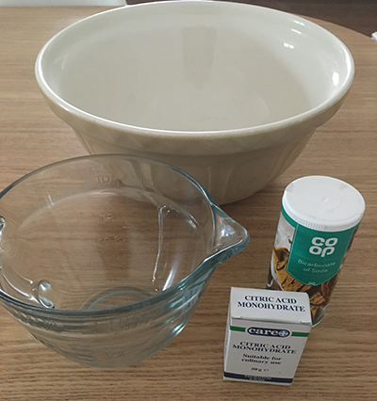
Extension  Ask your child to think how the mixture has changed. Can we separate the powders now?  Make bath bombs by gradually adding and mixing in cooking oil to the same dry mix. Squash into ice cube moulds to make bath bombs. They will fizz when dropped into water. | Questions to ask  What do these powders look like?  Can you scoop 5 tablespoons into the jug? Can you count them out?  What does the water look like?  What do you think will happen if we put the powder into the water?  What happened to the powder?

Activity 10 – Investigating and testing
Carry out a minibeast study
What to do  - Talk about the different minibeasts that might live in your garden (e.g. ladybirds, butterflies, ants, snails, bees etc.). Which can you see easily, and which might be hiding?  - Explain that scientists find out more by looking very closely at things (observing them).  - Go on a hunt, noticing that different minibeasts can be found in different places. Try looking under plant pots, in dark, leafy places and under stones.  - Carefully move a minibeast into the clear container using the brush for gentle contact. Cover the top for spiders and ants, etc.  - Observe the creature, photographing, videoing, drawing and talking about what you see.  - Return your minibeast carefully to the place it was found. | What you need  Clear container, soft bristled paintbrush, plastic wrap with air holes  Optional: Magnifying glass, insect books  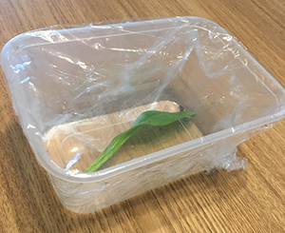  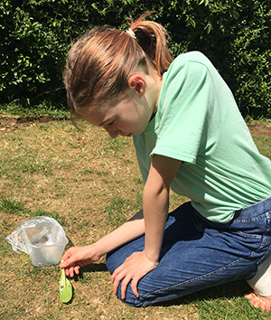
Extension  Keep a tally or tick off animals as you find them (see printable from Woodland Trust or create your own).  Talk about the importance of minibeasts in their role of helping pollination, providing food and eating rotting plants.  Make a bug hotel to encourage biodiversity in your garden.  Find out more about the minibeasts you find by reading books or looking on the internet. | Questions to ask  What animals live in our garden?  What minibeasts can you think of? (Child-friendly term for invertebrates)  Where would we look for ants, worms, caterpillars, snails?  How should we treat these creatures?  How does it move?  How many legs can you see?  Does it have wings?  What do you think the shell is for?

Activity 9 – Measuring using informal units
Measure longer lengths in ‘sticks’

What to do  - Collect some sticks. This could be done as part of a walk.  - Talk about the different lengths, finding the longest and the shortest.  - Choose a stick and explain that you can use this like a ruler. We can measure things in sticks.  - Choose a large thing in your home, like a chair. Say how many sticks long you think it might be and then check by ‘measuring’, counting the stick lengths.  - Find other things in your home (furniture, windowsills, rugs etc.). Together, estimate the length in sticks and then check by placing and counting how any times you can fit the stick along the length. | What you need  A few different length straight-ish sticks  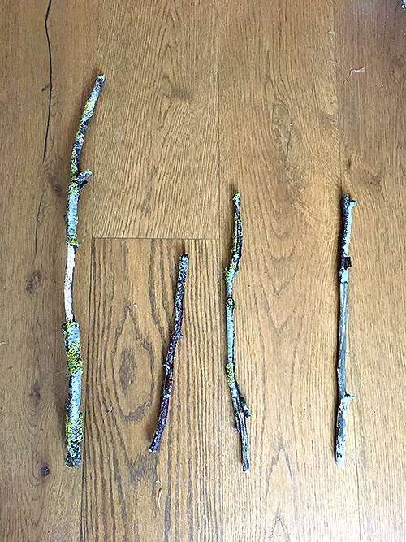
Extension  Record your findings in a table, drawing or writing different objects and writing the length of each in sticks. Compare your measurements. Which was the longest/shortest?  Try taking a stick each (one longer than the other). Estimate and measure an object. Why do you have different numbers? | Questions to ask  Are all our sticks the same length? Which is the longest/shortest?  How could we use this stick like a ruler?  How many sticks long do you think the rug is? How can we check?  How can we find out if the front path is longer than the back?

Activity 8 – Investigating and testing
Carry out a bird survey
What to do  - Talk about the different birds you can see from your window or in your garden. Do you know what type of birds you often see?  - Look at the reference material and talk about birds common to your area. How can you recognise them? Explore the different colours and markings.  - Which one do you think visits your garden the most? How could you find out? Carry out a survey.  - Create a tally chart on a piece of paper with 4-6 named/drawn birds you are most likely to see.  - Sit quietly and count the birds which visit. Identify the type and draw a line for each to make a tally. | What you need  Paper and a pencil  A garden bird identification poster/book or  Print a guide from the internet, such as:  https://cdn.shopify.com/s/files/1/1538/3241/articles/garden-birds-identification.jpg?v=1517000716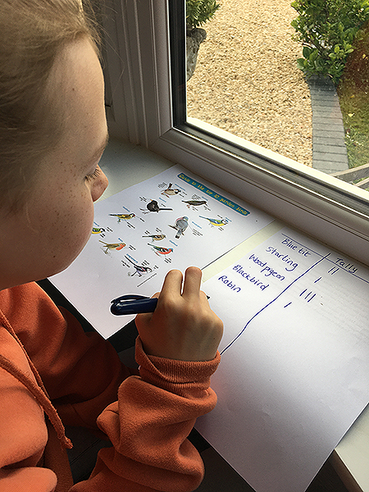
Extension  Talk about ways to encourage feathered visitors. Consider providing food or a bird bath: https://www.bbc.co.uk/cbbc/thingstodo/p00lx9r9  Find out more about UK birds with:  https://www.bbc.co.uk/cbeebies/joinin/garden-bird-spotting | Questions to ask  What types of birds do we often see outside? Do we know their names?  Can we recognise a blackbird, robin or pigeon?  What type of bird visits us most? How could we find out?  When are we most likely to see birds?  How can we draw a tally? Can you count how many sparrows we saw?  Which type of bird was the most common?

Activity 7 – Investigating and testing
Carry out a ‘Puff Test’

What to do  - Share the story of The Three Little Pigs, telling it from memory or playing: http://player.hamilton-trust.org.uk/story_telling_display.php?cid=225  - Remind children how the wolf huffed and puffed. Discuss what sort of things can be easily moved/are hard to move by the wind.  - Explain that we can test some things to see how easily they can be moved by blowing.  - Collect a range of objects together and predict which ones will be moved by a puff and which will not. What clues can we use to help us predict?  - Test these together using a pump or by blowing through a straw and put into the correct tray. | What you need  Things to test  This could include straw, twigs, bricks/blocks, feathers, paper (scrunched up & flat), toys, straws, any other interesting objects  2 trays, baskets to sort into  Optional – balloon pump or drinking straws  Optional – labels to print (see below)  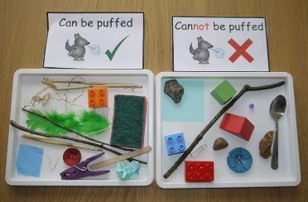
Extension  Talk about things that the puff-able and not puff-able objects have in common.  Test natural and found objects.  Record finding by photographing, or drawing or listing the two group in a table. | Questions to ask  What happens in the story? Which houses blow down and which stays upright? What different materials do the pigs use?  What things can be moved by a puff? How could we test this prediction?  What makes things easy to move by blowing? Can we make paper easier or more difficult to move? How?

Optional Sorting Labels

Can be puffed
Cannot be puffed
Activity 1 – Measuring using informal units
Find out how much your hand is worth

What to do  - Set up the challenge – can we find out how much your hand is worth?  - Help your child to draw around their hand and then measure it by placing a coin and drawing around it as many times as it takes to create a line from top to bottom – this will be tricky so give lots of help and encouragement.  - How many coins did it take? Count in 2s to reach an amount and help your child to record the number on their hand shape, with a £ or p. | What you need  A coin: 2p or £2 piece (you can choose other coins, but these are easiest to draw around and count)  scrap paper and a pen or pencil  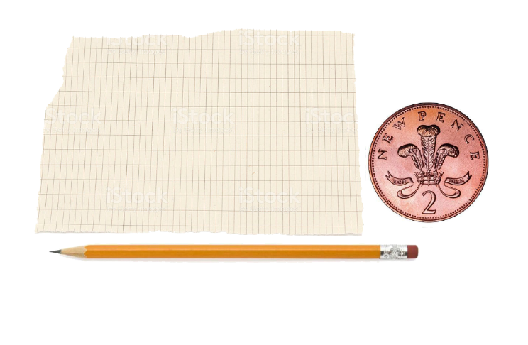
Extension  Find out the worth of each person in the home’s hands – create a display of hands with the worth recorded.  Place the hands in order, highest to lowest.  Try with a different coin – 10p and counting in 10s.  Can we do the same with feet? | Questions to ask  How many times did you draw around the coin?  Can we count in 2s?  How much is your hand worth? (in pence or pounds)  Do you think my hand will be worth more or less than your hand? Why?  Whose hand will be worth the most/least? How can we find out?

Activity 2 – Sorting objects by criteria
Sorting toys by the material they are made from

What to do  - Set up the challenge – can we find out how which materials are most commonly used in toys?  - Gather together some toys and discuss the type of materials they are made from (wood, plastic, metal, fabric, etc.)  - Encourage your child to sort them by material. If you come across an object which is made of more than one, encourage your child to think of a solution (i.e. have a ‘mixed’ group).  - Check each group to see that all the items fit the criteria and count them. Compare the numbers to answer the question. | What you need  Toys of different materials, e.g. plastic ball, metal car, cuddly toy, wooden train  Paper and a pencil  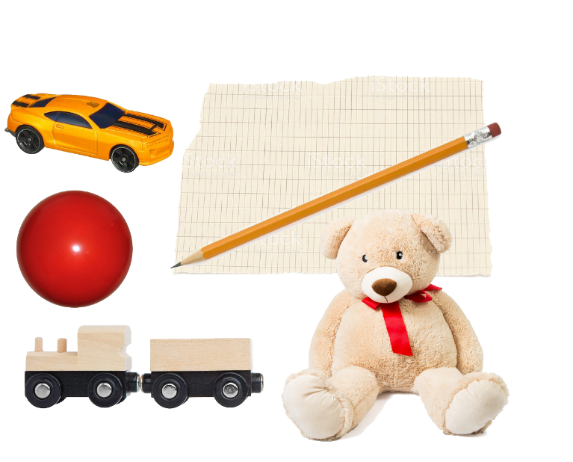
Extension  Make a record of your findings by writing each material and writing the number next to it.  Find out which material is most and least common by comparing the number in each group.  Think about why some materials are used more for toys.  Sing along with Maddie Moate’s materials songs:  https://www.youtube.com/watch?v=ys-IR2KGeoY  https://www.youtube.com/watch?v=WqKrGbPORfs | Questions to ask  How can we tell which materials these toys are made from?  How can we group the toys to help us find out which material is most common?  What materials make good toys? What materials do we not usually make toys from? Why?

Activity 3 – Explore colour mixing
Create a colour mixing picture

What to do  - Talk about the different colour paints that you have – what colours do you have? Squeeze them out onto a palate or plate in coloured blobs.  - Say it is a shame that you don’t have any other colours. Does your child know how we could get some different colours? By mixing.  - Help your child mix two colours at a time, predicting what the colour will be before you mix and then discussing what the result is.  - Create addition type sentences to show what happens when you mix each two colours. You could draw ⁺ ⁼  three times and your child can record their findings in the shapes, i.e. red+yellow=orange. | What you need  Ready mixed paint – yellow, blue and red (primary colours)  A paint pallet or small plates for paint mixing  Paint brushes  paper  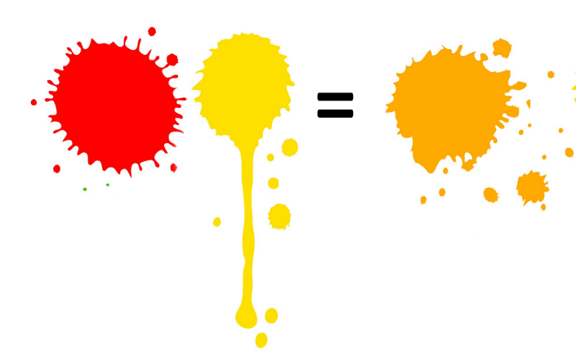
Extension  Use the mixed colours to make a colourful picture – you could make a butterfly by painting one side and folding the paper to print the other  Share your findings so your friends can make lots of new colours  Try mixing the secondary colours together (green, orange and purple) to see what colours you get | Questions to ask  How could we get different colours?  What happens when we mix two colours together?  What colour will we make if we mix red and yellow?  What happens if we add more of one colour?  Can we write a rule, so we remember how to make green?

Activity 4 – Measuring using informal units
Who can jump the furthest?

What to do  - Warm up with some jumping. Agree that we can jump up high, but we can also jump across (like if we had to jump over a puddle).  - Ask who can jump the furthest in your home. Is there a way we could measure our jumps?  - Create a fixed starting point and a way of recording where people land (this could be a toy, a chalk mark or a coin).  - Have some practice jumps and then take turns to jump, record the landing point and measure by placing a shoe as many times as it takes to cover that distance. You are measuring in shoes. | What you need  A shoe  A way of marking a start and end point: Outside – chalk, cone, tape  Inside – toy, ribbon, cone  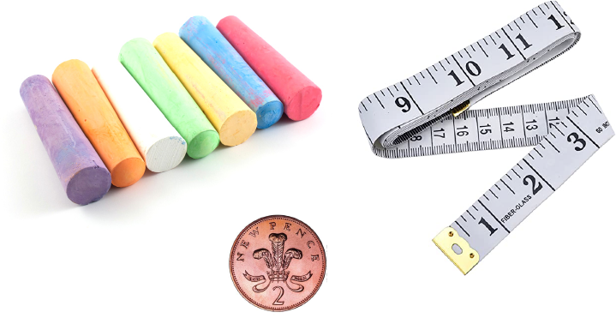
Extension  Help your child to create a table to record everyone’s jumping distance.  Challenge your child to increase their distance.  Use the internet to find out the jumping distance of other animals – mark out the distance using your shoe. | Questions to ask  Who do you think can jump the furthest?  How can we find out?  How can we measure the distance?  What if we used different shoes for each person?  How can we record/remember how far each person has jumped?

Activity 5 – Solving a problem by testing
Testing objects for floating and sinking.

Adult supervision is essential for water activities
What to do  - Tell a story which presents a problem to be solved: explain that you are looking for some good things to use as bath toys but you want them to float so that you won’t have to hunt round for them under the bubbles.  - Explain that you are not sure which things will float and which will sink – we will have to test them.  - Go around the house collecting a selection of likely & less likely items.  - Before testing, talk about each object and sort according to your child’s prediction. Which will sink? Which will float?  - Test the predictions, one at a time. If you have a transparent container, you look through the side and easily see which floats and which sank.  - Record your findings by drawing, listing or creating a table. | What you need  Lots of objects to test – you can collect these together (e.g. wooden, plastic and metal spoons, marble, pencil, cork, rubber, coin, plastic, metal and wooden toys, etc)  A water filled container – transparent is best for careful observation  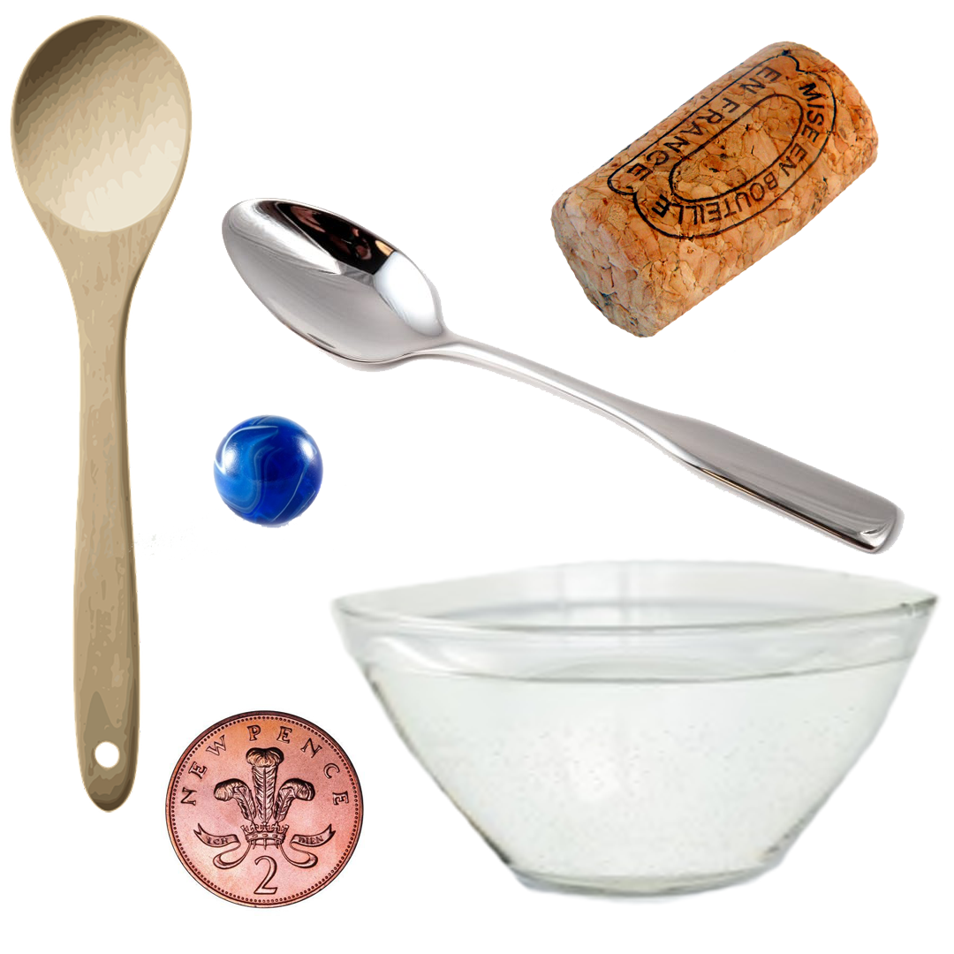
Extension  Talk about why your child thinks some objects floated and some sank.  Provide some of the tested objects as toys next bath time.  Make a poster to share your findings. | Questions to ask  What happens when an object floats?  How can we tell if something has sunk?  What materials are bath toys made of?  Do you think this will float? Why?  What sort of things float?  How can we test our predictions?  How can we remember what floated and what sank?

Activity 6 – Researching and sharing
Give an expert report

What to do  - Follow your child’s interests – dinosaurs, unicorns, a team, a sport or a collectable toy, etc.  - Pick someone who needs an ‘expert’ to tell them all about it, e.g. ‘Grandma was asking me the other day about Twisty Pets. She didn’t know what they were.’  - Discuss what information you could give your audience and if you need to check some facts – use books, the internet and/or factual programmes.  - Prepare a talk together (in the style of show and tell) where your child talks about their topic, showing objects or pictures.  - Give the report in person, over social media or by videoing and sending. | What you need  A topic of interest  An audience  Ways to check facts – internet, books, etc.  Printed pictures or objects to show  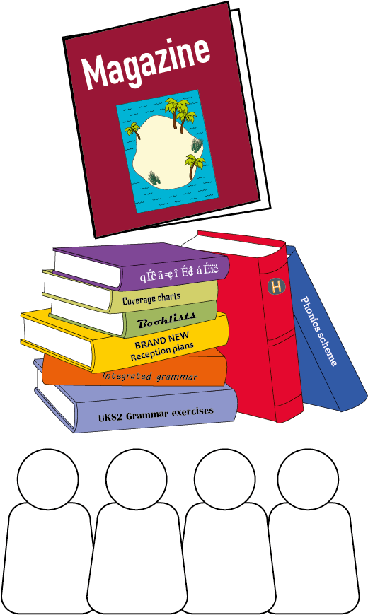
Extension  Make a poster or booklet together to share the key facts. Draw some pictures and add labels.  Create a quiz to test your audience.  Look at non-fiction books and find out about other topics. | Questions to ask  What do you know about unicorns?  What do you need to explain to Grandad?  How can we find out how many types of frog there are?  What picture would help show what a stegosaurus looks like?

