Helping round the Home
IMPORTANT Parent or Carer –
Check that you are happy with any weblinks or use of the internet.

NB New activities are being added at the top of each document.

Activity 12 – Washing and cleaning
Wash the car (or the windows)

What to do  - Collect what you need together. Assemble each item, counting out your resources and reading any labels as you go.  - Talk about the different stages of washing: how to wet a cloth and to wring it; how to rub a surface, covering it in a methodical way; and how to rinse away any soapy or dirty residue.  - Wash the car (or windows) together. Expect lots of splashing and rewashing.  - Buff the surface with a soft, dry cloth and admire your handiwork. | What you need  A bucket, sponges, and soft cloths, (optional) suitable soap  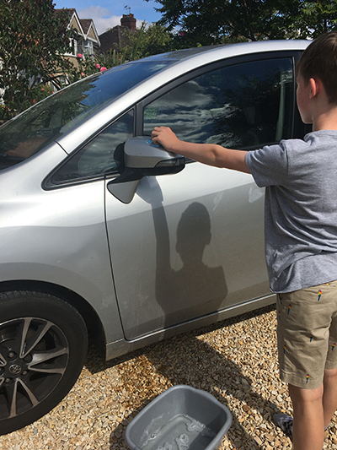
Extension  Valet the car inside, using handheld vacuum cleaner, cloths and clearing clutter.  Write instructions together, listing steps in order and making a ‘You will need’ section.  Set up a car wash in the garden in a sink, washing toy cars. | Questions to ask  What will we need to wash the car?  How many cloths do we have?  What is the name on this label?  How can we stop the cloth from dripping too much?  Is the car clean now? What do we need to do next?

Activity 11 – Tidying up and daily jobs
Help with weeding, watering, and deadheading

What to do  - Walk around the garden looking for jobs that need to be done (or review potted plants).  - Show your child how to see if a plant needs to be watered, where to water (usually at the base – children tend to water the flowers), and when to stop watering!  - Explain which plants are wanted and which were unplanned (weeds). Explain that we weed in order to help our plants have enough space and nutrients. Show your child how to remove weeds, including the roots so that they don’t grow back.  - Explain why we deadhead, removing older flowers to encourage more to grow. Show your child how to remove flowers by pulling or cutting with safe scissors (explaining that they must be with an adult to do this).  - Repeat this regularly allowing your child more independence as they develop confidence. | What you need  Plants to care for, watering can, scissors  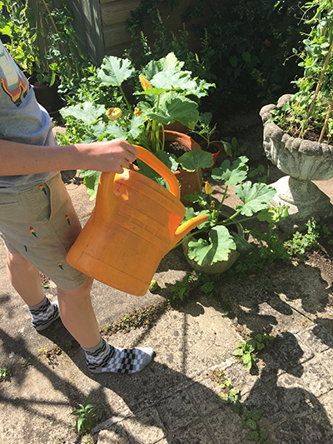
Extension  Give your child a small patch in the garden to plant as their own or a small tray or pot to make a miniature garden.  Keep a photo diary of a growing plant from sowing the seed to flowering.  Try growing edible plants, such as quick growing cress and salad leaves. | Questions to ask  What do plants need to grow? What jobs need to be done?  How can we tell if this plant needs watering? Where do we need to direct the water flow?  What are weeds? How can we stop them growing back?  Why do plants grow flowers? What will happen if we pull off the old flowers?

Activity 10 – Sorting and organising
Tidying Ten

What to do  - Practise counting to ten. Praise your child for being so good at counting.  - Now challenge them to use this skill by moving around your home and spotting ten things which are in the wrong place and putting them in the basket. Can they do this in less than one minute?!  - Start the ‘parent timer’, counting down in your head from 60, and be amazed when they return with a full basket within the time.  - Count out the objects together. Are there ten?  - Take the basket round your home, asking your child to be the deliverer – delivering each item back in its rightful place. | What you need  A basket or container  A messy home  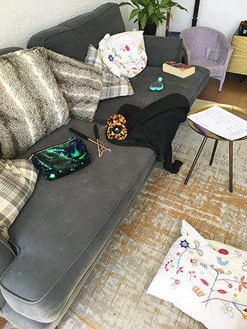
Extension  Give a basket to every member of the household. Can they each find ten things? – this will make a big impact. Count two or more baskets together or count in tens.  Give a competitive spin on the game with two children or more. How many Lego/jigsaw/game pieces can you pick up in 60 seconds? Who has the highest score? | Questions to ask  Can you count to ten?  How many seconds are there in one minute?  Where would be a good place to find messy things? What can fit in the basket?  How many have you collected?  Do you know where they belong?

Activity 9 – Tidying up and daily jobs
Caring for a pet

What to do  - Talk about hand hygiene, and how it is important to wash hands after touching animals and their bedding, etc. (Some pets require handwashing before handling too.)  - Talk about what your pet needs to be healthy, including water, entertainment and suitable housing.  - What jobs need to be done each day/regularly? Make a list. Decide which jobs can be done by your child and draw up a simple timetable together, e.g.  - AM – fill water & food bowl.  - PM – give salad food & handle  - Support your child as they help to care for the pet. | What you need  A pet, pet essentials  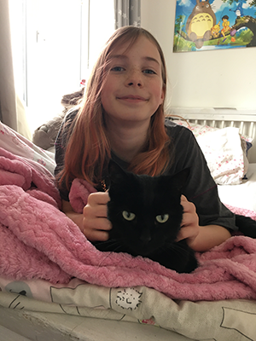
Extension  Create instructions together for different tasks, breaking them down into steps.  Include weighing, counting and measuring in the tasks.  Practise more skilled tasks such as grooming.  Make a suitable pet toy from packaging. | Questions to ask  What does our pet need to be healthy?  What sort of food/drink/entertainment does it need?  What must we do after touching our pet or their things?  What jobs need to be done every day for our pet? Which could you help with?  How can we remember what needs to be done?

Activity 8 – Sorting and organising
Sorting and tidying shoes
What to do  - Take a ‘before’ photo.  - Look at the different footwear. Sort into pairs. Who do they belong to?  - Talk about each shoe/boot and what it is for - think about activity and weather.  - Decide if any can be put away and which must stay.  - Talk about how to arrange them in their space. Your child might decide to sort by size, colour, owner or type.  - Take an ‘after’ photo and admire your efforts. | What you need  Messy shoe space/rack/box  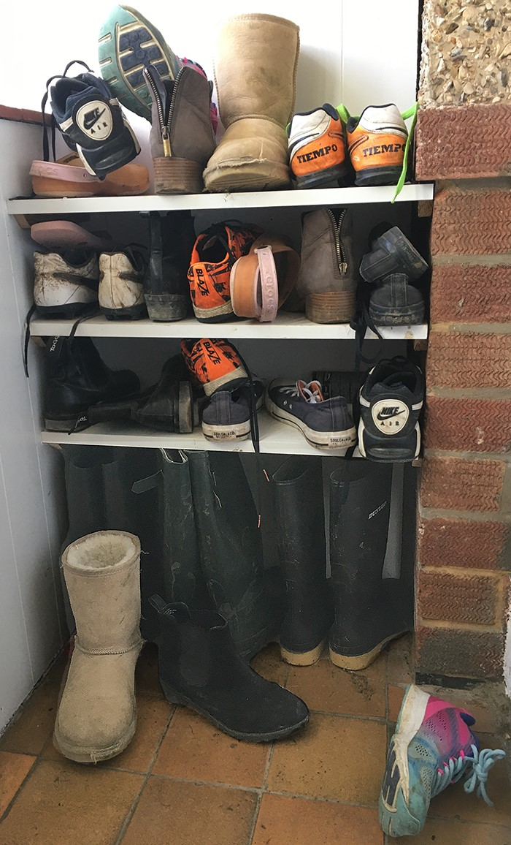
Extension  Count the shoes in pairs/twos.  Put in order of size.  Make labels for the new shoe spaces.  Make a shoe storage space from boxes and decorate. | Questions to ask  Can you find matching pairs of shoes? How many in a pair?  Who do these belong to?  Who has the most/least shoes?  Which shoes are for sport/wet weather/ inside?  Can we put any away for winter/next term?  How could we sort these to make them tidy and easy to find?  Can you see what a difference we have made?

Activity 7 – Preparing meals
Make your own lunch

What to do  - Talk about hand hygiene, getting everything ready first and the best order to carry out each task.  - Allow your child to experiment with the best order of the process. It is likely that they will not think ahead at first but will fine tune as they go.  - Consider which tasks will always need adult input (slicing cheese) and which can be increasingly left to your child as they become more confident (cutting the sandwich).  - Example lunch-making process:  - Washing hands  - Laying the table  - Spreading butter/jam on bread.  - Placing ham, cheese slices on the bread.  - Placing one slice on the other and pressing.  - Cutting into pieces (hard at first)  - Clearing up after eating | What you need  Sliced bread, spread and table knife, sandwich filling (ham, jam, sliced cheese, etc.), bread board and plate  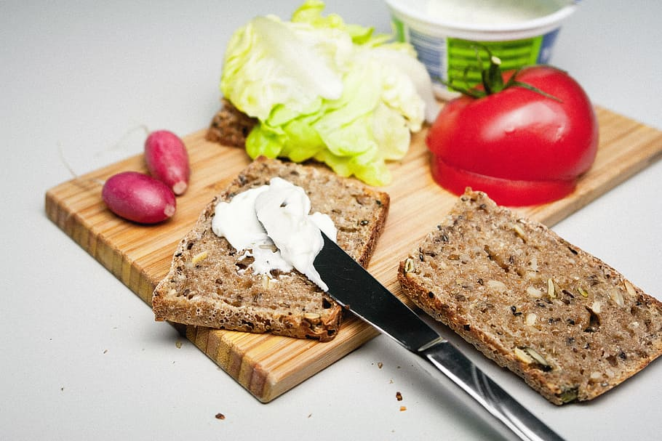
Extension  Create a list of lunches together and encourage your child to choose and organise what they need each lunchtime.  Make lunch for someone else.  Make a sandwich list and ask diners to choose from it. | Questions to ask  What must we always do before cooking and eating? Wash hands!  What things will we need?  What do we need to put on the table?  How can we keep the sandwich together?  What’s your favourite filling?

Activity 1 – Preparing meals
Make your own breakfast

What to do  - Talk about hand hygiene, getting everything ready first and the best order to carry out each task.  - Reduce risks of spilling and wastage by decanting milk into a small jug, cereal into a smaller container and jam or spread can be spooned onto a plate –this will need some patience and lots of praise.  - Consider which tasks will always need adult input (toasting bread) and which can be increasingly left to your child as they become more confident (pouring cereal from a box).  - Example breakfast tasks:  - Laying the table  - Spreading butter and jam on toast  - Pouring cereal and then milk into a bowl  - Breaking eggs and mixing batter for pancakes  - Clearing up after eating | What you need  Breakfast food  Jugs, bowls and spoons for decanting  Cutlery and crockery  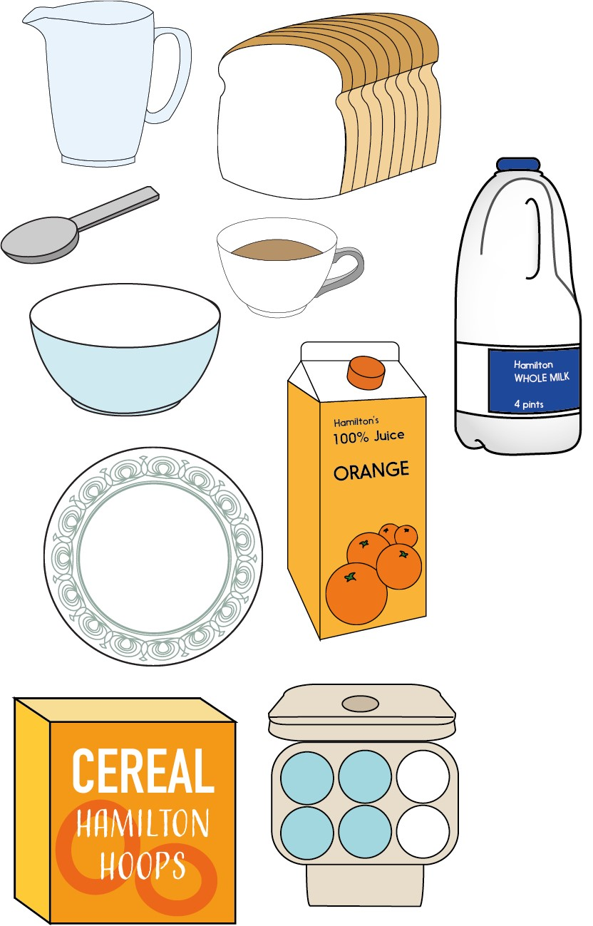
Extension  Create a list of breakfasts together and encourage your child to choose and organise what they need each morning.  Make breakfast for someone else. | Questions to ask  What must we always do before cooking and eating? Wash hands!  What ingredients will we need?  What do we need to put on the table?  How can we slow down how fast the cereal will come out of the box?  What’s your favourite breakfast?

Activity 2 – Sorting and organising
Pairing socks and sorting clean laundry

What to do  - Make the jobs fun by setting challenges, playing music or adding competition.  - Give small, manageable jobs, such as finding sock pairs (actually pairing them is a hard task for small hands), sorting clothes by wearer or where they are stored. | What you need  Clean laundry  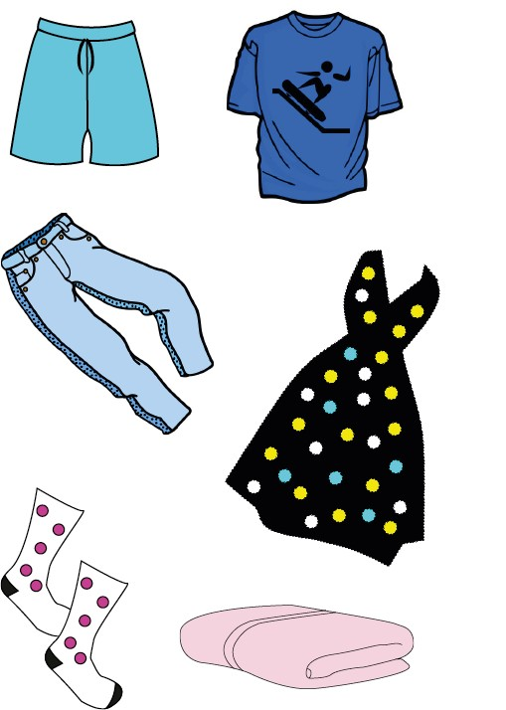
Extension  Teach your child to fold easy items, like T shirts, or put their clothes on hangers.  Encourage them to put their own clothes away if storage can be reached.  Challenge your child to organise their own clothes drawers or wardrobe – shoe or cereal boxes can be repurposed to create dividers. | Questions to ask  Can you find matching pairs of socks? How many in a pair?  Who has found the most pairs?  Who does this belong to?  Who is each pile for?  Where do we keep vests?  How could we sort the drawer?

Activity 3 – Washing and cleaning
Washing toys
Adult supervision is essential for water activities

What to do  - Talk about the importance of hygiene and keeping our toys clean.  - Set up children with toys to wash, warm, soapy water, washing tools and a place to lay out toys to dry – this is best as an outdoor activity, if inside lay down towels on the floor.  - Encourage your child to push sleeves up and wear an apron (or old T shirt).  - Expect toys to be rewashed many times – children love this sort of task. | What you need  Waterproof outdoor or indoor toys  Sponges, washing up brushes, cloths, soap  A bowl of warm water or a filled bath  Aprons and towels on the floor if indoors  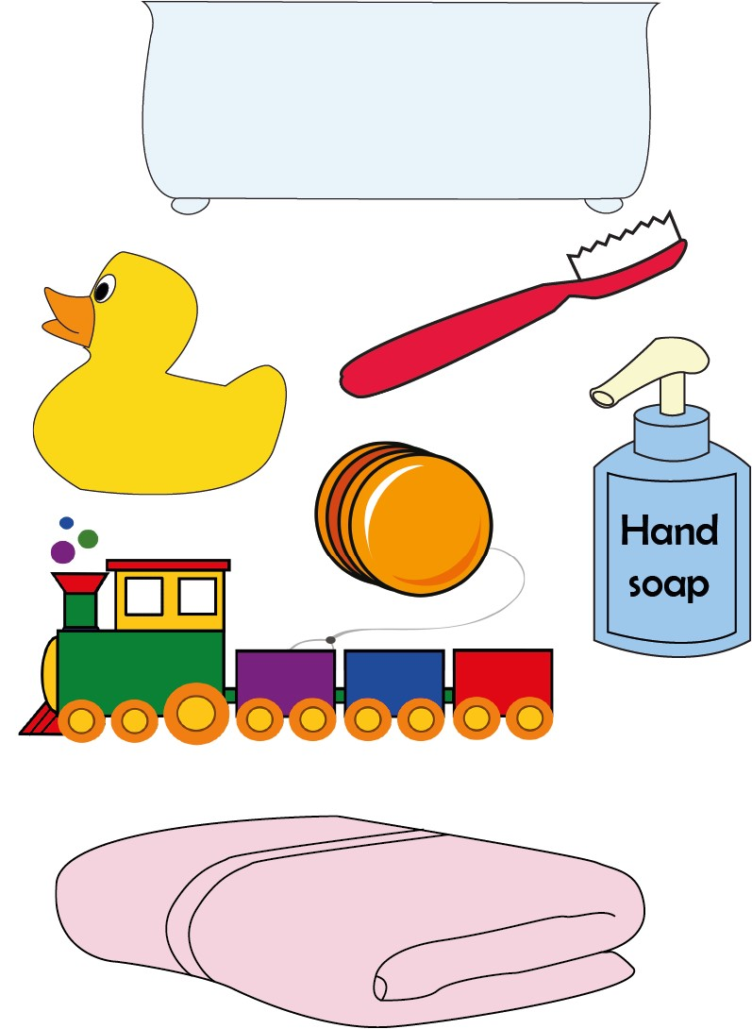
Extension  Add waterplay toys for pouring and scooping (jugs, cups, Nurofen-type syringes).  Include sorting as a task – mix up the type of toys and get children to sort them by type once dry.  Make a poster to explain why we need to keep our toys clean. | Questions to ask  What are the safety rules when we play with water?  How will we stop getting too wet?  What do we need to wash the toys?  How will we dry them?  Can we wash all toys like this? What about books or soft toys?

Activity 4 – Sorting and organising
Sorting recycling

What to do  - Talk about what recycling is and why we do it.  - Lay out a range of clean recycling and talk about the different materials that the different items are made from.  - Sort them by type.  - Explain the different categories your local recycling requires the materials be sorted into.  - Work together to sort the recycling. | What you need  Clean packaging and recyclable materials  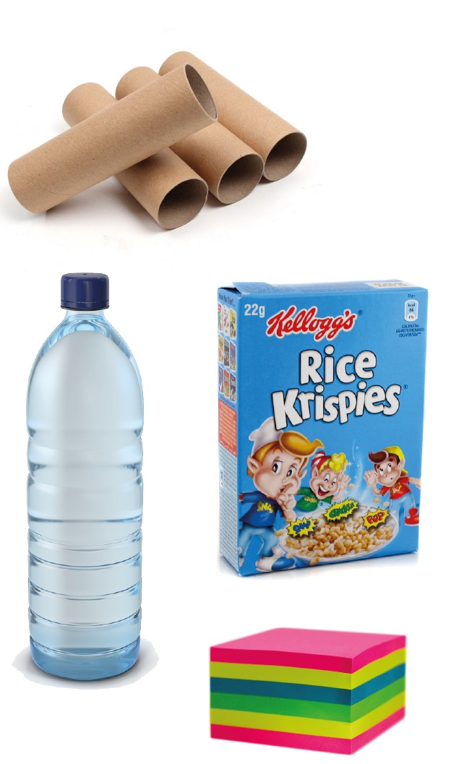
Extension  Wait for the recycling vehicles to arrive and watch what happens next to the rubbish.  Make a junk model using recycling materials.  Watch Maddie Moate discussing recycling with Buster: https://www.youtube.com/watch?v=W-v2QPF21nU | Questions to ask  What is recycling?  Why should we recycle?  What material is this made from?  Where do we put cartons?  Could we reuse this for something else?

Activity 5 – Tidying up and daily jobs
Making your own bed

What to do  - Talk about how it feels to have a cosy, tidy bed.  - Make the bed together, arranging pillows, tucking in sheets and straightening covers.  - Arrange any soft toys and/or cushions.  - Admire the finished result – won’t it be lovely to jump into tonight? | What you need  Clean bedding  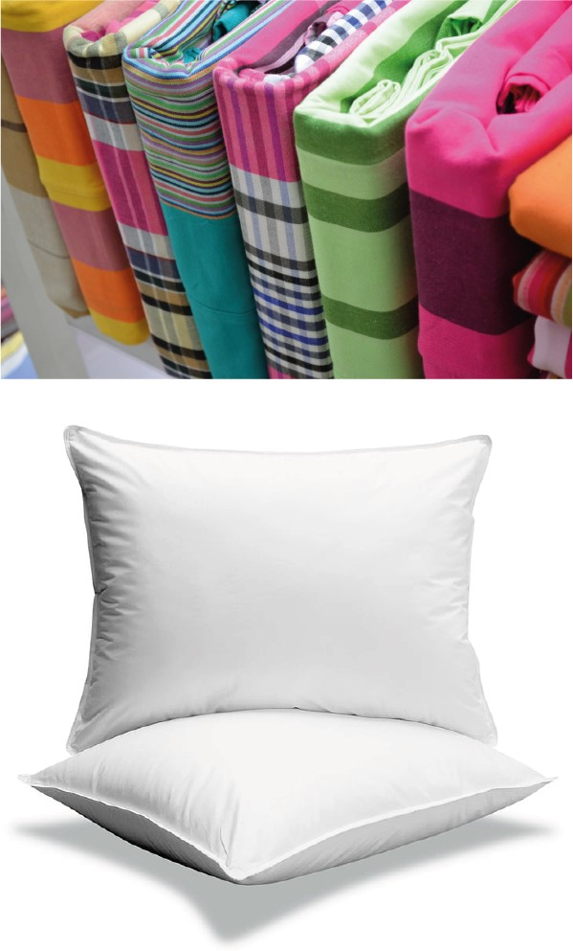
Extension  Increase the independence of each task, starting with easy things like arranging pillows.  Make someone else’s bed as a nice surprise.  Make a bed for a toy using a box and blankets. | Questions to ask  What makes your bed feel cosy?  What happens if the sheets are not tucked in properly?  Where does the pillow go?  Can you pull the duvet straight?  How can we test the bed?!

Activity 6 – Tidying up and daily jobs
Tidying a room for the length of a song

What to do  - Talk about how breaking up tidying into little jobs can make them easier and more fun. Also, if everyone helps, jobs are finished much more quickly.  - Challenge children to tidy a room for the length of a song.  - You will need to allocate and specify the task/s, e.g. Put as many toys in the basket while the music is playing, or pick up as many Lego pieces as you can until the music stops.  - Celebrate your achievements made in the time one song took to play. | What you need  A messy room  Music to play  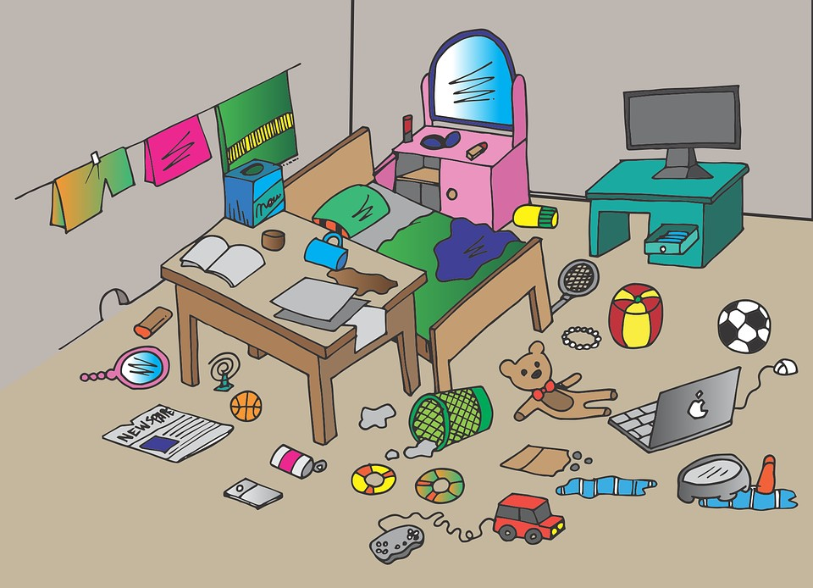
Extension  Put regular jobs on lolly sticks and children choose to randomly allocate the jobs.  Do before and after photographs to celebrate the difference made.  Create a tidying playlist with energetic songs.  Watch and sing along to Mary Poppins tidying the nursery with a spoon full of sugar: https://www.youtube.com/watch?v=_L4qauTiCY4 | Questions to ask  What jobs need to be done?  How long do you think a song lasts in minutes?  How long do you think it will take to fill the laundry hamper?  How many pencils can you pick up in the time it takes for the song to play?  How different does the room look now?

