Make-Believe Play
IMPORTANT Parent or Carer –
Check that you are happy with any weblinks or use of the internet.

NB New activities are being added at the top of each document.
Activity 12 – Create and use a time machine
Travel back in time to investigate dinosaurs

What to do  - Talk about dinosaurs. Do we have any living now? When did they walk the earth?  - Agree that it would be amazing to be able to go back in time and see some.  - Make a time machine together. This can be as complicated or simple as you like and could have features drawn, painted and/or stuck on.  - Include buttons to press, dials to turn, screens to read.  - Include numbers and words to read, such as ‘start’, ‘stop’, ‘press’ or ‘0-10’ to help with a count down.  - Travel back in time in your machine and go on field trips, using toilet roll binoculars and making notes and drawings on the dinosaurs that you find. | What you need  a large box  toilet rolls and recycling materials  paper and pencils, paint and glue  (optional)  dinosaur toys, tape measure or ruler, torch, magnifying glass, backpack, books about dinosaurs  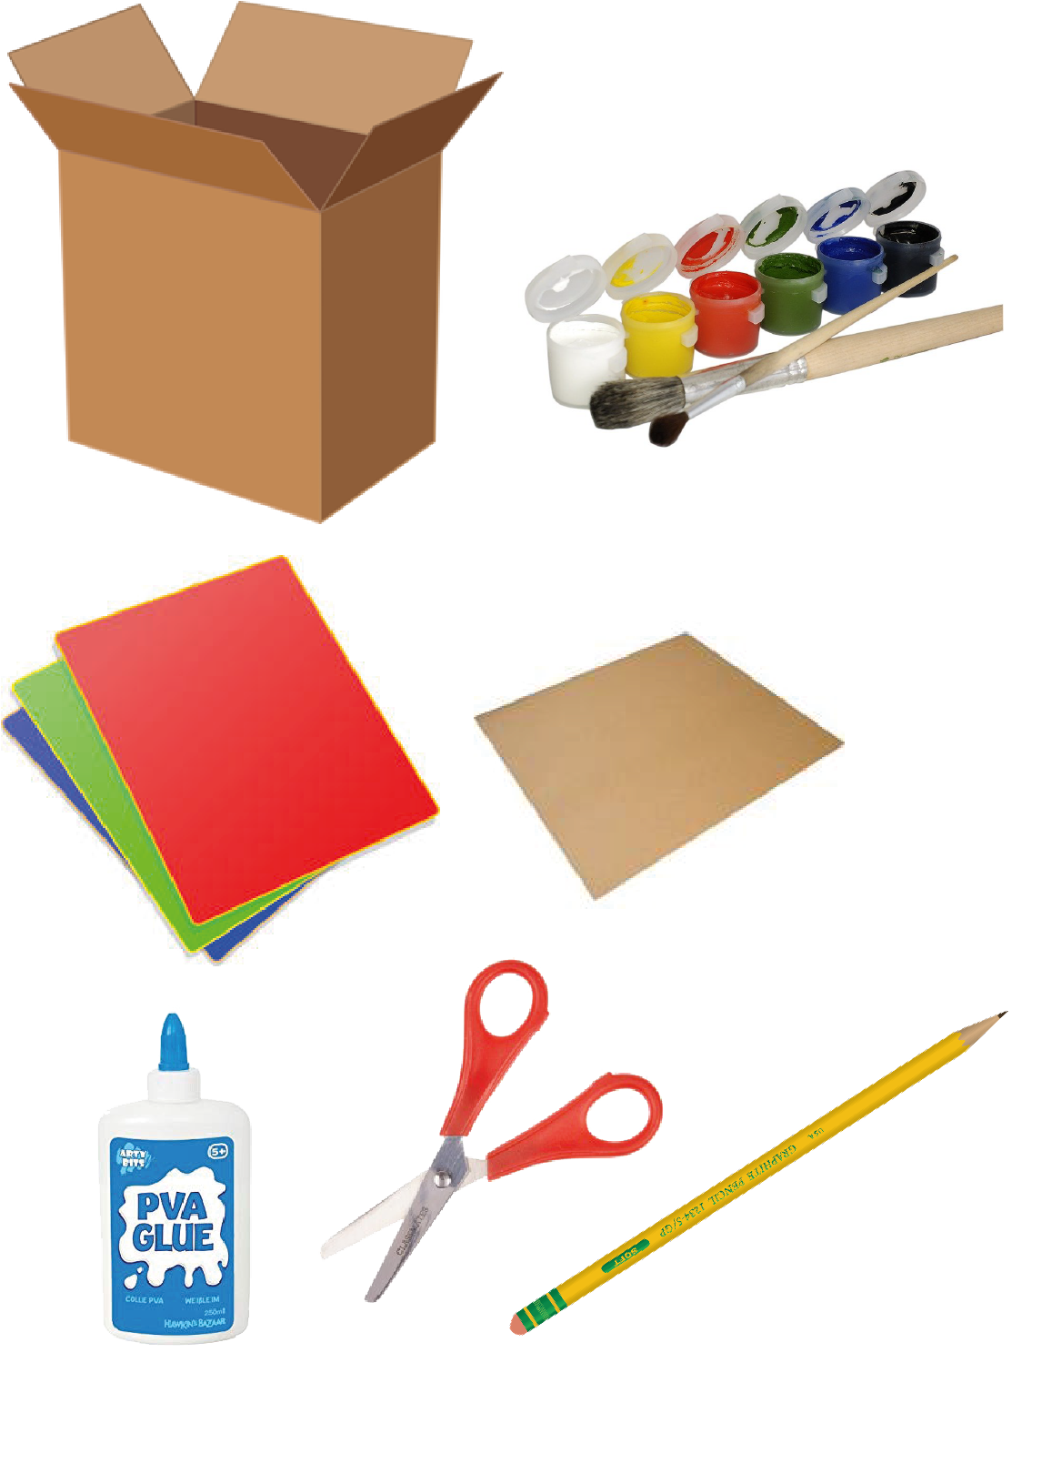
Extension  Make a museum to show what you have found in your travels. Include pictures, measurements, and field notes.  Share books and websites about dinosaurs.  Travel back to other time periods that your child might be aware of. | Questions to ask  Do we still have dinosaurs alive today?  How can we start/stop the machine?  What does this button do?  What can we write to label this switch?  What dinosaurs can you see? What do they look like? How long is that footprint?  What are they eating?

Activity 11 – Create a mini jungle/dinosaur land
Play with a small world terrain

What to do  - Create the jungle together.  - Level the soil in the tray. Sink a jar lid or bowl and put in some water. Stick in twigs and grasses to make plants and trees and arrange pebbles and bark to make pathways or nests.  - Play with small world toys together, making up stories and adventures. | What you need  A tray of soil or sand  small dinosaur/animal toys, twigs, bark, grasses, leaves, pebbles, jar lid or small bowl  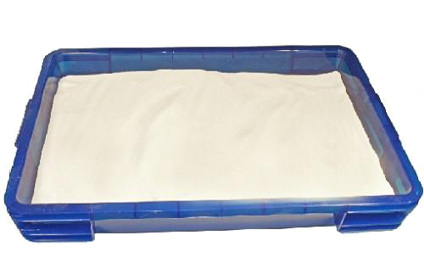
Extension  Create stories around finding food or looking for a new home.  Grow some real plants in your world, such as cress.  Turn your world into a safari with small world visitors and signs to explain the different places.  Try taking photos at a level with the tray. Explore different angles. | Questions to ask  What will live in this world?  What plants will there be?  What will they eat/drink? Shall we make a lake?  Where will they get shelter?  Who will travel along this path?  Which dinosaurs will be friends? Will they fight?  Will the dinosaurs live in families or will they live alone?  How many dinosaurs are living here?  Which is the tallest/shortest tree?  What type of dinosaurs live here?

Activity 10 – Get building
Set up a construction site and do some building
What to do  - Set up a construction site together. This could be inside or outside.  - Put on protective clothing.  - Make safety signs to warn other workers to wear hats and goggles.  - Cone out the area.  - Draw up some plans for what you are constructing. You might be building a school, bridge or a house for a story character.  - Get digging, levelling, measuring, hammering, building, sanding, etc.  - Have a tea break. Who has some biscuits?  - Order more materials, discussing how long your planks need to be or how many sacks of sand. You may need a list! | What you need  Any of the following will help to make fun imaginative play:  Hard hat, goggles and hi-vis jacket, cones, small or large building blocks, play tools, digger toys, large paper and pencils, measuring tape/ruler, pieces of wool, large tray with sand or soil  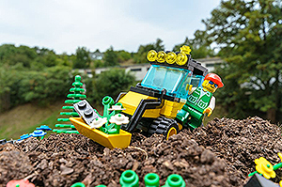
Extension  Deal with first aid needs. Wash and dress a cut, wrap a sprain with a bandage or call an ambulance for broken bones.  Be a building inspector. Take a clipboard and do some careful measuring and checking. Give the work a mark out of 10.  Drive a digger, roller or crane. You may need to make a control box from recycling with buttons and switches. | Questions to ask  What do we need to keep safe? How can we tell others?  What are we building today? Do we have some plans?  What tools do we need? Where shall we put the walls? How long is this doorway?  Who fancies a cup of tea? How many biscuits shall we have each?  How many sacks of sand shall I order? Do you know the telephone number?

Activity 9 – Visit the seaside
Have fun by the seaside

What to do  - Suggest that you go to the seaside for the day. What will you need? Pack a bag.  - Travel by car, bus or bike until you can smell the sea and hear seagulls.  - Spread out a blanket on the beach. Will you need to put on sunscreen and wear a hat and glasses?  - Paddle in the sea and make sandcastles. Look for rockpools and collect shells. Count the shells and see who can build the tallest castle.  - Have a picnic or buy fish and chips. You might set up a beach café or an ice cream stand. Count coins to play for your food. | What you need  Bucket and spade, picnic blanket, sunglasses and hat, paper and pens, bag to pack, coins  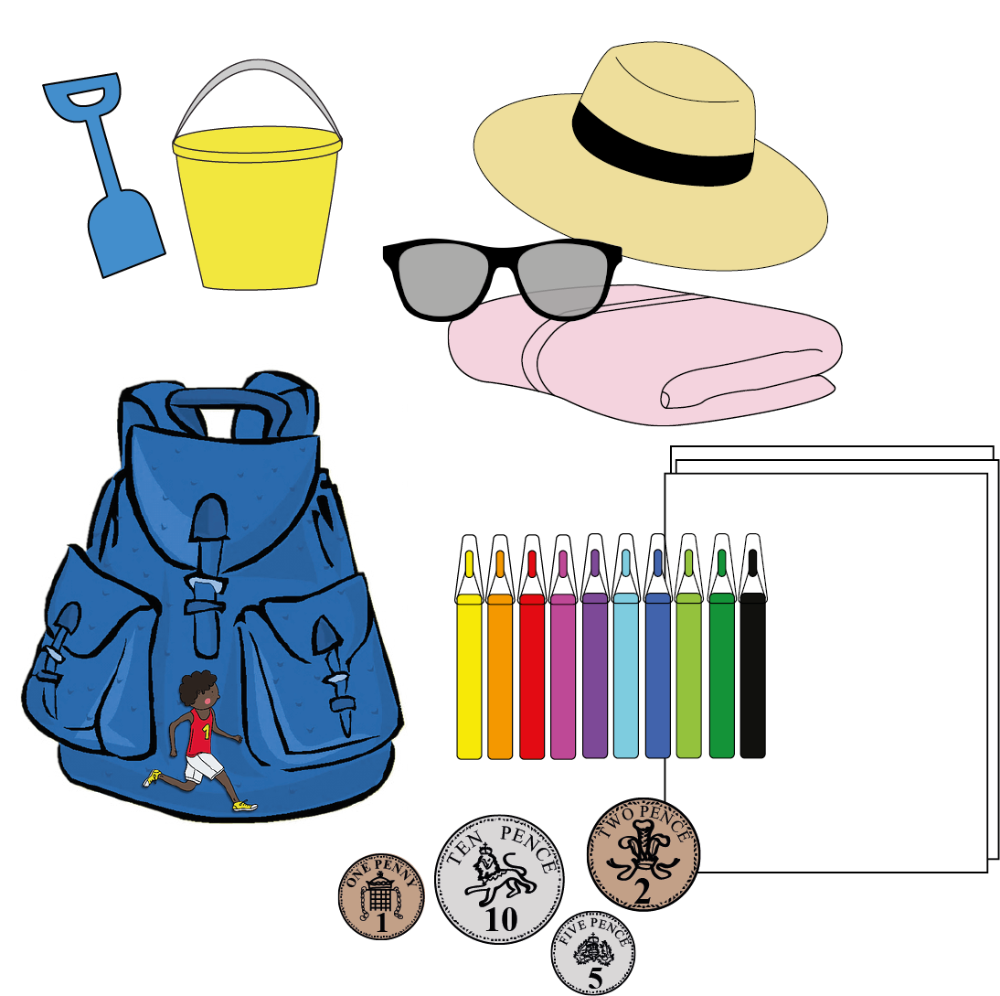
Extension  Introduce the coast guard. Make paper flags to show where is safe and signs to tell people the number to ring for the coast guard. Rescue stranded teddies.  Write a postcard and ‘post’ it to family back home.  Make a map of the beach.  Take the play outside on a warm day, with a sand pit and/or paddling pool. | Questions to ask  Where shall we go today? How shall we travel there? Are we nearly there yet? Can you smell the sea/hear the gulls?  Where should we put our blanket? Have you remembered sunscreen?  How deep is the sea? Shall we have a paddle? Can you see a rockpool? What animals are inside? How many shells can you collect?  How much does ice cream cost? Have we got enough money?

Activity 8 – Go camping
Set up a campsite and have a ‘sleepover’
What to do  - Hunt for the perfect camping spot (this could be inside or outside). This might require some hunting, using a map and binoculars.  - Set up camp, putting up a tent and arranging bedding.  - Enjoy your new surroundings, checking out the local wildlife and picking ‘wild’ fruit.  - Create a fire by collecting some firewood (real or imagined) and cook your dinner in a pan.  - Tell stories around the fire and settle down to sleep with your cuddly toy. | What you need  Play tent or materials to make a tent (sheet, chairs, clothes pegs)  Bedding (sleeping bag and pillow, or blankets and cushions)  Torch, lunchbox, cuddly toy, paper for map and toilet roll binoculars  Optional cooking equipment and twigs  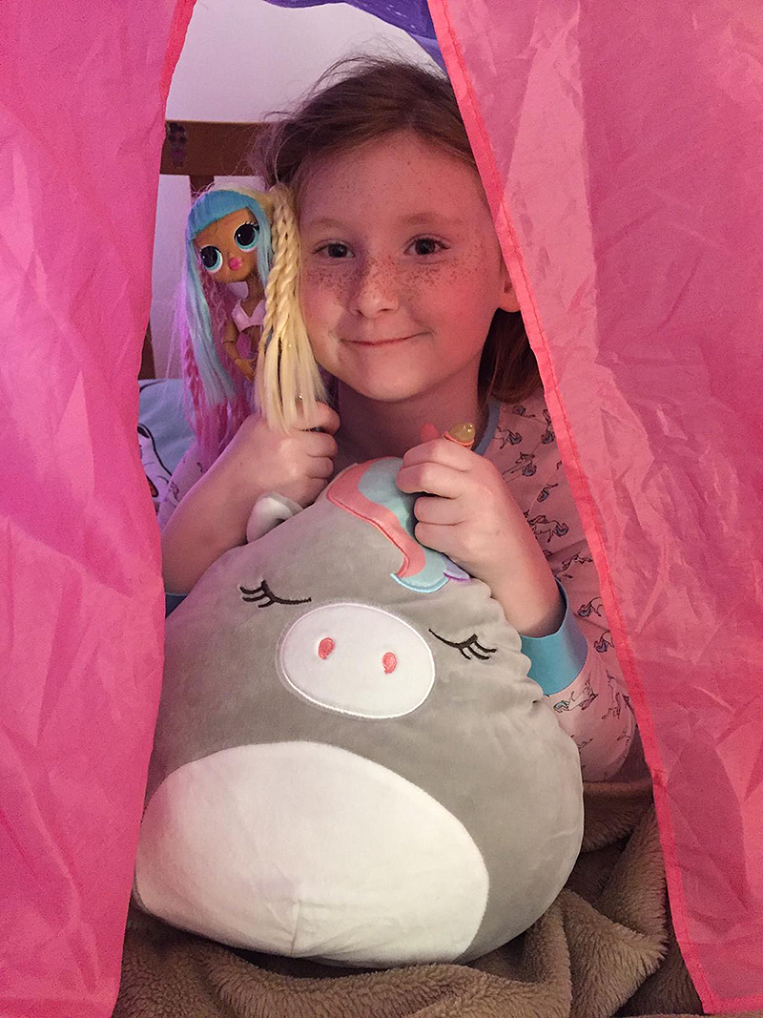
Extension  Introduce some peril to the play – imagine a storm or an invasion of sheep.  Have a real living room sleep over. Sing camp songs and have a midnight feast. | Questions to ask  Have you got your map? Where shall we camp?  Can you set up the tent? How will we stop it blowing away?  How can we make the tent nice and cosy?  What wildlife can you see through your binoculars?  Let’s make a fire. Can you collect some wood?  What stories shall we tell?

Activity 7 – Run a café
Create a café for toys or your household

What to do  - Create the café together. You can lay a table, add tableware and finishing touches like flowers.  - Use play items, make things or use imagination for food, placemats, a kitchen area etc.  - Create a menu with food and prices written and/or drawn on.  - Create an open/closed sign and open the café for business.  - Play cafés, taking turns to take orders, make food, serve, clean up and to be customers. | What you need  Table and chairs  Tableware – plates, cups, cutlery, cloth  Play food, play till, (optional)  Notepad and pencil, apron, ‘cooking’ area, paper and pens  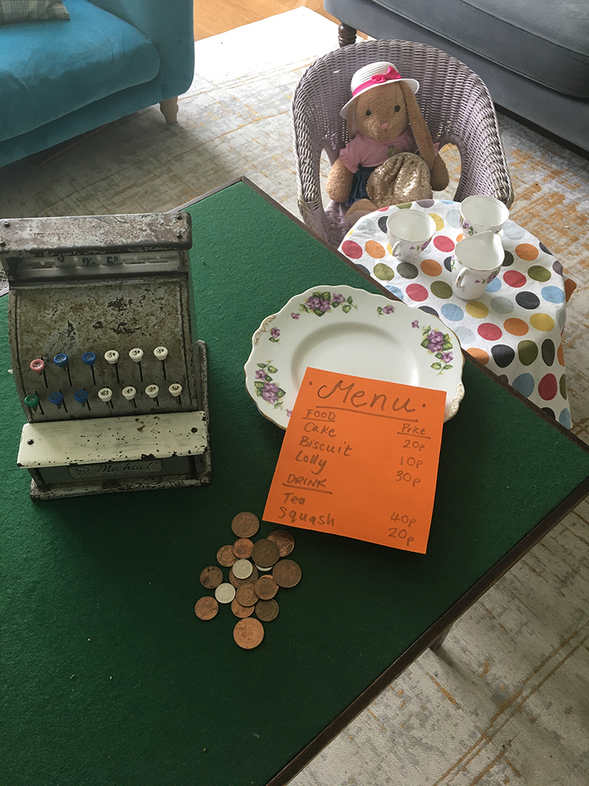
Extension  Take the dining al fresco and set up the café in an outside space. The café could serve barbeque food or be by the seaside.  Play with real coins, counting out pennies to pay for food.  Serve some real food, making sandwiches or serving biscuits or fruit.  Think of a name for the café and make a sign. | Questions to ask  What will we need to open a café?  What food shall we put on the menu?  How much should we charge for orange juice?  What would make the table look nice?  When will the café open/close?  Can you make a cheese sandwich?  What are you serving today?  Which pudding do you recommend?  How much is my bill?

Activity 1 – Create a road system
Make a road that we can use with our toy vehicles…

What to do  - Take your cardboard and lay it flat.  - You are going to create a long road using several pieces of road drawn on white paper. You will stick these on to the card.  - On white paper draw a road.  - On another piece, draw another road the same width. Repeat this.  - Stick the pieces of road so they touch and together make a long road.  - Now create some more road so that you can have a crossroads.  - Maybe make a roundabout?  - How about a T junction? | What you need  Cardboard pieces which will lay flat,  white paper,  glue or paste,  fat felt-tips or paint  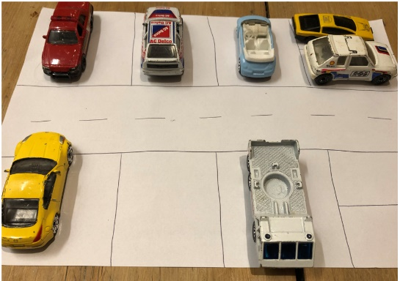
Extension  Add road signs and road marking.  What signs are written on the road? E.g. STOP  What road signs do you know?  What letter indicates a car park? | Questions to ask  What marks go down the middle of the road? How can we draw these?  Where do the roads go? Can we draw houses? Shops? Maybe a swimming pool? Or somewhere to eat?

Activity 2 – Create an animal rescue centre
Use your soft toys as rescued animals

What to do  - Set up the role play activity with pens beds for them, placing some animals in pens/ houses, and leaving others in a box or perhaps in a large toy lorry.  - Have little bowls for the animals.  - Make sure you have some bandages and pretend medicines.  - Allow children to explore the activity, before introducing question prompts. | What you need  Soft toys, cushions or folded towels for beds  Bandages perhaps cut out of an old unwanted tea towel, T-shirt or rag  Plasters, pretend medicine and spoon  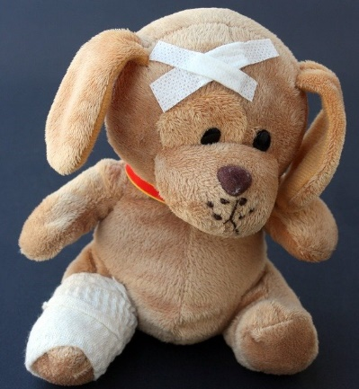
Extension  Have a register with the names of the animals and a tick list.  Register each animal as it comes in. Be sure to write what is wrong with it. | Questions to ask  Two more lions are arriving today… How many lions will there be altogether?  How many animals will there be altogether?  What is wrong with the bear?

Activity 3 – Go on safari
Use your soft toys to make a safari adventure

What to do  - Set up the animals in the garden or around the home. You can make some easy to spot and hide others to provide more hunting opportunity.  - Make a spotting sheet, dividing the paper into a 4x4 grid (with drawn lines or by folding).  - Prepare for the trip by packing a bag and dressing for the occasion.  - Agree on safari rules – we must be quiet and move slowly so we don’t scare the animals, we must be careful as some might be very protective over their young, etc.  - Go on safari and see what you can find! | What you need  Soft toys of any type  Binoculars made of loo rolls or rolled paper taped together or hands shaped to peep through  Paper and pencil and something to lean on (like a clipboard or hardbacked book)  Safari clothes (a hat to keep the sun off, backpack for provisions, etc.)  Real or play photographic device  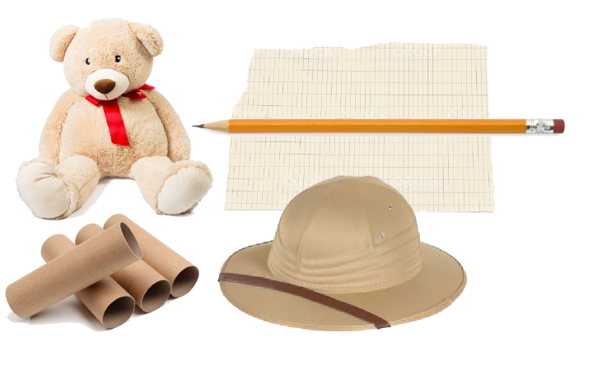
Extension  Draw or list animals found – you could keep a tally chart if you find several of the same animal  Take photos of what you see.  Sort animals by size, colour or leg number  Try a safari by torchlight with the curtains closed | Questions to ask  What animal is that? Can you describe it?  How can you tell that it is a unicorn?  How many bears have you found?  What animal have you found the most/least of?  What do you think this animal eats?

Activity 4 – Role play a shop
Set up and run a shop

What to do  - Set up the shop together, laying out the different items.  - Make up price labels together, writing them on the paper (e.g. 2p, 10p, 50p etc.) and pricing up the goods.  - Set up a till area with money (the money can be imaginary).  - Make an ‘open’ and ‘closed’ sign’ by folding a sheet of paper so it will stand up and writing one word on each side.  - Take turns with your child being the shopkeeper and a shopper. | What you need  Goods to sell (this could be anything: canned food, toys, books, craft supplies, clothes, etc.)  Paper or post its for making price labels  Play till or container for keeping real or play coins  Tabletop space  Other paper or card for making signs, labels and promotions  A telephone  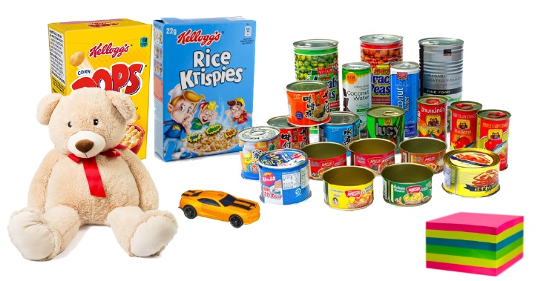
Extension  Work out the cost of two items by adding them together. What coins do we need?  Order the items by price.  Hold a sale. Now everything is 1p less.  Do a stocktake. Make a list of what is in the shop. Ring up the supplier to replace sold goods. | Questions to ask  How much does this book cost?  Can you help me find the peas?  I want to make a cake. What ingredients should I buy?  What time do you open tomorrow?  Can I work in your shop? What tasks will I need to do?

Activity 5 – Role play a school
Role play schools with toys/household members

What to do  - Set up learning spaces, one with paper, pencils and any educational equipment that you might have and another with a cosy space for ‘carpet time’ and sharing books.  - Create a simple timetable together and stick it to the wall (include Tidy-up time!).  - Create a register and tick off names.  - Take turns to be teacher and student.  - Include activities such as playtime, P.E., Art and Music.  - Include visits to places significant to your child, e.g. The Office, the library, medical room etc.  - Have a story at home time. | What you need  Paper, pens, pencils, art equipment  A table and chair/s  Any educational equipment you have, e.g. key word lists, numbers, counters, ruler  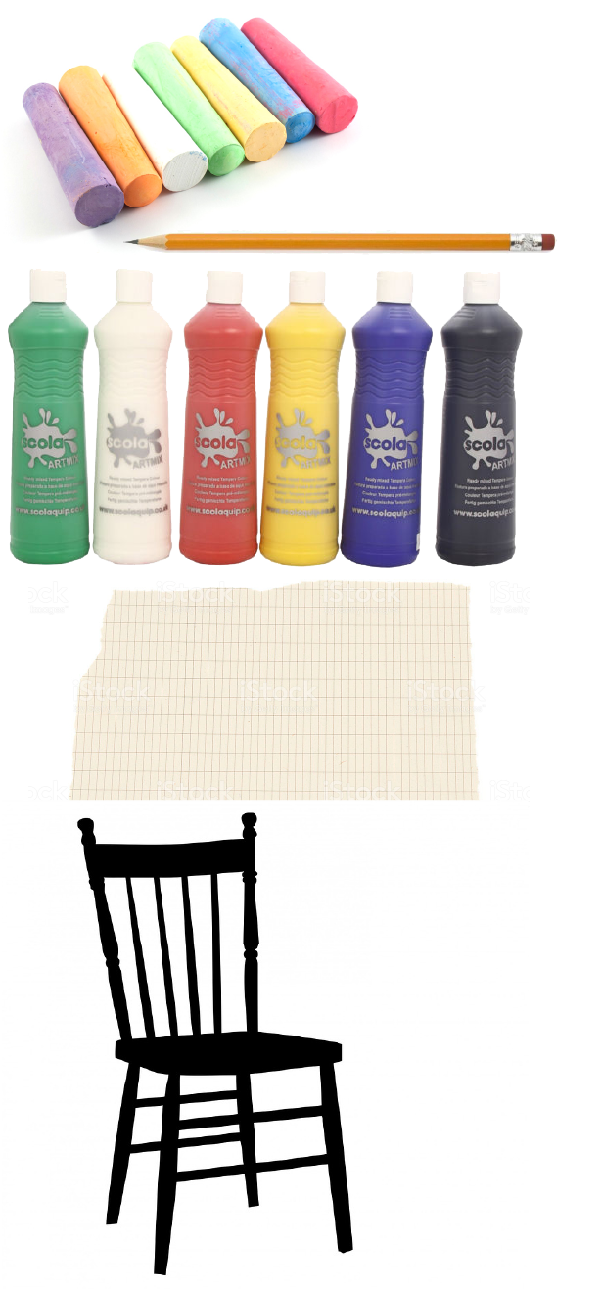
Extension  Create and record school rules.  Plan and go on a school trip.  Give an assembly to your toys.  Hold a fire drill – count everyone out.  Create a forest school (outdoor learning with natural objects). | Questions to ask  What time does school begin/end?  How many children are here today?  What is on the timetable?  What are we learning today?  How long is lunch time?  What are the school rules?

Activity 6 – Create a tiny/fairy garden
Make a small world garden

What to do  - Set up the ‘garden’ putting a shallow tray out and filling it with soil or sand (if inside you could use paper or felt).  - Lay out the rest of the equipment and talk about what sort of garden you could make.  - Think about places for growing, places for playing and places for relaxing.  - Create a garden together, arranging the objects and talking about them.  - Make up stories together, playing with the garden and developing it. | What you need  A shallow tray or wide plant pot  Soil, pebbles, sand, real or artificial flowers, petals, grass, shells, lolly sticks, twigs  Small figures, toy animals, dolls house furniture  Craft supplies, e.g. gems, beads, buttons, feathers.  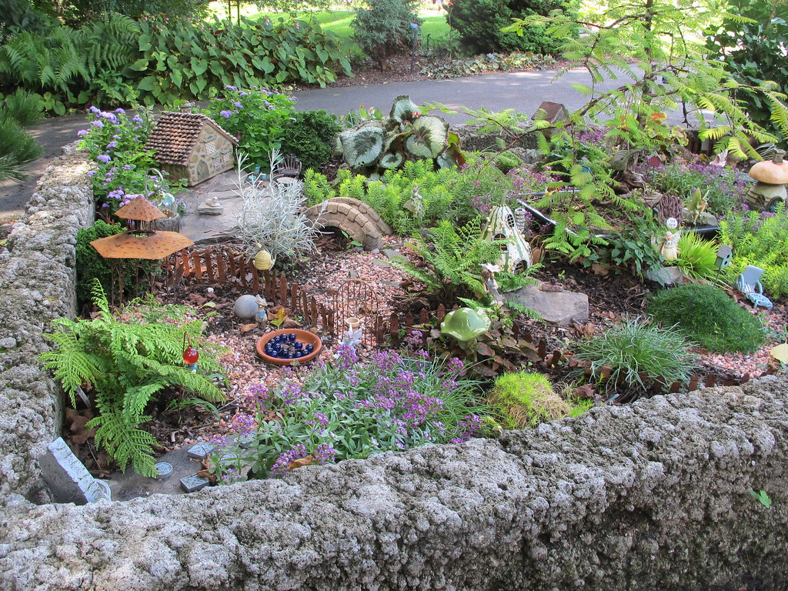  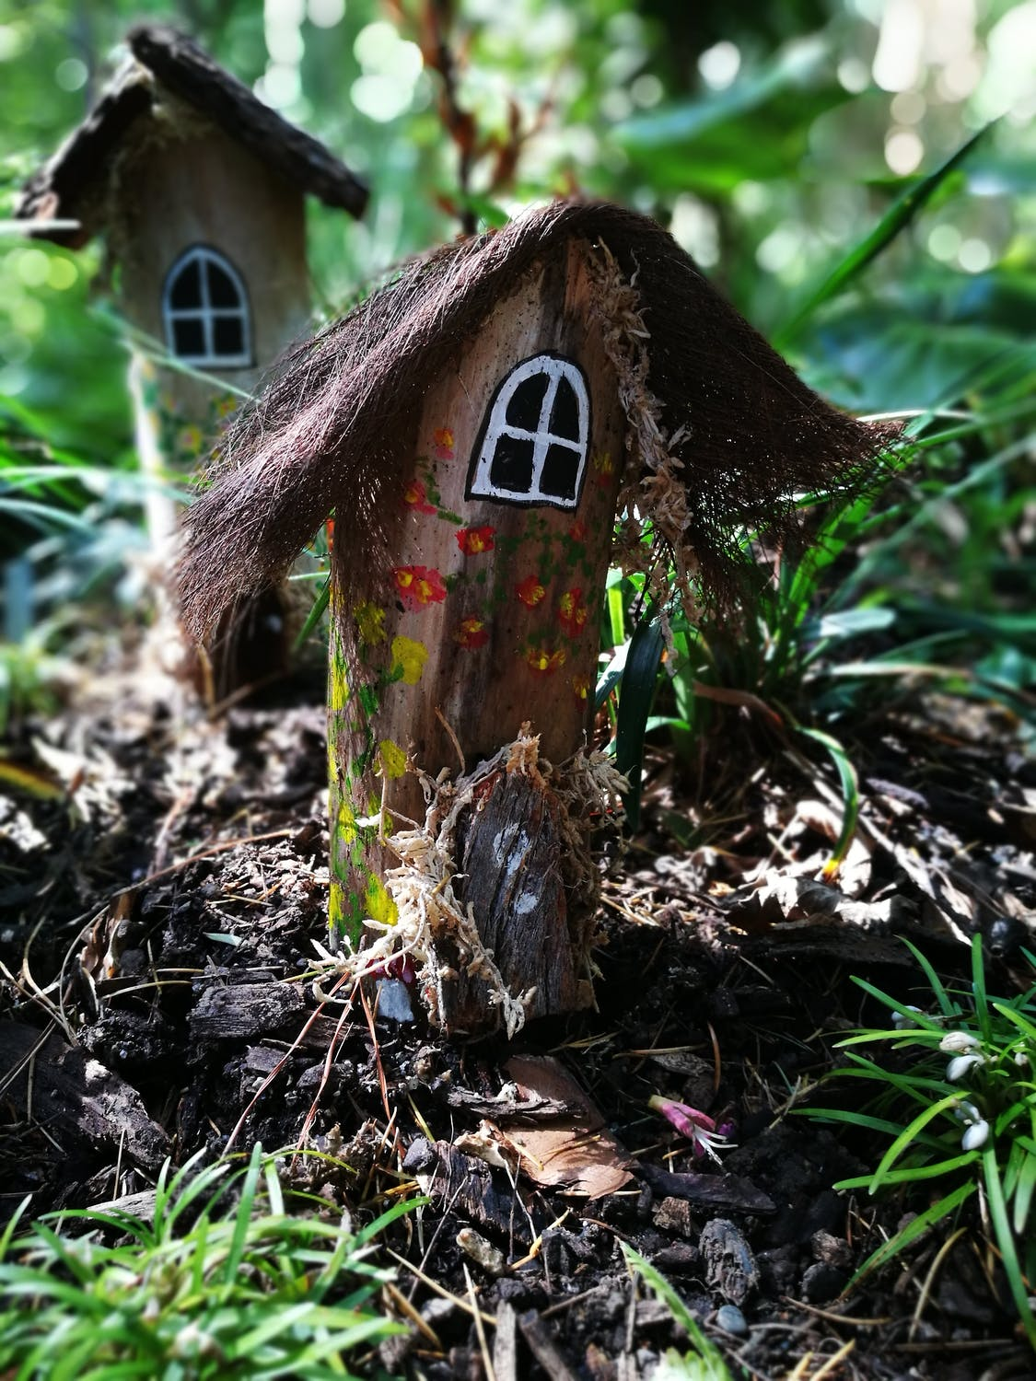
Extension  Make benches, swings, fences, scarecrows and houses from twigs, lolly sticks, card and string.  Add a shallow pond, filling a jar lid with water.  Put real small plants in the garden, and or plant cress seeds in a shallow tray and watch the crop grow over a week. | Questions to ask  What could our garden be like?  Who might live there?  Where will the flowers grow?  Will there be a path? How could we make it?  Where will the children hide when they play hide and seek?  What if the rabbits eat the lettuces?  What will stop the birds eating the seeds?

