Movement
IMPORTANT Parent or Carer –
Check that you are happy with any weblinks or use of the internet.

NB New activities are being added at the top of each document.
Activity 12 – Movement Games
Glow in the dark dancing

What to do  - Dress your child in long sleeved and legged clothing.  - Crack/shake a couple of glowsticks and explore what happens when you shake them, make large movements while holding them. Can you make patterns, shapes, letters or numbers? Can you make big shapes and small shapes?  - Now use tape to attach a line of glowsticks down each limb and their torso, all at the front of their body (almost like a cartoon skeleton).  - With them facing a mirror if possible, encourage your child to try different movements and explore the impact. There should be lots of dancing and jumping about.  - You could put on upbeat music for maximum movement! | What you need  Glowsticks, tape, a darkened room,  A large mirror if possible    
Extension  Have a glowstick dance party with the curtains shut and lights off.  Video their movements so they can see the impact if you don’t have a large mirror.  Try this in the garden at night, if you can stay up long enough for dark to fall. | Questions to ask  What happens when we activate the glowstick?  Which parts of our bodies are we using?  What shapes and patterns can you make?  Can you make big shapes and small shapes?  What happens when we dance?

Activity 11 – Fine-motor Craft
Break and mend baby bear’s chairs

What to do  - Talk about the story of Goldilocks and the Three Bears. What did Goldilocks do in the bears’ house? If you have not shared this story recently, you may like to tell it together or share a version in a story book.  - Remind your child how to safely use a pair of scissors.  - Cut out the chairs together along the dotted lines and have some fun thinking of the different ways you could break the chairs.  - Draw lines for cutting along (aiming for 2-4 pieces per chair) using straight, wavy and zigzag lines.  - Your child can ‘break’ each chair by cutting along the lines.  - They put the pieces together like mini-jigsaws and ‘mend’ them by cutting tape and sticking the chairs together or gluing them onto a larger piece of paper. | What you need  Scissors, tape, printed chairs (see below)  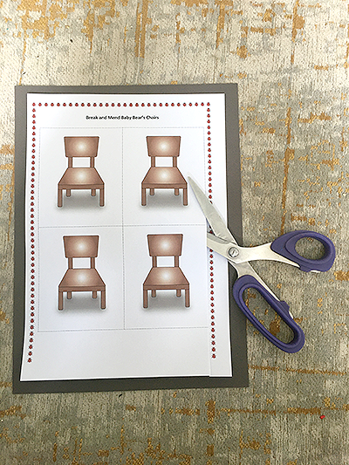  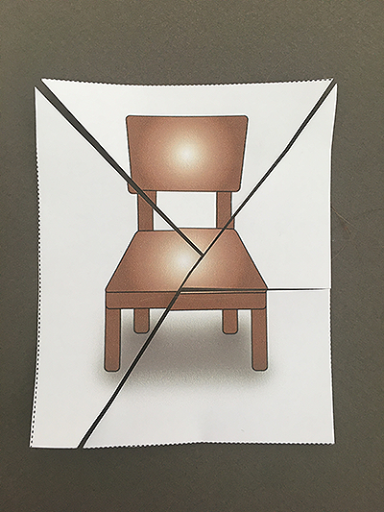
Extension  If you don’t have a printer, you can draw some different chairs to be cut and mended.  Encourage your child to draw some lines of their own to follow with a pair of scissors.  Design a new and improved chair for Baby Bear or one for Goldilocks to sit in so she can share a story with Baby Bear. | Questions to ask  Do you remember the story of Goldilocks and the Three Bears? What happened to Baby Bear’s chair?  Can you cut carefully along the lines?  How can we fit the chairs back together?  Can you mend them? What can we use?

Break and Mend Baby Bear’s Chairs

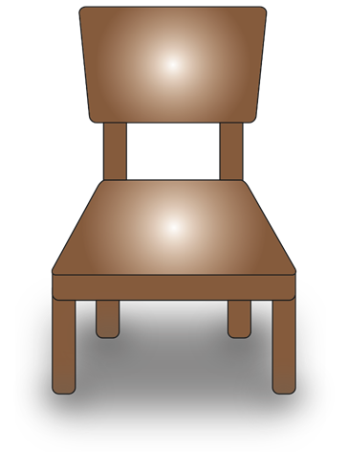

Activity 10 – Fine-motor Craft
Make a pompom
What to do  - Draw around a jar on the card to make two disks the same size. Cut them out.  - In the centre of one, place the coin and draw around this together. Cut out the circle so that you have a ringed doughnut shape.  - Place the doughnut on the second disk and use as a template to draw a matching circle and cut this out.  - Cut a length of wool, around two arm lengths, and tie one end to the doughnut. Start posting the wool through and wrapping it round. The idea is to wrap the entire doughnut with wool until it is thickly wrapped.  - You may need to add more wool. Tie off one end around the doughnut and start another in the same way.  - When finished, secure the wool and use scissors to snip around the edge, pushing the scissors between the two disks.  - Slide some wool between the two disks, pull tight and knot.  - Pull the pompom out of the doughnut. You may prefer to cut a slit to free it. | What you need  Cereal box card, pen, scissors, wool, a jar and a 10p coin  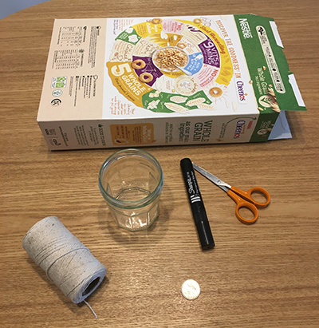
Extension  Experiment with different sizes of disk, colours and textures of wool.  Combine to make a hanging decoration. | Questions to ask  How could we make a card circle? What could we draw around?  Can you help me cut around the edge?  What colour wool can we use?  Can you post it through?  How can we stop the wool slipping?  Have we covered all of the card?

Activity 9 – Large movements
Herd a flock of balloons

What to do  - Inflate ten or so balloons. If they are plain and pale coloured, you could add sheep faces and fleecy curls with a marker pen.  - Explain that this is a flock of excitable sheep and they need to be herded into the next room.  - Explore how they can be moved – sheep are too heavy to carry – they can be wafted, nudged, tapped and ushered.  - Set the shepherd to work or have a team of sheep dogs working together. | What you need  A packet of balloons, (optional) balloon pump  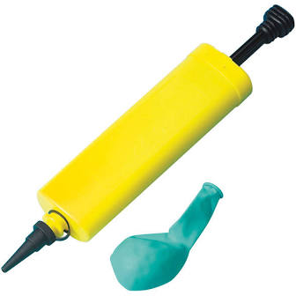
Extension  Dress the part, with wellies, coat and hat.  Increase the flock size. Make sheep noises for authenticity.  Use words for position, in front, behind, under, on top of, between, etc.  Hold some sheep trials, with points for herding round obstacles and into smaller spaces. Make and award rosettes. | Questions to ask  What do you think these balloons will be?  How many sheep are in the flock?  How can we get them to move?  Where do they need to be? Why do we need to move them?  Where are they now? How many are stuck under the table?  Who is in charge? Who is giving the instructions?

Activity 8 – Fine-motor Craft
Make an egg box bird feeder
What to do  - Talk about all the birds that like to visit the area near your home. Agree that you could encourage more by putting food out.  - How to make the bird feeder together:  - Tear the lid from the base.  - Make holes for the string by pushing a pencil through each corner.  - Cut the string to the correct length.  - Thread the string through the holes to make a hanging loop.  - Decorate the underside of the box with felt pens.  - Using a pinching movement, your child can put in bird seed in each section.  - Put up your beautiful feeder and wait for the birds to visit.  Hint: It may take several days before birds feel brave enough to visit. | What you need  Egg box (papier Mache kind), string, scissors, sharp pencil, bird seed, felt pens  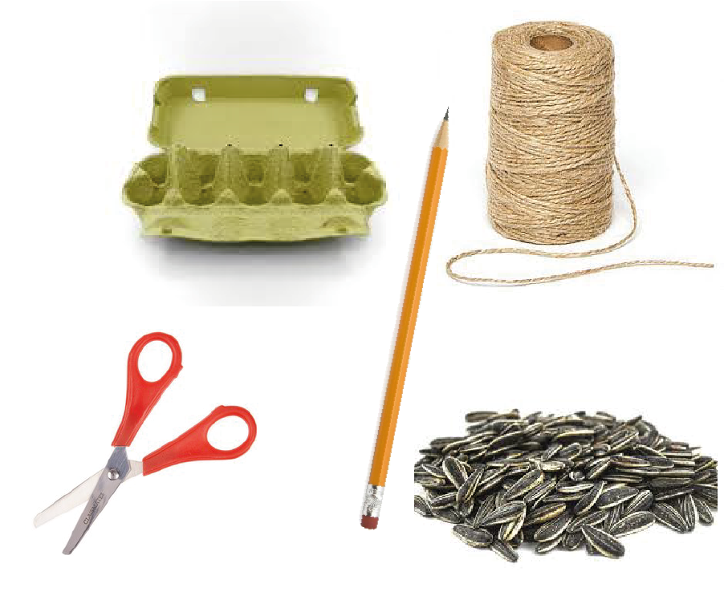
Extension  Try putting small pieces of apple, pear or cheese in the sections. A table knife can be used for safe cutting.  Try making feeders from other packaging.  Do some bird watching. | Questions to ask  Why do birds visit our garden? What might encourage them?  How can we separate the lid from the base?  How can we avoid tearing the cups?  How can we fix the string to the box? How can we make holes safely?  How long shall we have the string? Can you cut it safely? Can we thread it through? Can you pick up these slippery seeds?

Activity 7 – Jumping Games
Do ‘French skipping’ or ‘Elastics’

What to do  - Set up the loop – usually this is done by two people stretching the elastic around their ankles and creating a rectangle with the elastic, but you can also use two dining room chairs.  - Explain how to play. Skippers jump in different ways depending on words in the skipping rhymes.  - Inside – both feet inside the rectangle.  - Outside – both feet outside the rectangle (wide legs on either side)  - On – both feet on either long side of the elastic rectangle.  - Every other beat – jump from side to side, with feet either side of the elastic (legs close together)  - Say some rhymes and do some skipping! | What you need  A long loop of elastic  (French skipping elastic can be bought for a couple of pounds or you can use haberdashery elastic or looped elastic bands)  Some skipping rhymes (see below)  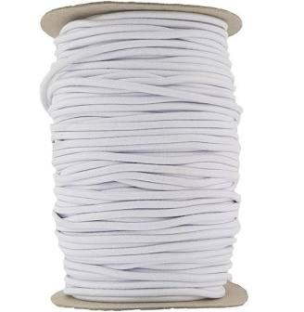
Extension  Make up your own rhymes, using the key position words.  Try raising the elastic a little higher to make the jumps higher. | Questions to ask  How does it feel when we exercise?  Which parts of our bodies are we using?  How are we getting better at each station as we practise?  What other stations would be fun?

Skipping Rhymes (first one broken down into movements)
England (Jump one side)  Ireland (Jump other side)  Scotland (Jump other side)  Wales (Jump other side)  Inside (Jump both feet inside)  Outside (both feet either side)  Out (jump away completely) | Mrs Mason broke her basin  On the way to London Station  How much did her ticket cost?  One, two, three…  (keep counting for each skip)
Chocolate cake, when you bake,  How many minutes will you take?  One, two, three, four… | Sausage in a pan,  Sausage in a pan,  Turn them over, turn them over,  (turn to face the other direction)  Sausage in a pan
Teddy bear, teddy bear,  Turn around!  Teddy bear, teddy bear,  Touch the ground!  Teddy bear, teddy bear,  Bend down low!  Teddy bear, teddy bear,  Touch your toe!  Teddy bear, teddy bear,  Turn out the light!  Teddy bear, teddy bear,  Say good night! | Ibble obble chocolate bobble  Ibble obble out.  Turn a dirty dishcloth inside out.  Once if it's dirty  Twice if it's clean  Ibble obble chocolate bobble  Ibble obble out!

Activity 1 – Exercise circuits
Create an indoor or outdoor circuit

What to do  - Set up the circuit: this can be done together or set out in advance.  - Go around the circuit together, deciding or explaining what movement will happen at each station and how many times/for how long.  - Start the circuit – several family members can take part at once, each at a different station.  - Music can be used to add energy to an indoor circuit.  - Example stations:  - 5 jumping jacks on the trampoline  - 5 runs around the washing line  - Sit on a cushion for the count of 20  - Throw 5 beanbags into a box  - 5 skips with the rope  - Crawl under the broom balanced between two chairs | What you need  Things that can mark out different stations in the circuit: e.g. hula hoop, cones, chalk drawn shapes on ground, carpet square/small rug/foam squares, cuddly toys  Small active equipment: e.g.  ball, bat, skipping rope, bean bags  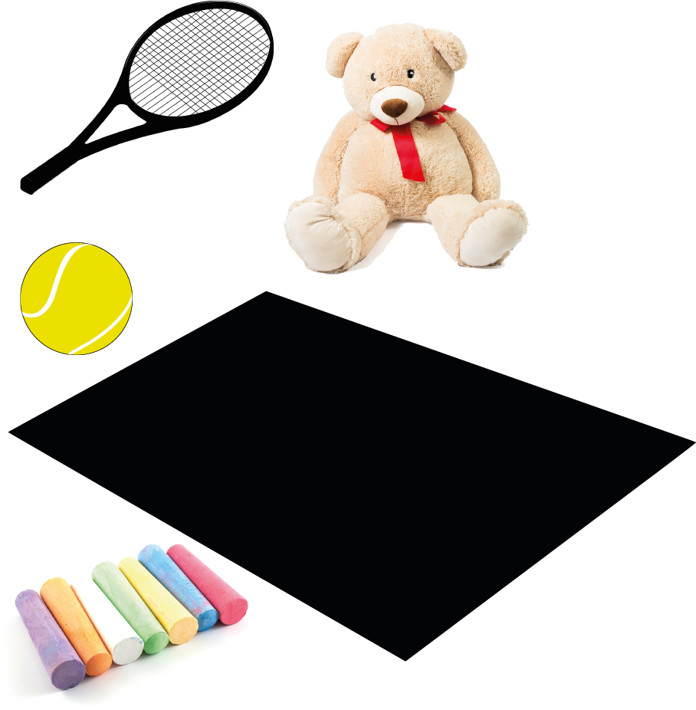  A circuit is a set of different exercises performed with short rest periods between for a set number of repetitions/a prescribed amount of time. For young children, moving to a different place (or station) for each exercise helps them understand the process.
Extension  Set novelty challenges – e.g. how slowly/fast/small/big can you make each movement? Can we do it at double speed? Can you set up a circuit for the family next time? | Questions to ask  How does it feel when we exercise?  Which parts of our bodies are we using?  How are we getting better at each station as we practise?  What other stations would be fun?

Activity 2 – Dancing to music
Play musical statues

What to do  - Play fun music to dance to – when the music is stopped everyone freezes.  - Add in elements, e.g. jumping, big movements, dance like a robot, dance like you’re in space, to provide variety to the dancing.  - Add challenges, e.g. when the music stops… freeze in an animal shape, pulling a face, with your hands on your head, etc.  - With more than one child you can add some friendly competition. | What you need  Music  Someone to control the music  
Extension  Dance to reflect the mood of the song, e.g. dramatic flourishes for ‘Let it go’, energetic for ‘Who let the dogs out’ etc.  Put together a playlist which includes songs which will appeal to each dancer.  Have a dancing competition. | Questions to ask  What parts of your body are you using?  Are you listening to the music?  How can you freeze without falling over?  How can we describe our movements? Are they big/small/fast/slow?

Activity 3 – Ball skills
Keep the balloon off the floor

What to do  - Blow up a balloon.  - Throw it into the air and challenge everyone to keep it from touching the floor.  - This can go on for a long time! | What you need  A balloon  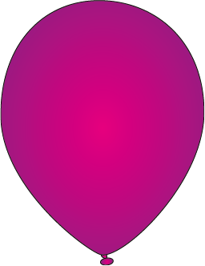
Extension  Introduce some rules for challenge, e.g. you can only touch the balloon once and then someone else must touch it next, you can only use hands/feet/one hand etc.  Have teams and invent a scoring system.  Introduce more balloons into the game! | Questions to ask  Is it better to be gentle or rough with balloon contact?  Can you use the back of your hand…just your fingers?  Who is winning?  How could we score a point?

Activity 4 – Action Rhymes with hands and fingers
Say or sing traditional and not so traditional finger rhymes

What to do  - Familiarise yourself with traditional finger rhymes (use websites below, nursery rhyme books and/or enlist family members).  - Sing or say them together – if you are teaching them to your child, break the rhyme down, asking them to repeat each line after you. | What you need  A list of rhymes to start with, e.g.  Grandma’s Glasses  Here’s the Church and Here’s the Steeple  Two Little Dicky Birds  One Finger, One Thumb  Miss Polly had a dolly  Tommy Thumb  Five Little Ducks  Incy Wincy Spider  Baby Shark  
Extension  Try changing the speed, size of the movements or invent new ones.  Teach a rhyme to someone else – you could do this with distant friends or family members using video calls or enlist help from grandparents etc. to teach children over. | Questions to ask  Can you copy what I say?  Can you do the actions?  Can you remember the action?  What words come next?

*Finger rhymes: https://www.nurseryrhymes.org/fingerplay.html lots on this site
https://www.youtube.com/watch?v=d1FKVdY-65g Grandmas’ Glasses
https://www.youtube.com/watch?v=smtucwvzuCc Here’s the Church
https://www.youtube.com/watch?v=1bmT6RMNQD8 One finger, One Thumb
https://www.youtube.com/watch?v=NWbyu4dqzuc Tommy Thumb

Activity 5 – Fine Motor Skills
Sorting coins, buttons, counters

What to do  - Provide the objects to sort and the container to sort them into.  - Look at the mixed-up buttons (or similar). Ask how we could sort them?  - Ask your child to sort the objects according to their own rules.  - This could be repeated for different criteria (e.g. shape, colour, pattern).  - You might need to give a reason for the sorting – e.g. I want to sort these buttons so I can do some mending. | What you need  Small flat items which can be sorted by type, colour, shape etc. e.g. coins, counters, buttons, beads  Sorting container with several sections, e.g. egg box, muffin/cupcake tray, circles drawn on a piece of paper  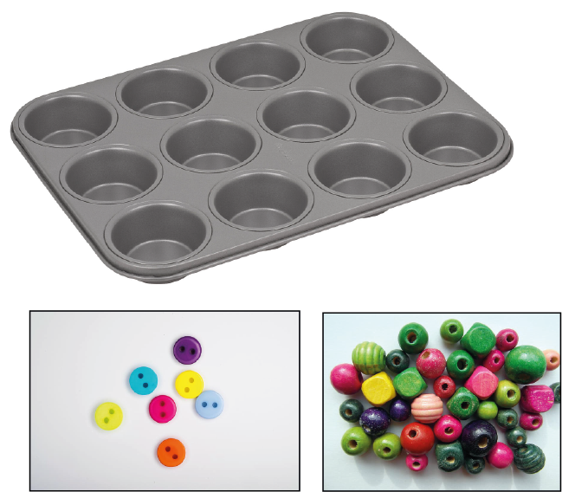
Extension  Make it harder by challenging your child to pick up the objects with tweezers – they are too hot to handle!  Introduce a timed challenge.  Try natural irregular objects, like pebbles or leaves.  Make a picture with the sorted items. | Questions to ask  How could we sort these?  Where will all of the red buttons go?  How many counters are in the green pile?  Which group has the most/least in it?

Activity 6 – Fine Motor Skills
Colander hedgehog or flower arrangement

What to do  - Collect the pokable materials and place a colander upturned  - Challenge your child to:  - poke as many pipe cleaners/ twigs/ spaghetti sticks in the holes to make a hedgehog/ monster etc.  - create a flower/nature arrangement by sticking stems through the holes. | What you need  An upturned colander  Things you can poke in the holes, e.g. pipe cleaners, dry spaghetti, thin twigs, picked flowers with thin stems, leaves with long stems  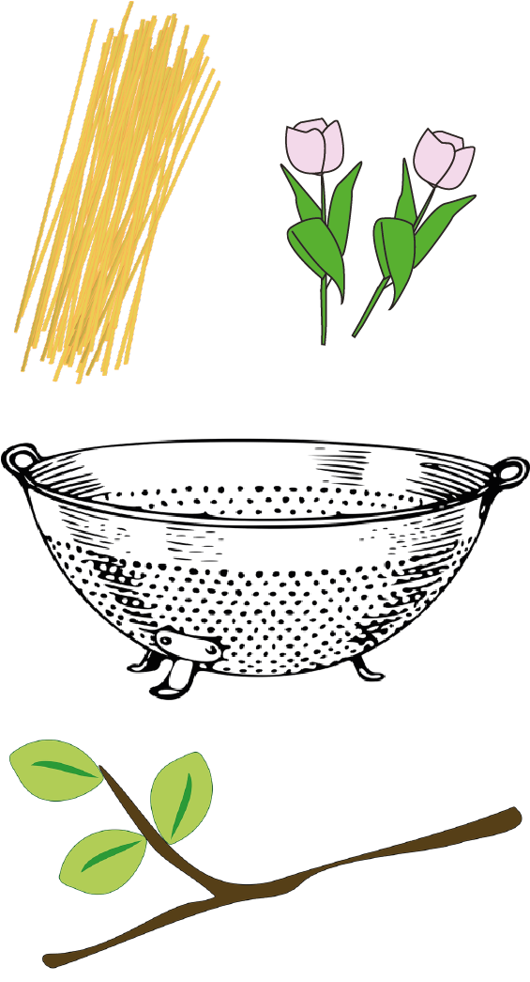
Extension  Turn the colander up the other way and challenge your child to make a web/weave with thread and a blunt sewing needle or pipe cleaners.  Mix and match things to poke through (e.g. leaves and twigs).  Make an arrangement as a table decoration. | Questions to ask  What animal have you made?  What is it called?  How many twigs have you used?  Can you make a pattern?  How can we fit things through the holes more easily?

