Numbers and Shapes
IMPORTANT Parent or Carer –
Check that you are happy with any weblinks or use of the internet.

NB New activities are being added at the top of each document.

Activity 12 – Counting and number recognition
Play number bingo

What to do  - Create a set of bingo calling tickets by cutting up 20 pieces of paper and writing numbers 1-20 on each. You could do this together, asking your child to write some while you write others.  - Fold each number ticket and place in the container.  - Then draw a bingo card for each player (at least two), a three-by-two grid with space for your child to fit a two-digit number inside each box.  - Write a different number 1-20 in each box, again helping your child with the number writing as much as needed.  - Play bingo by taking turns to choose a folded ticket, reading the number aloud and circling the number if you have it. The winner is the first to a full house. | What you need  Paper, pencil, scissors, a container  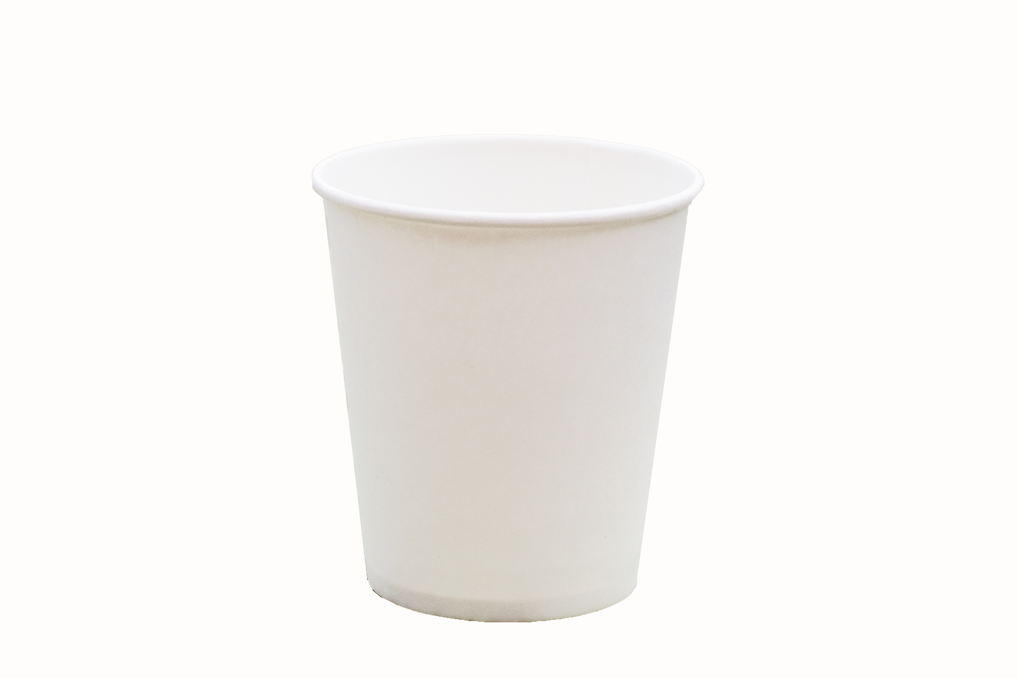  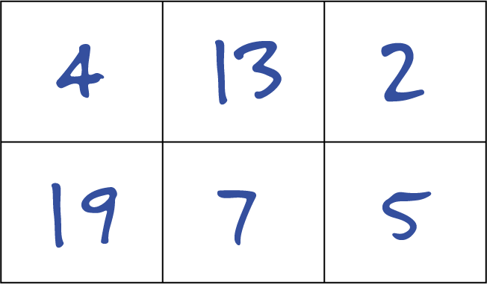
Extension  Play the game as often as you like, making new bingo cards to use with the tickets.  Make the game easier, sticking to numbers below 12.  Make the game harder, including large numbers. | Questions to ask  Do you know how to play bingo?  What numbers can we write up to 20?  What numbers will you choose?  Can you write 14? What digits do I need?  What is the number on the ticket? Can you say it?  Have you got the number?

Activity 11 – Counting and number recognition
Set garden records

What to do  - Explain that you are going to set some garden records. Choose a piece of equipment and demonstrate a challenge, e.g. How many jumps can you do in 10 seconds? Ask your child to be in charge of counting aloud while you time for ten seconds (this can be counting in your head if you don’t have a timer app).  - Ask your child to tell you how many jumps you did and make a record of this – or ask them to write the number for you. Explain that this is a record you are going to try to break. Repeat the process and see if you can beat your record. Now swap roles.  - Try records like:  - Most ball throws in 10 seconds  - Most jumps over a skipping rope  - Most runs around the garden  - Most ball throws and catches  - Encourage lots of counting and discussion about the numbers recorded. | What you need  Timer, paper and pencil, any outdoor play equipment and toys, e.g. ball, skipping rope, cones, hula hoop etc.  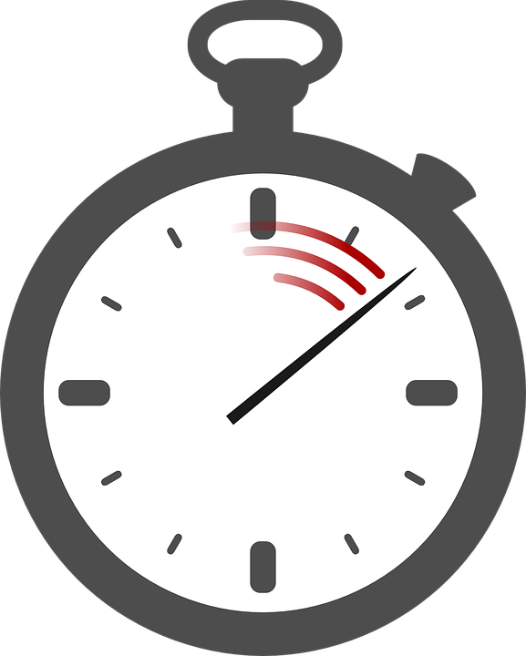  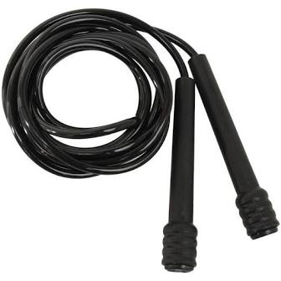
Extension  Hold indoor records, e.g. most Lego bricks pushed into a base in 20 seconds, etc.  Create a leader board for the most popular records, writing each name and best three scores.  Enlist other members of the family to join in and have their record adjudicated by your child. | Questions to ask  Do you know what a record is?  How many jumps do you think I can do in 10 seconds?  How will we know when the time is up?  Can you count for me?  Can you write my number? What number is that?  How many more jumps did I do the second time?

Activity 10 – Counting and number recognition
Play a counting and building game

What to do  - Explain the game:  - Each player takes turns to roll the die.  - They count the spots on the die and take that number of blocks from the pile.  - They build a tower with the blocks.  - The aim of the game is to be the first with a tower of ten bricks.  - Play the game doing lots of counting and talking about who has the highest/lowest tower, the difference between the towers in blocks (two more/less, how many more to have the same number, etc.) | What you need  Duplo-type bricks of the same size (20 for the base game, more to extend)  a die  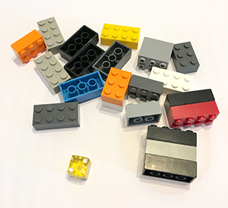
Extension  Change the target number. First to 20.  Have two dice and include adding the totals in the game.  Play the game on squared paper, drawing or colouring the squares to make tower pictures. | Questions to ask  What number have you rolled? Shall we count the spots?  How many bricks can I take? Can you help me count them out?  Whose tower is the highest?  How many bricks do you have so far?  Who has the most/least bricks?  How many more do you need to win the game?

Activity 9 – Exploring and recognising shapes
Make flat shapes from straight

What to do  - Look at the equipment together. Say you want to make a square. How many sides will we need to make? Count them out together and make a square (four straight sides, all the same length). Count the sides and count the corners. – 4 of each.  - Explore making triangles. Can we make a circle? Why not?  - What if we want to make a rectangle? We need to make 2 of the sides longer. How can we do this?  - What if we want to make a bigger square? What could we do? (Have two sticks per side.)  - Try this with rectangles and triangles. Each time, count the sides and count the corners. | What you need  Lolly sticks  (or similar regular length straight sticks)  For extension: felt pens, PVA glue, paint  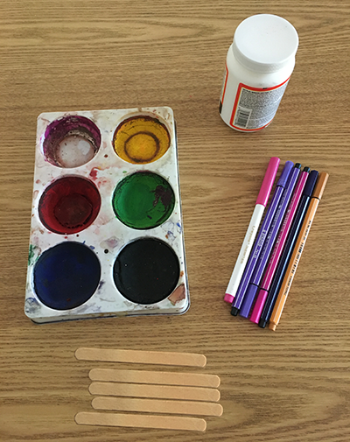
Extension  Fix the pieces together with glue to make permanent shapes. Colour with pen or paint and suspend to make a hanging shape decoration.  How could we make a hexagon? That needs 6 sides… Or an octagon? (8 sides). | Questions to ask  What shapes could we make from these sticks?  How many sides/corners does a square have?  How could we make a triangle? What are triangles like?  How can we make longer sides for the rectangle?

Activity 8 – Counting and number recognition
Put number leaves in order and compare them
What to do  - Write numbers 1-20 (or 10) on leaves so you end up with number cards. Ask your child to help you remember the numbers as you write them.  - Ask them to help you put the leaves in order, starting with ‘1’, in a line.  - Play games like:  - flip over a few leaves (while in their ordered line) and ask your child what the hidden numbers are.  - Choose two leaves at random, asking which is the higher/lower number. Check by counting to see which comes first.  - Choose a leaf each. Who has the higher number and has won?  - Put down two numbers. Can your child say which number would go in the middle? e.g. 6, __, 8  - Put down a leaf. Can your child find the leaf which shows one more and one less? | What you need  Flat leaves, a marker pen  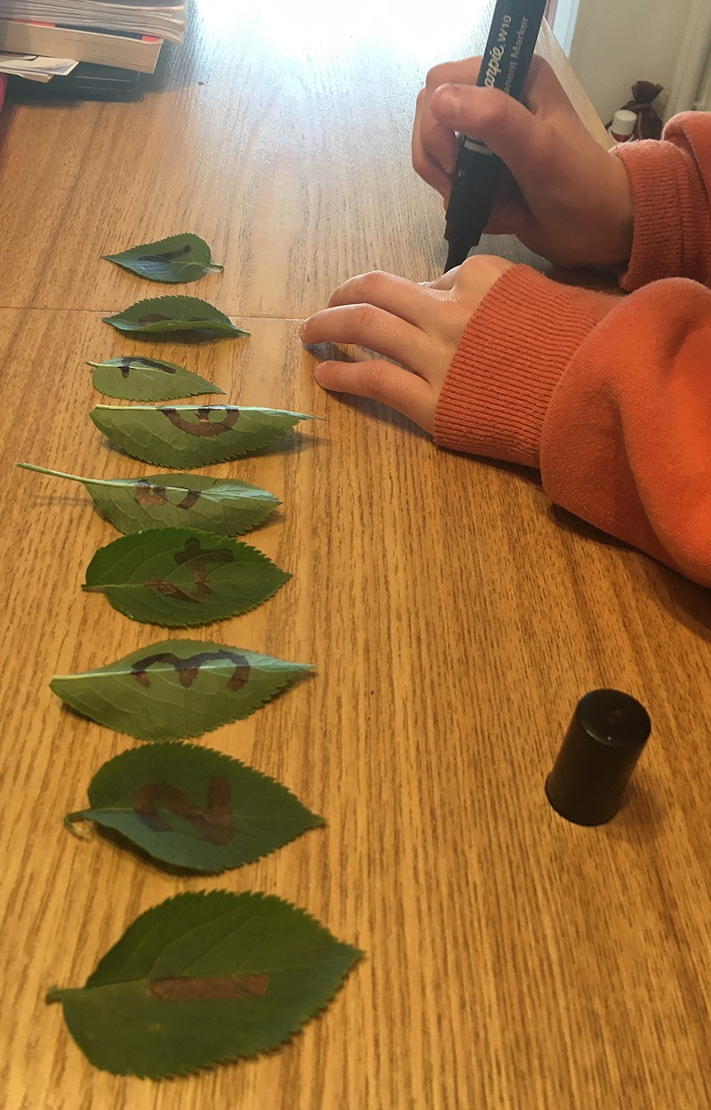
Extension  Place a leaf on a sheet of plain paper. Can your child draw spots which match the number?  Hide the leaves for your child to find and then put in order.  Lay out the leaves randomly. How quickly can your child find a…3…9…etc.? | Questions to ask  What number should I write first? What comes next?  Can we put them in order, starting with the lowest number? What will the last number in my line be?  Can we say the numbers in order?  Which number is missing?  Who has the higher/lower number?

Activity 7 – Exploring and recognising shapes
Play shape peekaboo

What to do  - Cut out different sized shapes from card. Include a few different:  - circles  - squares  - rectangles  - triangles  - (hexagons & octagons)  - Place these all in a bag.  - Explain that you have hidden some 2D (flat) shapes in your bag. Ask your child what they might be.  - Take one shape at a time and make it ‘peep’ out from the bag. Can your child guess the shape from the part they can see? Show different parts of the same shape talking about what is peeping out, e.g. ‘One point, another point, one more point. Hmm. Three points. What must that shape be?’  - Each correct guess wins your child the shape. Continue until your child has won all of the shapes. | What you need  Card - could be from packaging  Scissors, a bag to hide the shapes  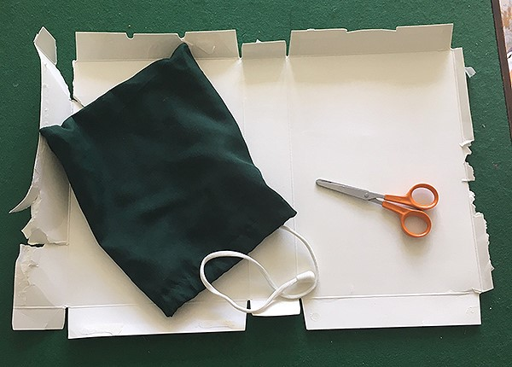
Extension  Play the game with you as the guesser.  Play the game by feeling the shapes rather than peeping at them. | Questions to ask  What shapes might I have in my bag?  How many sides/points does that shape have?  What clues do we have so far?

Activity 1 – Exploring and recognising shapes
Go on a shape hunt

What to do  - Explain that you are going to be going on a shape hunt looking for 2D (flat) shapes.  - Talk about the different shapes that you might see - this is more a warm-up than to test shape knowledge.  - Go on the shape hunt, spotting, describing and identifying the shapes that you can see. You could do this on a walk (pavements, houses and signs have lots of potential for spotting) or around your home.  - Record the shapes you spot by drawing and/or photographing them.  - Not all the shapes will be traditionally mathematical shapes (like triangle, square, circle, etc.). It is fine to have heart, star and moon shapes etc. | What you need  Paper, pencil, and something to lean on…  Or a camera/phone.  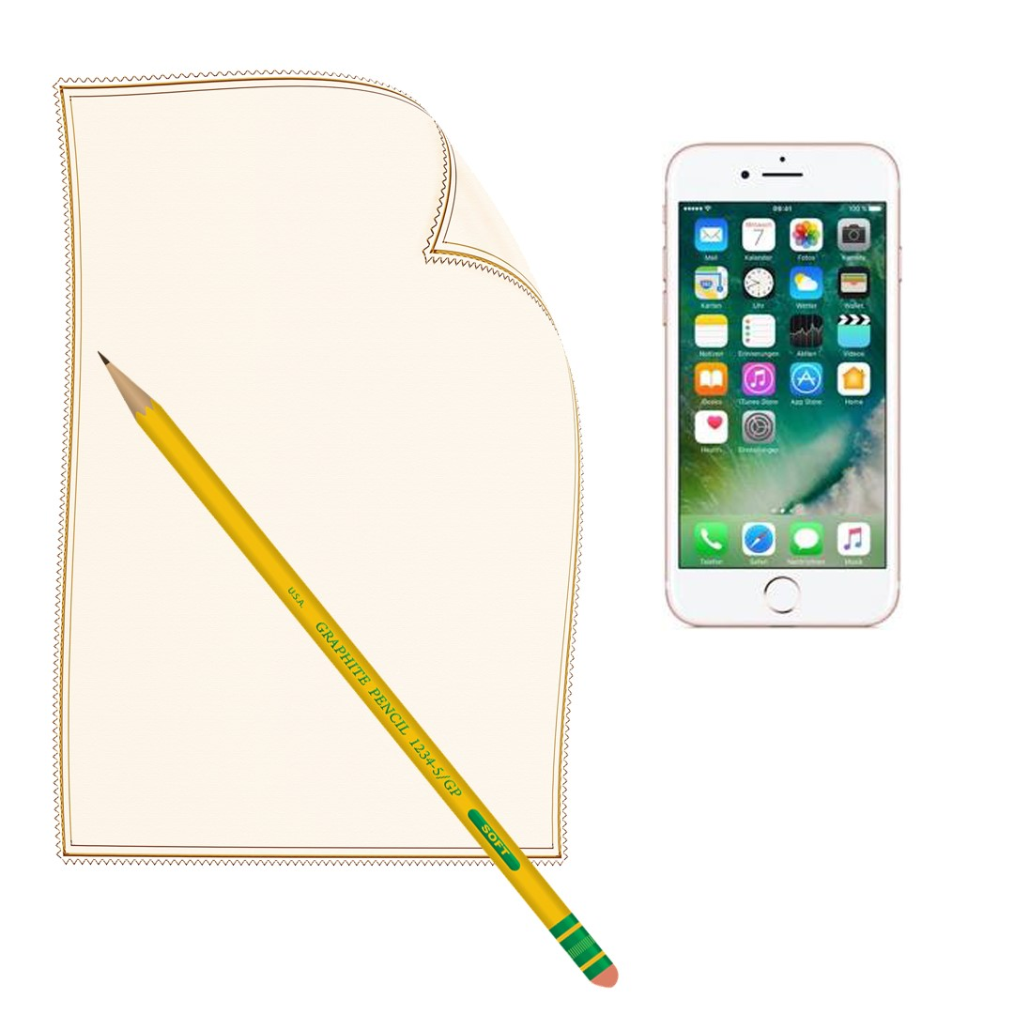
Extension  Make a shape book. Draw or use photos and label the shapes.  Talk about the properties – number of sides and points, straight or curved sides.  Play a shape spotting games with Super Numtum: https://www.bbc.co.uk/cbeebies/games/numtums-kingdom-of-fluffy | Questions to ask  What shapes will we see?  How many sides/points does that shape have?  Can we find any circles?  How many triangles have we spotted?  Why is a star shape not a triangle?

Activity 2 – Counting and number recognition
Create a counted collection

What to do  - Show the collecting containers. Read the numbers together.  - Discuss what sort of things your child could collect in them. Help them to think about what might fit inside and what might not.  - Set them off collecting, encouraging them to count the objects in carefully.  - Get them excited by saying that you are really looking forward to seeing what they will collect.  - Ask your child to share their collection. Check the correct number is present together and admire their haul. | What you need  A selection of collecting containers, labelled with numerals written inside: e.g.  - an eggbox with 1,2,3,4,5,6 written, one number in each section  - 6 cupcake cases with numbers on the bottom 2,4,6,8,10,12 placed inside a tin (blu-tak-ed in place)  - 6 flowerpots labelled 10-15  - A grid drawn in chalk with different numbers written inside the boxes  And things to collect, e.g. different petals, leaves, grass blades, mini figures, Lego pieces, beads, buttons, hair bands, etc.
Extension  Display the collection. It could have labels and a sign to introduce it.  Change the numbers for a new collection.  Encourage your child to write some new numbers, forming each digit carefully*.  Change where the collection is made – take it into the garden, into the kitchen, to the toy box, etc. | Questions to ask  What are these numbers? Can you say them?  Which is the biggest/smallest number?  What could we collect 6 of in here? Would 6 fit?  How could we check that there are 9 daisies in here? How many more/less do we need?

*If you are not sure about number formation, these rhymes are commonly used in schools: https://www.youtube.com/watch?v=vjB5aSyWD6U
Activity 3 – Counting and using number facts
Jumping up and down a number track

What to do  - Draw a number track: a series of boxes or divisions in a line with numbers 1-12 written in order along it (like hopscotch but only one square thick each time).  - Jump on each number saying it aloud going forward. Repeat starting on 12 and jumping back.  - Play about, jumping forward and back saying ‘add one/takeaway one’ ‘add two/takeaway two’ as you jump forward and back.  - Start just before 1 on the track and flip the plate. The game starts on the first +2. Take turns to flip the plate jumping forward and back the displayed number of places. You win by landing on (or going past) the 12. | What you need  Chalk and a pavement or patio  Or  A large roll of paper and thick pen  and  a paper plate with +2 written on one side and -1 on the other  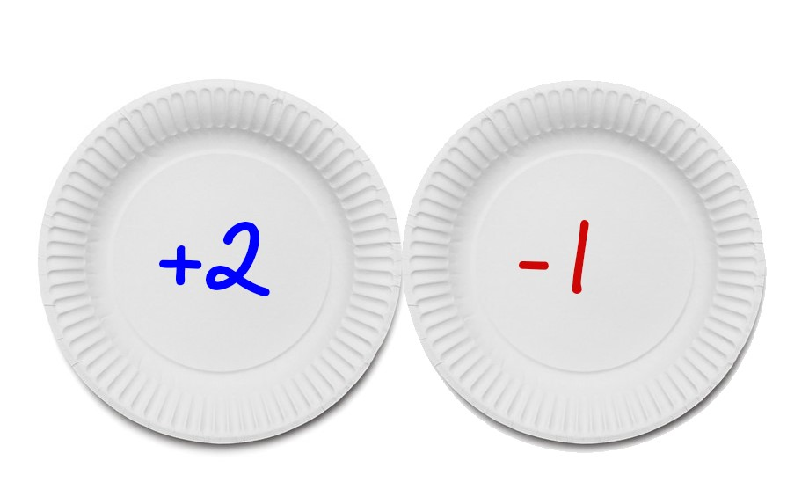
Extension  Make a game die (cube shape made sticking 6 card squares together). Include +1, +2, -2, -1 and a couple of comedy actions, e.g. pat your head and rub your tummy on the other two squares.  Make a mini version on A4 paper and use counters to make a competitive game. | Questions to ask  I want to write the numbers from one to twelve in order. Can you help me?  Can you jump to one more/less?  Can we add 1/takeaway 1 by jumping?  How many jumps would +2 be?  The plate shows -1. What do we do?

Activity 4 – Exploring and recognising shapes
Make a shape picture

What to do  - Make some shape stencils by drawing them on card and cutting them out, e.g. circle, square, rectangles and triangles of different types.  - Show your child how to use the stencils to draw their own shapes. They may need support knowing how to hold the stencil still with one hand while drawing around it with the other. This can be tricky and may require adult help each time.  - Together cut out the shapes and talk about the different ones you have made.  - Now your child can make some pictures arranging the shapes and sticking them down when they are happy with their position. | What you need  Card, children’s scissors, pencil, paper (coloured if possible), paper glue  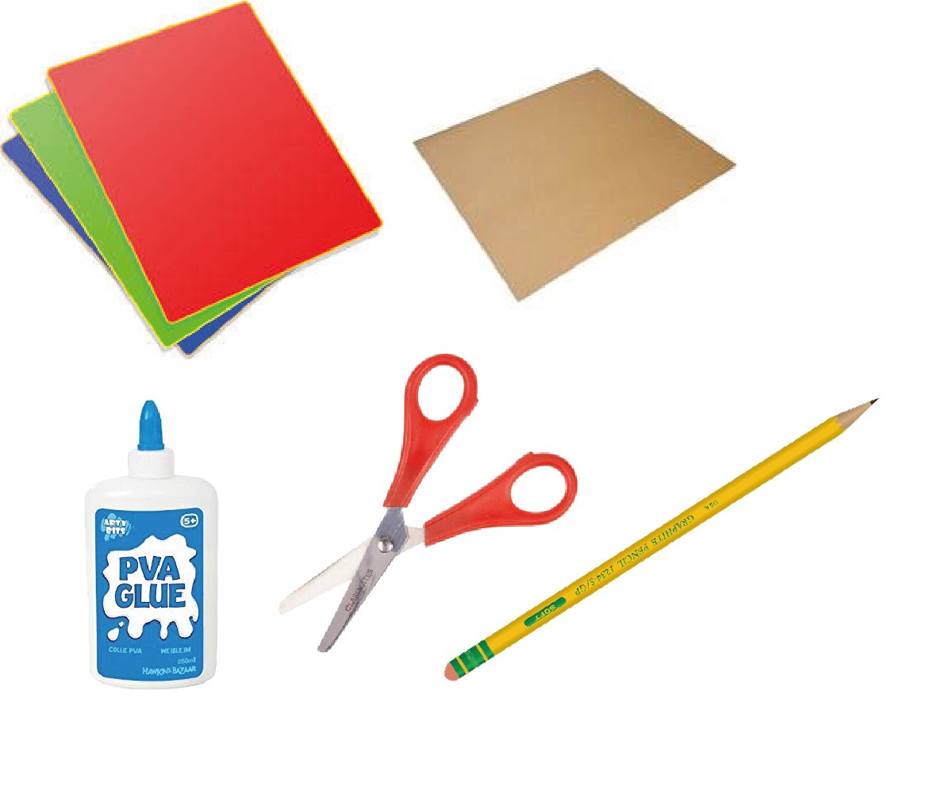
Extension  Do not provide glue. This can be a reusable activity which just needs a small container to keep the pieces in.  Include a greater range of shapes, e.g. hexagon, octagon, parallelogram, but focus talk on describing these shapes’ properties rather than learning their names. | Questions to ask  How can we use a stencil?  What shapes do we have stencils for?  How do we know this is a triangle?  How many points does a square have?  Is this a rectangle or a square? How can we tell?  What different patterns/pictures could you make?  What shape did you use for the hat?

Activity 5 – Counting and using number facts
Play with number bond egg puzzles

What to do  - Start with number bonds to make 10. These are pairs of numbers which when added together make ten.  - Print the egg shapes (or draw some) on card. Cut each egg in half to make a different ‘crack’ design. On the top and bottom of each egg, write a pair of numbers which total 10.  - Your child can then explore matching the egg halves to make the correct number bonds to 10.  Tip: You don’t have to include all possible combinations to start with. Select from the possible pairs and add more when your child seems confident. | What you need  Card, scissors, thick pen, egg template (see below)  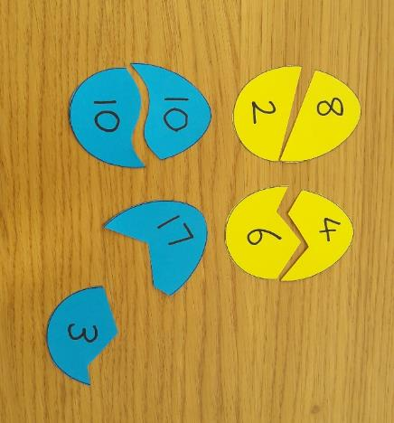
Extension  Hide the shell halves to make a treasure hunt game (around the garden/house or in dry cereal).  Make a second set which are not differently cracked – your child can use counting and/or memory of the bonds to match them.  Create a new set (a different colour if possible) with number bonds to make 20. | Questions to ask  Do you know some number bonds to make 10?  Which pair of numbers make 10 when you add them? Can you find the pairs?  I have 8 here. How many more will I need to count to 10?  Which is the biggest/smallest number?

Number Bonds to 10

0+10
1+9
2+8
3+7
4+6
5+5
6+4
7+3
8+2
9+1
10+0

Number Bonds - Egg Template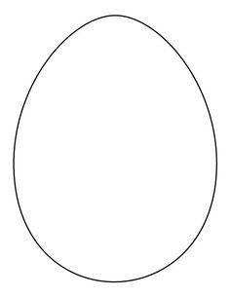
Activity 6 – Counting and using number facts
Work out a missing number

What to do  - Start with 5 counters on a surface. Count them together. Explain that the cup is going to catch some counters and the only way to free them is to say how many are under the cup.  - Make a game of the cup hovering over and then ‘catching’ some counters. Can your child work out how many have been caught underneath using the number of counters remaining?  - They may use number facts (3 still free, 3+2=5 so 2 caught), counting on with fingers (3 free, so 4…5…= 2 under the cup) or guessing.  - Repeat the game. Your child may become more strategic in their working out as they play, or you can reduce the number of counters to help them.  - You can repeat this game, changing the number of counters in play. | What you need  A cup (optional eyes drawn on)  5-10 counters (cereal shapes, buttons, coins, etc.)  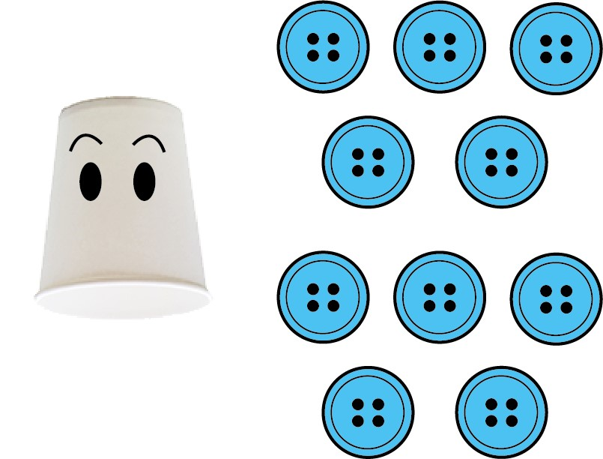
Extension  Perform the trick together in front of an audience but tell them you are using ‘magic’. You could cover the counters with a magic hat (paper rolled in a cone with stars drawn on it) and see if you and your child can hoodwink the audience using magical maths.  Use this principle with small animals or people and a box for a building. How many people are in the house/animals in the barn?  Reverse roles and get your child to test you. | Questions to ask  How many counters are there?  What if the cup trapped one? How many would still be free?  There are 5 Cheerios. Munch, munch, munch. Now there are two left. How many has the cup eaten?  Can we count on to find how many are hidden?  If there are 4 still free then how many are under the cup?

