Reading and Listening
IMPORTANT Parent or Carer –
Check that you are happy with any weblinks or use of the internet.

NB New activities are being added at the top of each document.
Activity 12 – Reading and sharing books
Enjoying rhyming stories

What to do  - Choose a book which has a strong rhyming pattern.  - Read a few pages and ask your child to listen for the rhyming words. Can they hear them? Can they find them on the page?  - Can your child anticipate the end word in each line using the rhyming line which comes before? Can they join in?  - Choose a pair of rhyming lines. Can you think of words to swap in for the final word, e.g. ‘Where are you meeting him?’ ‘Here by these rocks, and his favourite food is roasted fox [socks].’ | What you need  Rhyming story books, e.g.  Rhyming picture books by Julia Donaldson (The Gruffalo, The Snail and the Whale)  Rhyming picture books by Nick Sharratt (Shark in the Park, Don’t Put Your Finger in the Jelly, Nelly!)  Oi Frog books by Kes Gray and Jim Field  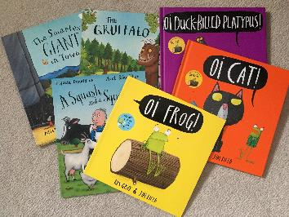
Extension  Collect pairs of rhyming words from your reading. You can play matching games with them or think of new words to add to the chain. | Questions to ask  Can you hear the words which rhyme?  Can you find the rhyming pairs?  Can you join in with the rhyming words?  What word could we swap this one for? How will the story sound now?
Some online versions
Stickman https://www.youtube.com/watch?v=o3lCfKhsOsY
Shark in the Park https://www.youtube.com/watch?v=nWRwBRVeGQs&t=25s
Kes Gray‘s books https://www.youtube.com/channel/UCoOhtVZl1EUE-o3rFpBghNg
Activity 11 – Reading and following instructions
Play dinosaur movement games

What to do  - Print and cut up the cards.  - Read them together, using sounding out to help read each word.  - Discuss what each word means. Can you do the movement? Move around being dinosaurs, using dinosaur movements.  - Shuffle the cards and pick one at random. Can you read the word and do the action?  - Try choosing the card secretly. Can you read the card and do the action while everyone tries to guess what the action is that you are doing?  - Hide the cards around the house or garden. Race about looking for the cards. When you find one, read the word aloud and everyone does the action. | What you need  Dinosaur movement cards (see below)  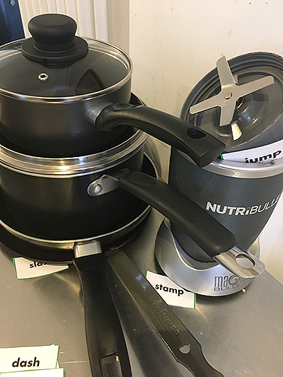
Extension  Create your own movement cards linked to a different type of animal, e.g. birds, insects, frogs. Read and follow the actions.  Write movement words in chalk on paving stones. Jump from stone to stone, reading the action and doing it. | Questions to ask  Can you read these words?  Can you sound them out?  What do the words mean?  Can you do the actions?  Can you guess my action?  Can you find some hidden cards? What does that one say?

plod | swing | hop | honk
dash | flap | sip | stamp
jump | wag | jab | chomp
creep | run | nip | slash
Dinosaur Movement Cards

Activity 10 – Listening and exploring sounds
Go on a sound hunt

What to do  - Label the box with a sound that your child can recognise, e.g. b, r, s. This could also be a sound made by using two letters, e.g. sh, ch. Look at the letter/s and read the sound together.  - Go on a sound hunt, looking for words which begin with that sound. Put them in the box if it will fit.  - Take the things out of the box and make a sound display. Say each thing in turn, emphasising the beginning sound as you say it.  - Repeat the game, changing the sound. Encourage your child to think of the sound. They could write it on the box. | What you need  A box or container  A marker pen  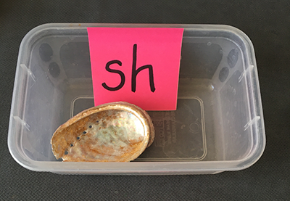
Extension  Try playing the game with a camera phone outside. Take photos of things which start with the agreed sound.  Try playing the game, hunting for words which end in a particular sound. This will need some practice first to make sure your child is confident with hearing the end sound. | Questions to ask  What sound does this letter make when we say it?  Can you think of some words which begin with ‘s’? Can you find anything to put in the box which begins with ‘s’?  Can you name each thing you have collected? What sound do they begin with?

Activity 9 – Reading and sharing books
Read some poems together

What to do  - Talk about the different poems and rhymes that you know.  - Say any traditional rhymes and poems that you remember, e.g. Humpty Dumpty, Hey Diddle Diddle, One two, Buckle my Shoe.  - Read some poems together in the books you have or ones you have found online or below.  - Choose some favourites and see if you can learn a line at a time. The rhyme will help.  - Rereading a poem is fun because you can play with the rhymes and say the poem with expression. | What you need  Poetry books, fun poems (see below), poems from memory and websites  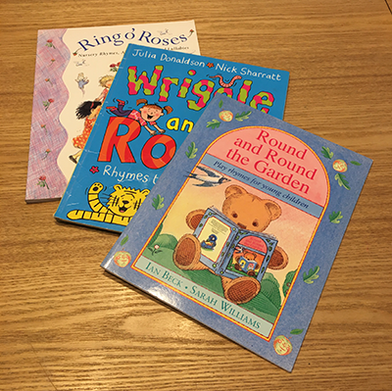
Extension  Start a ‘Favourite Poems’ book, copying out or printing favourite poems and sticking them in a book. You can illustrate them together.  Ask other people to contribute poems for your collection.  Ask your child to choose a poem to share whenever they like. | Questions to ask  What poems do we know? Can we say some?  Can we read this one together?  Which poems do you like best?  Which one shall we read together?  Can we say this one making our voices louder for the countdown?

Fun Poems
Astronaut and Rocket Ship  Put on your spacesuit.  We're going to the moon.  Climb aboard your rocket ship.  We're going to blast off soon.  Put on your helmet.  Strap yourself in tight.  Check your controls and instruments.  Get ready for the flight.  Time for your journey.  The countdown has begun.  Here we go,  Get ready, Get set!  5, 4, 3, 2, 1  Blast off! | Bear was afraid  Bear was afraid,  sitting in the dark.  Heard a scary noise,  a short, deep bark.  Bear hid his eyes.  What made the sound?  Deer in the forest,  leaping around.  Bear was afraid,  sitting all alone.  Heard a scary noise,  a long, low groan.  Bear hid his eyes.  What could it be?  Beaver in the river,  chopping down a tree. | Hands and Apron Song  Roll up your sleeves,  Give your hands a wash!  With slippy, dippy soap,  Splish, splash, splosh!  Have you done your hands?  Washed and dried?  Sleeves rolled up?  Apron tied?  What can you do?  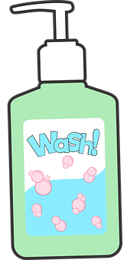  I CAN COOK!

Activity 8 – Listening and exploring sounds
Play a rhyming game
What to do  - Say a string of words which rhyme, e.g. cat, hat, mat. Can your child spot the pattern? They all rhyme/end with the same sound.  - Say a new word. Can you child think of another word which rhymes with yours, e.g. toe, grow.  - Try taking turns adding words to make a rhyming string, e.g. toe, grow, show, blow, know, etc. It is like you are playing catch, throwing the rhyme back and forth.  - Try to make the longest rhyming string together that you can. | What you need  A list of short words to rhyme, either in your head or noted down  (You could start with cat, hot, bin, toe, tree, day, high)  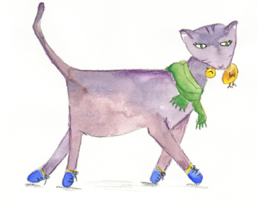  cat and rat
Extension  Move the game around: say, ‘I’m thinking of something which rhymes with flea.’ Your child looks around for something which rhymes, such as tree.  Draw a set of rhyming words such as a cat, mat, hat and bat.  Enjoy books with strong rhyming features such as the ‘Oi Frog!’ series by Kes Grey (see below). | Questions to ask  Can you guess what I have seen?  What things can you think of which begin with that sound?  Does ball really begin with m?  Can you have a go? What can you see? What sound does it begin with? Try whispering it if you need to.

https://www.youtube.com/watch?v=NVnIpS1IReg Oi Frog! Read aloud
https://www.youtube.com/watch?v=imqf0NtQ77s Oi Cat! Read aloud
https://www.youtube.com/watch?v=uldum2bSFlU Oi Dog! Read aloud
Activity 7 – Reading and sharing books
Read a favourite story to a sibling, pet or toy

What to do  - Pick the book together. Can your child remember what happens in the story? Look at the pages and talk about what happens.  - Set up a calm and cosy place to share the book.  - Ask your child to tell the story, either by reading the words or using the pictures to prompt their own retelling. They might do a mixture of both and that it fine.  - You could do this together, taking turns to read pages or parts. Your child will enjoy reading repeating words and phrases. | What you need  A favourite picture book which your child knows well  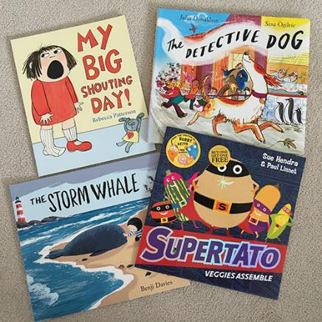
Extension  Do this as a Skype or other video call for a distant friend or relative.  Build up a repertoire of books that your child is confident to ‘read’ to someone else.  Make a video | Questions to ask  Which is your favourite book?  What happens in the story? Shall we look at the pictures?  Where will be a cosy place to share it?  Who would enjoy hearing this story?

Activity 1 – Reading and sharing books
Set up a cosy book nook

What to do  - Set up the book nook together. You can make this as simple or decorated as you like. For example, a shoe box with books inside, a cushion and a cuddly toy, or a pop-up tent, fairy lights, sleeping bag, torch and cuddly toy and decorated book box. You might start simple and develop the nook over time.  - Rotate the books in the nook each week, including your child with the process – some books will be too favourite to swap out! | What you need  A selection of books in a box  Cushions, blankets, soft toys etc.  A cosy spot (in a corner, by a window, under a table, in a pop-up tent, etc.)  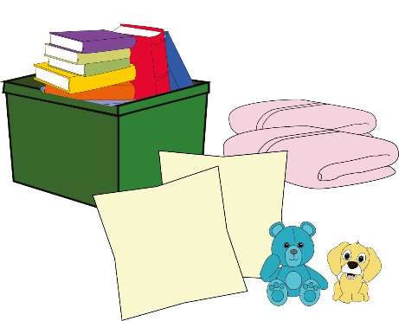
Extension  Theme the nook, working together to make paper bunting, reading posters and other decorations on a theme or favourite book, e.g. a Gruffalo’s cave.  Make some books to add to the nook, folding paper and writing together (see Writing Activities 6).  Move the nook to new locations for variety. | Questions to ask  Where shall we have the book nook?  What would make it cosy?  Which books shall we have first?  How could we make the box look special?  Which toy would be great to read your books to?

Activity 2 – Reading and sharing books
Make and use a story sack/box

What to do  - Choose a simple picture book which you will both enjoy reading.  - Share the book enjoying the story and discussing the different events.  - Collect or make props together to present parts of the story to help to retell it. You don’t have to have everything represented – just the key elements and nothing needs to be perfect! They are just prompts.  The making can be spread over a few days – it should feel like fun.  - Once you have made and/or assembled the props, take turns to tell the story with the props.  Example story sack contents:  Room on the Broom by Julia Donaldson  Toy wand, ribbon tied in a bow, fancy dress witch hat, broomstick made from a lolly stick and paper fringe stuck on one end. Characters drawn on card, coloured, cut out and stuck on lolly sticks: witch, cat, dog, bird, frog, dragon. | What you need  An engaging picture book  Objects/images that can be used to retell the story (paper, card, pens, lolly sticks, scissors and tape for making props)  A bag or box to keep everything in  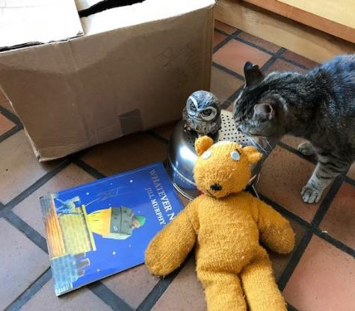
Extension  Choose a character and talk about them. Give them advice, make them a present, design a new outfit for them etc.  Retell the story but make some changes – a different ending, different character etc. This can be done physically by swapping props before the telling.  Make up conversations between the story characters. | Questions to ask  What happens at the beginning/next/at the end of the story? Can we remember how the story starts/ends?  Which characters are in the story?  What other things can we make or find to show what happens in the story?  Can we tell the story using the sack objects?  What if we changed…?  What advice would you give the witch?

Activity 3 – Listening and exploring sounds
Play ‘I Spy’

What to do  - Play the traditional game ‘I Spy’. Pick something that you can see and give a clue with the phrases, ‘I spy with my little eye something beginning with…’. For example, if you are looking at your cat, you would end the phrase by saying the c sound.  - Your child guesses the mystery object, saying words which begin with the sound. Keep praising any words which begin with the right sound and give clues if the guesser gets tired.  - Swap roles and play again.  Key Tip: Use the sound not the letter name with the game. Try to use ‘pure sounds’ which your child will have learnt at school. (The hardest are f, l, m, n, r, v, w, x - if you are not used to this). See website below for help. | What you need  Nothing for the base game  To extend: a book with detailed illustrations  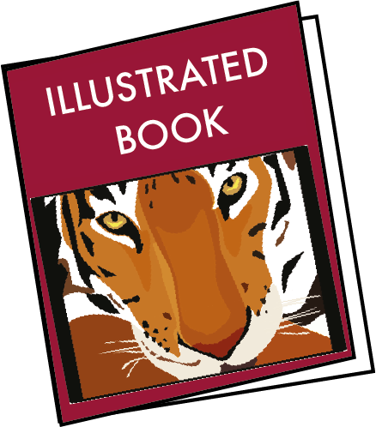
Extension  Move the game around: in different rooms, by the window, on your walks.  Use a page from a book for a new setting or use imagination, e.g. What would you see under the sea, in a witch’s cottage, etc. | Questions to ask  Can you guess what I have seen?  What things can you think of which begin with that sound?  Does ball really begin with m?  Can you have a go? What can you see? What sound does it begin with? Try whispering it if you need to.

Cbeebies Alphablocks take us through saying each sound in the alphabet: https://www.bbc.co.uk/cbeebies/watch/alphablocks-watch
Activity 4 – Word recognition
Go on a high frequency/key word treasure hunt

What to do  - Write 10-20 words on your searchable objects. If you don’t have key words provided by your school, you can choose from this list.* The idea is to include 80% words which your child can read easily (recognise by sight) and 20% which they are learning.  - Hide the words around the home/garden and start the hunt. Each time your child finds a word they can only pick it up once they have read it aloud. If they can’t read a word, tell them what it is and re-hide it to be found again in a moment.  - You can repeat this game, gradually swapping in new words as your child becomes more confident. Keep word number manageable to keep it fun. | What you need  High frequency words/key words* written on objects you can hide, e.g.  card rectangles, lolly sticks, pebbles, gold coins (paper disks painted), plastic egg shapes, etc.  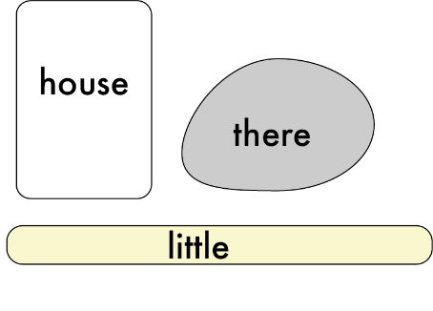  Avoid the temptation to turn this into a lengthy test. These words are usually learnt over the year in Reception. Rushing to ‘tick them off’ risks damaging confidence and enthusiasm – these are hard to regain.
Extension  Challenge your child to set up the hunt for you. They are in charge of reading each word as you find it.  Choose some new words on a topic which your child is interested, e.g. animals, vehicles, etc. | Questions to ask  Which words do you know already? Which are a bit tricky at the moment?  Can you find the words?  How many can we find in 3 minutes?  Do you know what this one says?  Look at it now. Will you recognise it when you find it next?  What words could we put on the cards next?

First 100 High Frequency Words http://www.highfrequencywords.org/first-100-high-frequency-word-list-precursive.html
Next 100 High Frequency Words http://www.highfrequencywords.org/next-200-high-frequency-word-list-precursive.html
Activity 5 – Reading and sharing books
Prepare a book reading
What to do  - Pick a book together which you are going to practise and perform for a planned person. This could make a lovely gift/focus for a video call.  - Read together, taking turns to read a page, or a section. The idea is to give your child practise in perfecting a reading but keeping it manageable by sharing the load by reading some too.  - Practise reading aloud until the reading is confident and fluent.  - Try to do different voices for the characters and develop sound effects, a tap on a glass for a spell, etc.  - When you are ready, share the reading with an appreciative audience. | What you need  A book which your child can read or partly read (a story book which your child really enjoys)  Simple items to make sound effects  
Extension  Create a recording which your child can listen to while they are looking at the book.  Share a recording with a faraway family member and ask them to send a similar one for you to enjoy together.  Make some ‘read along’ recordings for your child of books which are a bit too hard for them to read yet. They will enjoy listening as you turn the pages (or ask an older sibling to).  Watch and enjoy some reading or animated versions of familiar story books (see below). | Questions to ask  Which story will Aunty Tára like?  Which parts will you read and which parts will I read?  Can you read this sentence?  How can we make it more fun to listen to? How will the snake speak?  What sound could we use for the fairy appearing?  Are we ready to share this? Could we make it even better?
Julia Donaldson’s
Room on the Broom: https://www.bbc.co.uk/iplayer/episode/p0102qfj/room-on-the-broom
Zog: https://www.bbc.co.uk/iplayer/episode/b0bwdw8y/zog
The Gruffalo: https://www.bbc.co.uk/iplayer/episode/b00pk64x/the-gruffalo
The Snail and the Whale: https://www.bbc.co.uk/iplayer/episode/m000cslw/the-snail-and-the-whale

CBeebies’ Bedtime Stories are regularly updated: https://www.bbc.co.uk/iplayer/episodes/b00jdlm2/cbeebies-bedtime-stories
Activity 6 – Listening and exploring sounds
Play ‘Guess the sound’

What to do  - Secretly collect a range of noise-making items and hide them from view.  - Make one sound at a time, challenging your child to guess the things making the sound.  - To make it easier, show them a range of objects first and then select one or two to make the sound.  - Repeat the game, sharing the task of finding noise-making objects like a scavenger hunt. Everyone can contribute at least one sound for everyone to guess. | What you need  Things which will make a noise, e.g. cereal and a bowl, glasses case which snaps shut, spoon and mug, stapler and paper, noisy toy, hard back book, musical instrument, etc.  A barrier to hide the hidden things (could be a box open on its side)  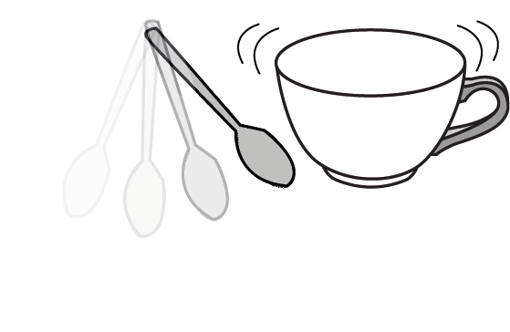
Extension  Give your child complete control of the game. Set ground rules to avoid family heirlooms being bashed together.  Play bingo: Set up as a bingo game with at least 2 players. Everyone picks 3 items from a choice of 6-8 – they can draw or write their chosen things on a piece of paper. You make a sound and they tick it off if they have it. First to full house wins. | Questions to ask  What do you think that sound is?  What is it like? How could you describe it?  What does it remind you of?  What things can you find that we could make a sound with?  How can you make a sound with it? Is there more than one way?  How many sounds have we heard?  How many points do you have?  Who will win?

