Sensory Play
IMPORTANT Parent or Carer –
Check that you are happy with any weblinks or use of the internet.

NB New activities are being added at the top of each document.
Activity 12 – Sensory art
Collage a duvet cover

What to do  - Look at the different colours, textures and shapes of the collage materials. Talk about what they look like and feel like.  - Show your child the duvet picture and explore different ways to arrange the collage materials on it. What patterns can they make? Which colours work well together?  - When they are happy with their duvet design, your child can start to stick down the materials, aiming to cover the whole duvet.  - When they have finished, ask your child to talk about what they like about the duvet. Would they like one like this? | What you need  Design a Cosy Duvet (see below), glue, scissors, collage materials, such as tissue paper, magazine paper, coloured paper, pompoms, scraps of fabric, sequins etc.  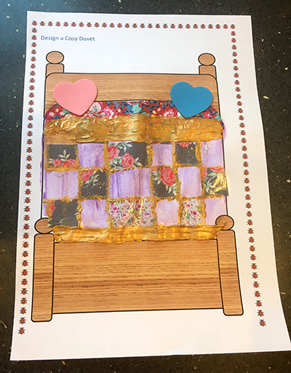
Extension  Make a blanket for a toy. You could decorate an old pillowcase or fabric square with pens (or fabric pens).  Get cosy with a duvet on the sofa and share some stories.  Make a duvet fort and play with torches or glow-in-the-dark toys under it. | Questions to ask  What colours can you see?  What textures can you feel?  What shapes can you see/make?  Which colours look good together?  What patterns can you make?  What do you like about your design?  What other things could you try?

Design a Cosy Duvet

Activity 11 – Sensory art
Make dinosaur bones

What to do  - Make the dough together (see below) feeling how the texture changes from powdery to smooth and pliable.  - Look at pictures of dinosaur bones or use your imagination to think about what different bones might look like.  - Talk about how palaeontologists use dinosaur bones to help them learn about dinosaurs. We can’t go and look at dinosaurs now, so we have to find out about them by using what is left behind.  - Use rolling, pinching, and bending to make a variety of bones together. You can spend as long as is fun doing this.  - Admire your bones and harden them in the oven (see instructions below). | What you need  Bowl, wooden spoon, baking tray, baking parchment  • 1 cup salt  • 2 cups of flour  • ¾ cup of water  Books about dinosaurs (optional)  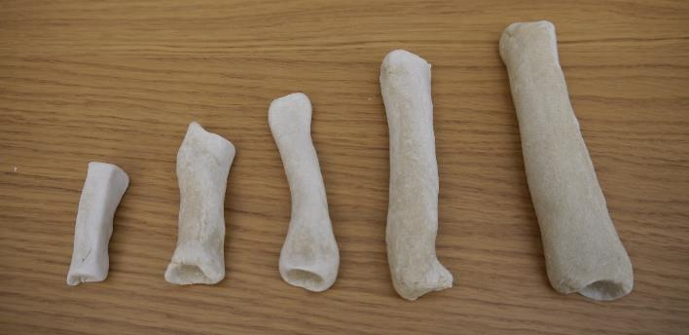
Extension  Play at being a palaeontologist. Bury the baked and cooled bones under dry soil, sand, or cereal to be discovered.  Measure, weigh and draw them.  Compare and order them by length, size or weight.  Create a dinosaur by putting the bones together.  Create a museum to display the discoveries and write labels or signs for the bones. | Questions to ask  What do you think dinosaur bones look like?  What does the flour feel like when it is dry/wet?  What does the dough feel like?  Can you change the shape by rolling, pinching and bending?  What do the bones feel like once they have been baked and cooled?

https://www.nhm.ac.uk/visit/virtual-museum.html Explore dinosaur bones in this virtual museum.
Salt Dough Instructions
Ingredients:

- 1 cup of salt
- 2 cups of flour
- ¾ cup of water
To make the dough:
- Mix dry ingredients in a bowl.
- Add liquid and mix with a wooden spoon.
- Turn out onto a surface and knead until the dough is smooth.
To make dinosaur bones:
- Shape bones, referring to dinosaur skeletons for ideas in books or on the internet. Aim for a variety of types for measuring, weighing, identifying, and putting together to assemble a dinosaur.
- Place on a baking tray lined with baking parchment.
- Bake at 180˚C for at least 4 hours (the larger and thicker the bones, the longer the cooking time).
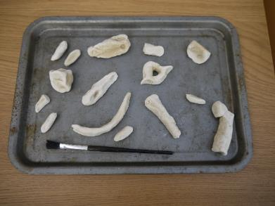
- Allow to cool. Keep ‘bones’ dry to prolong use.
Salt dough ‘bones’

Activity 10 – Exploring and playing
Make cornflour slime

What to do  - Make up the slime with your child – watching the transformation is part of the fun!  - Put 2 cups of cornflour into the bowl. This is very light so needs slow pouring. Encourage your child to feel the flour and describe its texture.  - Pour the water onto the flour and mix it in together. Encourage your child to help, feeling the change with their fingers.  - Once the slime is well mixed, the slime will behave in an interesting way. If gently tipped or drawn through with a finger the slime with act like a liquid but if put under pressure it will behave like a solid.  - Put on the tray. Your child will want to play with this for a long time! | What you need  Cornflour, water, a bowl to mix in and a tray to play with  (Optional) food colouring  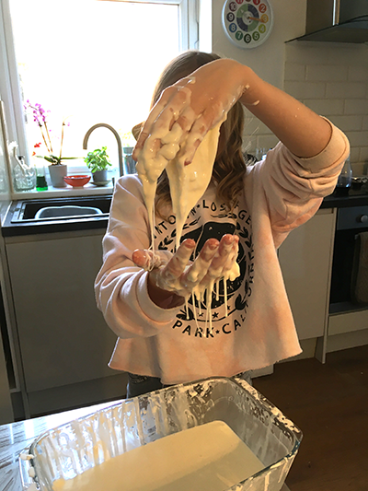
Extension  Add food colouring to the flour before mixing in the water for a colourful slime.  Add tools, a play tea set or small toys to the play. | Questions to ask  What does the flour feel like?  What happens when we add the water? What does it feel like now?  How is it changing as we mix it?  What happens when you squeeze, stroke, press, write in the slime?

Activity 9 – Exploring and playing
Listen to music

What to do  - Talk about the music you like to listen to. Are there types you listen to at certain times, e.g. when you are exercising, relaxing, in the morning, on long journeys.  - Listen to different types of music with your eyes shut. How does it make you feel? Does it make you feel calm, excited, happy etc.? Include familiar and unfamiliar music.  - Try different activities to music:  - Dancing to lively music.  - Snuggling on the sofa to calm music.  - Exercising to energising music.  - Colouring or drawing to inspiring music.  - Craft or construction toys to focused music. | What you need  Music to play* - there are lots of apps and websites to choose from, or use your own music collection  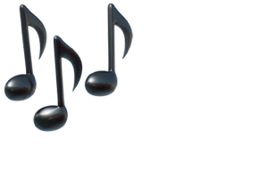
Extension  Make a playlist of different types of music for different activities and moods.  Watch musicals and think about the different moods the songs create.  Make some music with musical instruments, or improvised ones. | Questions to ask  What types of music do we like? When do we listen to music? How does it make us feel?  Which music makes you feel calm/ excited/ energised/ happy?  What music would be good to relax to/ dance to/ draw to?

*Playlist to get you started (use the audio rather than music videos)
Happy https://www.youtube.com/watch?v=y6Sxv-sUYtM Pharrell Williams – Happy
Calm https://www.youtube.com/watch?v=EBIKYRXGz2k Johannes Brahms - Wiegenlied (Lullaby)
Inspiring https://www.youtube.com/watch?v=TXvtDm820zI Mike Oldfield - Tubular Bells
Energising https://www.youtube.com/watch?v=8OZCyp-LcGw Mozart - The Marriage of Figaro
Fun https://www.youtube.com/watch?v=wB9YIsKIEbA I’m a Believer – The Monkeys

Activity 8 – Sensory art
Make fruit and vegetable prints
What to do  - Look at your collected foods. Name the fruit/vegetables together. What do they feel like, smell like? Which do we like to eat?  - What do they look like? Think about what they might look like inside, if you cut them in half.  - Keeping the knife away from your child, cut the foods in half, and then look at the patterns inside.  - Put paint on paper plates and give your child some paper.  - Show them how to dip a fruit or vegetable in the paint, making sure that the bottom is evenly coated.  - Press the fruit or vegetable firmly onto the paper.  - Explore the different ways you can make interesting prints by dipping different parts of the food or slicing in different ways.  - Try different colours and explore making patterns or pictures. | What you need  Fruit and vegetables, knife, chopping board,  mixed paint, paper plates or trays, paper (thicker paper is better if you can get it)  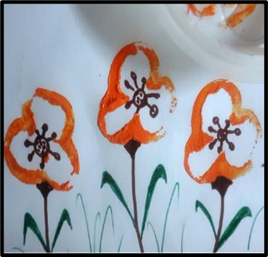
Extension  Make pictures once the prints are dry by drawing on features in marker pen. Can you turn your prints into flowers, people or animals?  Make a print card for someone who would like a colourful greeting.  Try identifying the foods by smell alone (before you put them in paint!). Can you identify them with your eyes shut? | Questions to ask  What do you think this will look like inside? Can you guess the colour and pattern?  Will it be different if I cut the apple from top to bottom or across the middle?  What pattern can you see inside?  I wonder what print that will make?  Which colour paint would you like first?  Which bit of the pepper will you put in the paint? What does the print look like?

Activity 7 – Sensory art
Make seasonal tree pictures using finger painting

What to do  - Divide the paper into 4 and in each section draw a similar tree shape with the brown pen. Include a thick trunk with thinner branches sticking out.  - Look at the trees together. Explain that you have drawn the same tree but during different seasons.  - Choose one and write ‘spring’ by it. Squirt some paint onto the plate. Ask your child to make blossom by pressing their finger into the paint and then making blossom prints around the branches.  - Repeat for summer, autumn and winter. (If you don’t have white paint, you could have festive tree lights instead of snow.) | What you need  A large sheet of paper  A brown felt tip, thick ready-mixed paint,  A plate for paint mixing/finger pressing  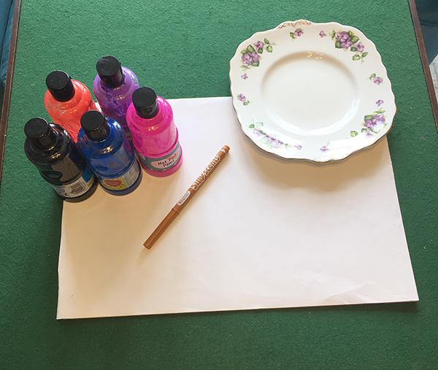
Extension  Make seasonal trees using scrunched tissue paper instead of paint.  Use real twigs to be the trees. You could collect leaves and blossom or small flowers to make a natural materials picture. | Questions to ask  What seasons do we know?  How do some trees change across the seasons?  How can we make the tree look like a spring tree? What colours can blossom be?  What if we want to make the green lighter? What could we add to the paint?

Activity 1 – Making sensory toys
Make a sensory bottle

What to do  - Decide whether you are going to have a dry or wet sensory bottle: dry bottles can have a greater range of fillings and can be shaken and tipped to make sounds; wet bottles are generally more appealing to look at and the liquid filling allows more free and mesmerising movement.  - Fill the bottle together with dry ingredients, discussing and choosing what to put in.  - Fill with liquid (if creating a wet bottle), premixing liquid in a jug and then pouring into the bottle.  - Check that you are happy with the finished result by screwing on the lid and tipping. Then, glue the lid in place using a glue gun or super glue away from your child. | What you need  A clean, clear plastic bottle with a lid.  Dry ingredients:  Glitter, beads, sequins, small plastic toys, small bells, small pasta shapes, dried lentils, rice, googly eyes, confetti, buttons etc.  Wet ingredients:  Water, food colouring, baby/cooking oil, glycerine, glitter glue, liquid soap  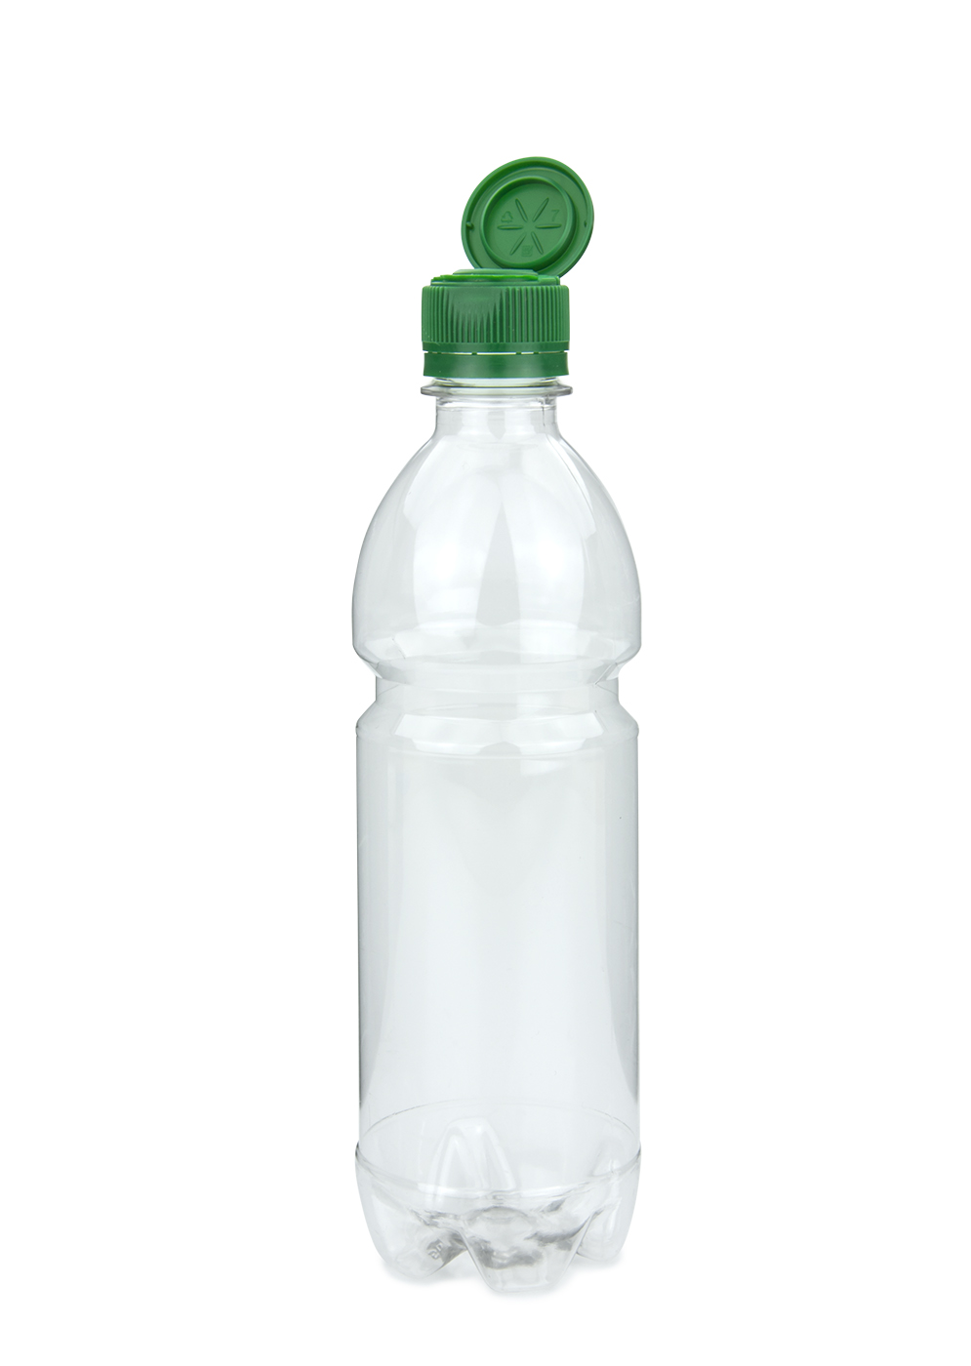  (You can use just water, or combine with colouring, glue, oil, and/or soap for different effects.)
Extension  Make a sensory bottle on a theme, e.g. a noisy bottle, a sparkly bottle, a spring colour bottle, natural objects, etc.  Try different combinations of liquids to achieve faster and slower flow.  Add colour mixing to the play, predicting and exploring adding different colours to your water before adding to the bottle. | Questions to ask  Why do we need a clear/transparent bottle?  What will happen if we shake a bottle filled with pasta shapes?  What will happen if we put food colouring in the water? What will yellow and blue make?  Will the objects move differently in water and in oil? What if we mix the oil and water?  How does the bottle make you feel?

Activity 2 – Making sensory toys
Make a musical instrument

What to do  - Look at your collected materials together and explore the different sounds you can make by hitting, scraping, shaking and plucking (wind instruments are much harder than they look!).  - Explore combining materials to make new sounds (rice in a crisp tube to make a shaker, elastic bands stretched over a box can be plucked, paper, cellophane or a balloon pulled over a jar to make a drum, etc.)  - You can enjoy keeping the materials fixed in temporary ways to allow for continual rebuilding and design changes or fix more permanently to make an instrument which can be decorated, played with and performed with. | What you need  Recycled packaging (such as boxes, tins, tubes, plastic tubs, paper, paper cups, jar lids, tins, bottle tops, cellophane wrappers).  Things to make shaker filling (e.g. rice, sand)  String, elastic bands, ribbons, balloons  Pencils as beaters  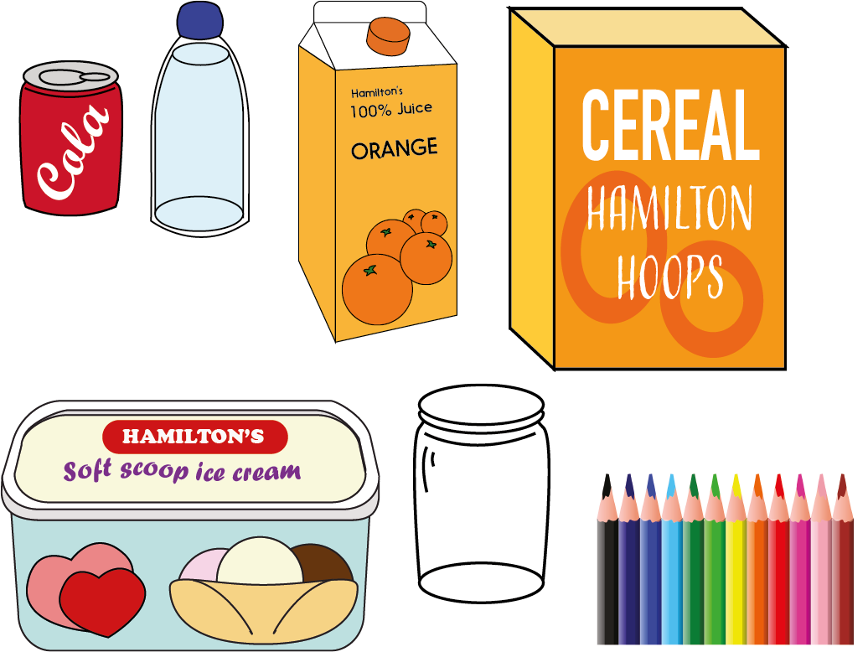
Extension  Play along with your favourite music.  Make a band and play together.  Sing along with I am the Music Man: https://www.youtube.com/watch?v=2Pge14jv2Ss With careful supervision, make a water xylophone by filling jars or bottles with water to make different notes when you tap them. | Questions to ask  What sounds can we make?  How can we make a sound with this material?  Can you make the sound louder or quieter?  Can we make the pitch higher or lower?  How can we fix the materials together?  Can you make a rhythm/tune?

Lots of ideas for making musical instruments can be found at: https://feltmagnet.com/crafts/Music-Instruments-for-Kids-to-Make
Activity 3 – Exploring and playing
Blowing bubbles

What to do  - If making, make up the bubble mix in a container, adding the water to the soap slowly. Stir gently. Make the day before for the best results.  - Pour the mix in a shallow tray (keeping the rest in the container – this will reduce spillages) and place outside if possible.  - Provide a range of bubble blowing equipment and allow your child to experiment with them, trying different blowing techniques and bubble blowing tools. | What you need  Bought bubble mix or  mix made with:  50ml washing-up liquid (one part)  300ml water (six parts)  Bubble blowing equipment: pastry cutters, bubble wands, pipe cleaners, a drinks bottle with the base cut out, plastic cup with hole in the base for blowing, plastic funnel  A shallow tray to hold the bubble mix for play and a container to make up and store the mix  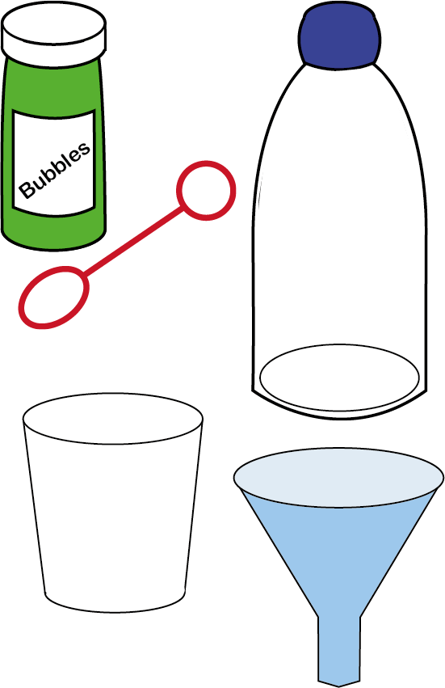
Extension  Set challenges: Can you blow a big bubble, small bubbles, lots of bubbles, long bubbles?  Can you make bubbles which are not round?  Can you catch your bubbles without them popping? | Questions to ask  Can you blow some bubbles?  What happens when you blow? Where do the bubbles go? Can you make lots of small bubbles? How can you make a really big bubble? What shape are they?

Activity 4 – Exploring and playing
Exploring mystery objects in feely bag

What to do  - Place a selection of mystery objects in your bag.  - Challenge your child to identify the objects by putting their hand in the bag and feeling them.  - Encourage lots of talk about texture, shape and weight, e.g. ‘What does it feel like? Is it hard and smooth or soft and fluffy?’  - Reverse the game and put your hand in and describe what you feel. Can they guess what you are touching?  - Look away while your child chooses one of the items to put in the bag. Can you guess what they have chosen? | What you need  A bag which hides the objects (e.g. pillowcase, P.E. bag etc.)  Any object which will fit in the bag – aim for a variety (e.g. small animal toys, hairbrush, deflated balloon, marble, dice, sock, leaf, squishy toy, sunglasses, feather, soft toy, hairband, facecloth, plastic cup etc.)  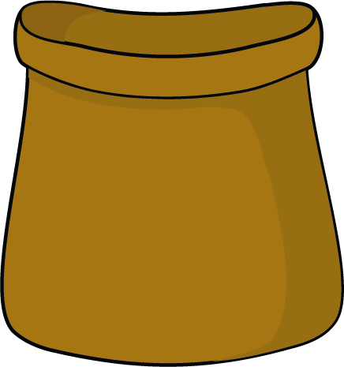
Extension  Use natural objects.  Collect new objects to make a game for someone else.  Make an ‘odd one out’ game with all of the objects bar one being of a type, e.g. 5 vegetables and a crayon. Can your child guess which was is odd and say why? | Questions to ask  What can you feel?  What might it be? What makes you think that?  Is it soft/hard/furry/smooth/bristly?  What does it remind you of?  Which object will be hard for me to guess?  What else could we hide in the bag?  Which is the odd one out?

Activity 5 – Exploring and playing
Freeing frozen toys

What to do  - The day before, fill the containers with water and then place toys in the water. Put them into the freezer overnight.  - Take the containers out for a few minutes to allow you to release the ice shapes from the containers. Place outside (or inside on a covered table) on a tray or in a bowl.  - Challenge your child to free the toys.  - On a warm day, children will enjoy watching the ice melt, handling it and helping the ice melt. | What you need  Small plastic toys or similar  Several plastic containers or freezer bags  A shallow tray, bowl or water table  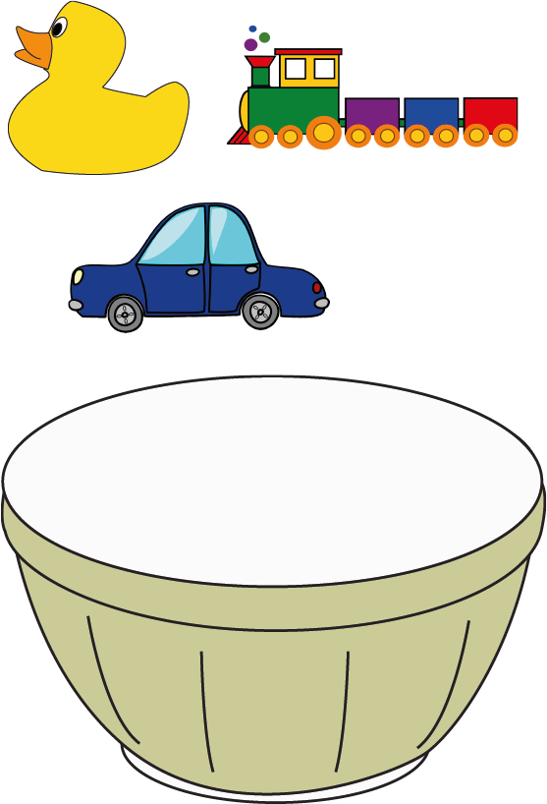
Extension  Provide cold water and a jug to speed up the process.  Let your child have a turn to freeze their toys.  Try putting an object in a balloon and then filling with water. This makes an interesting shape. | Questions to ask  What do you think might be in there? Can you see through?  What does the ice feel like?  How will we get them out?  What will happen to the ice outside?  How long do you think the ice will take to melt?  Where will the ice go?  Can we make it melt faster?  What else could we freeze?

Activity 6 – Exploring and playing
Playing with playdough

What to do  - Before playing, help your child wash and dry their hands.  - The options are endless with playdough. Let them explore and play independently.  - Introduce play ideas:  - Can you make our family, some cakes, a house, wiggly worms, a pattern, a garden, a face?  - What prints/patterns can you make in the dough?  - What can you push into the dough to make an animal, a monster, a farm?  - Can you make different shapes?  - Can you make numbers, letters, your name?  - Photograph to celebrate and if you want to reuse the dough for another day, keep in a sealed container. | What you need  Playdough (bought or made* – see below)  Tools to help with shaping and cutting, e.g. rolling pin, cutters, board, pastry tools or table knife and a pencil  Anything else which can be pressed into the dough  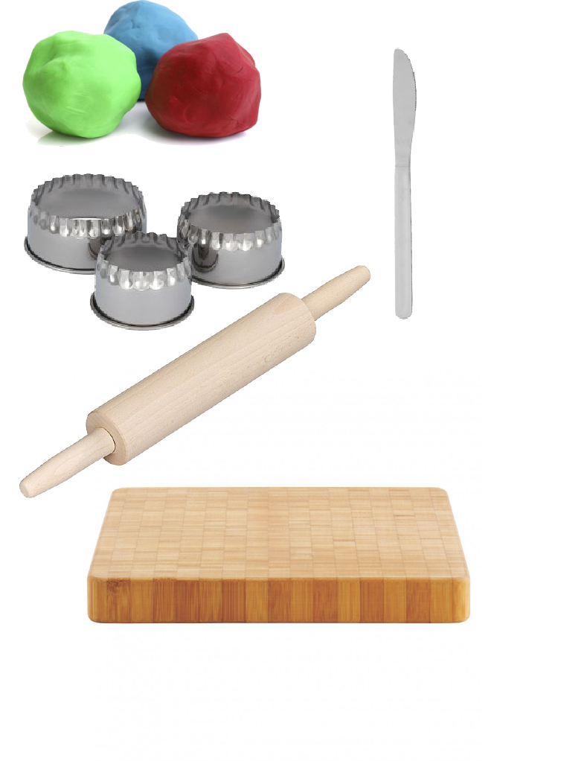
Extension  Set challenges linked to stories: Can you make a bridge for the troll?  Set challenges linked to number: Can you make a cake with enough candles for…?  Set challenges linked to position, direction or shape: Can you make a circle, square and triangle biscuit? Can you make a nest with some eggs inside it? Can you make a pot with a lid on top? | Questions to ask  What does the dough feel like? How can you change the shape? What patterns can you make?  Can you make some worms? Can you make a ball? How can you make a thin, flat shape?  Can you make shapes by pinching?  What are you making now? Tell me about your model.
*Simple 10 minute playdough recipe: https://www.bbcgoodfood.com/howto/guide/playdough-recipe

