Writing
IMPORTANT Parent or Carer –
Check that you are happy with any weblinks or use of the internet.

NB New activities are being added at the top of each document.

Writing is hard for young children. Scroll down for important dos and don’ts and for guidance when you are helping them
Activity 12 – Writing and sharing
Write a warning poster about a fictional baddie

What to do  - Share the book together, or watch a story telling video (see below).  - Agree that the baddie is a bit of a menace - it would help other characters if we warned them.  - Explain that they could create a poster warning people about the character. Ask what would be useful to tell people.  - Agree that it would help to have a picture of the character and a few ideas written around it as to the sort of things they do that cause trouble.  - Create the poster together, sharing the writing if needed and using sounding out as the main way of spelling any words. | What you need  A picture book with a baddie  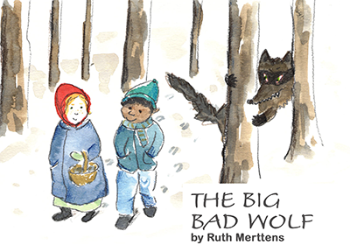  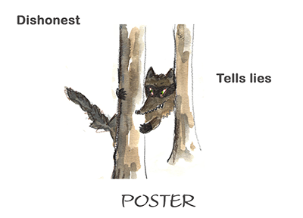  See below for Guidance for writing and Handwriting Letter Groups for formation help.
Extension  Put up the poster and encourage other people to read it.  Collect more baddies to warn people about as you share stories.  Try making a Thankful poster, telling people about a real or imaginary person who has been helpful to those around them. | Questions to ask  Who is the baddie in the story? What is a baddie? How do they behave?  How would you recognise them? What do they look like?  What sorts of things do they do that causes trouble?  How could we write ‘blows down houses’? What sound does the first word begin with?
https://www.bbc.co.uk/cbeebies/radio/the-three-little-pigs
https://www.youtube.com/watch?v=s8sUPpPc8Ws
https://www.worldbookday.com/videos/little-red-riding-hood-2/

Activity 11 – Writing and sharing
Write a book about your favourite things

What to do  - Talk about your favourite things. You could talk about colours, foods, animals, places, toys or anything else your child is enthusiastic about.  - Explain that it would be fun to make a book about some of these favourite things and show the empty book waiting for their ideas.  - Make a front cover together giving it a title and explaining that as they are the author, you need to write, ‘by…’ with their name - just like a real book.  - For each page you could stick a photo, do a drawing or stick an image on the page.  - Depending on your child’s writing development, they could write a title for each picture, labels or a sentence about it.  - This will be most fun as a project done over a few days, so that the task does not become overwhelming but is something your child is proud of. | What you need  A book made by folding paper  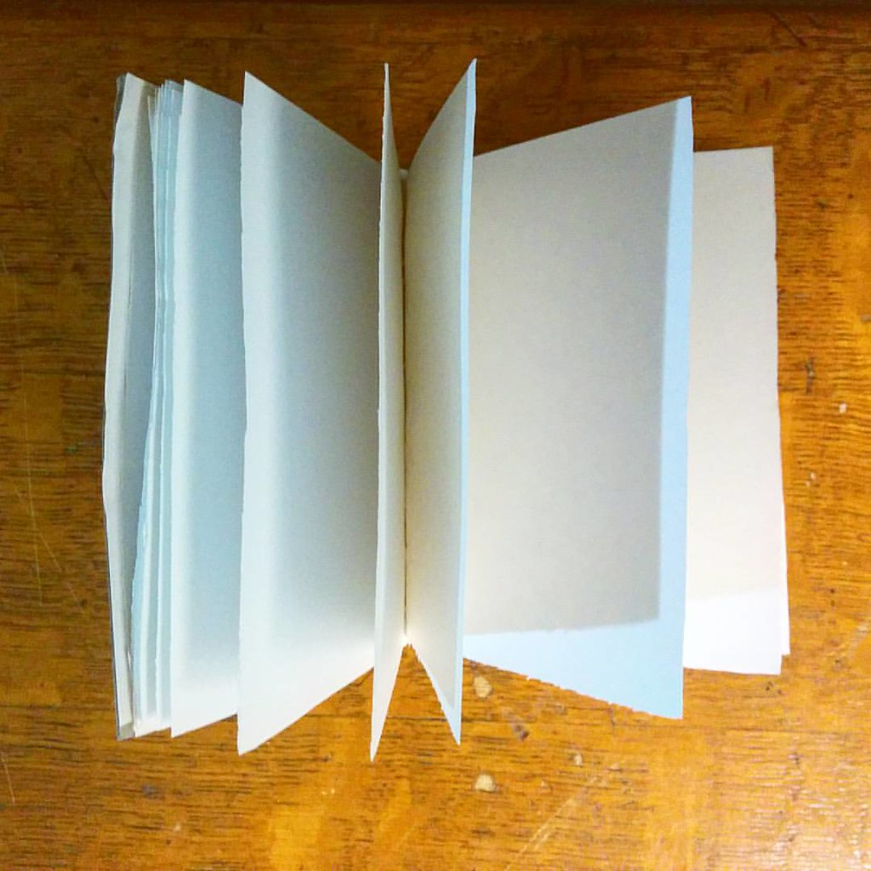
Extension  Write a blurb at the back and include a barcode and price. You could include some rave reviews written by members of your household.  Ask your child to share their book with others.  Make a collection of favourite things and write labels explaining why the objects are special. | Questions to ask  What are your favourite things?  How could we show them in a book?  Can you draw, find pictures or take a photo of some of them?  What would be a good title for this page?  What labels could we write?  Can you explain why you love worms so much?

Activity 10 – Writing to share ideas
Write useful lists
What to do  - Talk about what a list is and why we might use one.  - Introduce a real purpose for writing a list: a shopping list, jobs list, birthday card list, ingredients for a recipe.  - Talk about all the different things you need and say that there are too many things to remember. We will have to make a list!  - Together write a vertical list on your paper. Sound out the words as you write and don’t worry too much about the spelling. You are aiming for most sounds to be present.  - Read back your list and thank your child for their help - the list will be very useful. | What you need  Pencil and paper  See below for Guidance for writing and Handwriting Letter Groups for formation help  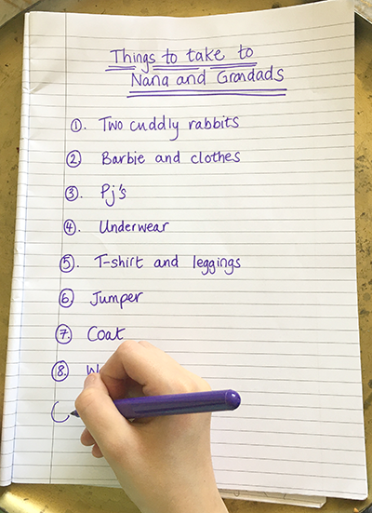
Extension  Make a list of places you would like to visit or people you are looking forward to seeing.  Make a list of favourite things. Ask others tell your theirs and make a list for them.  Make a list of fun things do. Tick them off as you try them.  Send your child on a survey. What fruit is in the bowl, what toys are on the grass, what cereals are in the cupboard? Ask them to make a list and bring it back to read to you. | Questions to ask  What do we use lists for?  How do we write a list?  Why do we need to write a list? What do we need to remember?  What shall we write first?  What sound does it begin with? What comes next? Can you sound it out? How does the word end?  Shall we read our list?  What will we do with it now?

Activity 9 – Letter formation
Write letters in sand

What to do  - Set your child up with a stick and a shallow tray of sand. Ask them to hold the stick as they would a pencil with a pincer grip (2 fingers and thumb).  - Get your child writing letters with the stick in the sand as if they were holding a pencil.  - Things to try:  - Pick a letter and ask them to write it. If there are any letter formation rhymes that your child knows from school, say them together.  - Play a guessing game. ‘What letter is at the beginning of top/pin/sit?’  - Ask your child to write key words or family names.  - For less confident writers, try drawing zigzags, wavy lines, dots, circles in both directions and crosses. | What you need  Tray of play sand, a stick  
Extension  Try writing with a finger – this is still good practice.  Try writing words that are on a topic of your child’s interest, e.g. animals, vehicles, or a sport.  Take photos if your child wants a record of their efforts before they wipe the sand clean. | Questions to ask  Do you know how to hold a pencil?  What letters do you know how to write?  Can you write the sound which pan begins with?  What letter could you write which has zigzags?  Can you write it bigger or smaller?  Can you remember how to start a ‘b’?

Activity 8 – Letter formation
Write letters using paint brushes and water
What to do  - Set your child up with brush and a pot of water. Ask them to hold the brush as they would a pencil with a pincer grip.  - Get your child writing letters with the brush as if painting them with the water. Can they cover the surface?  - Things to try:  - You could write some letters in chalk to remind your child of letters they could write.  - You could prompt them with phrases such as ‘Write the letter which starts the word apple/ball/dog’ etc.  Tip: Don’t worry if they end up drawing or doodling. They are practising pencil grip and fine-motor movements! | What you need  Outside surface, paintbrush, a pot of water  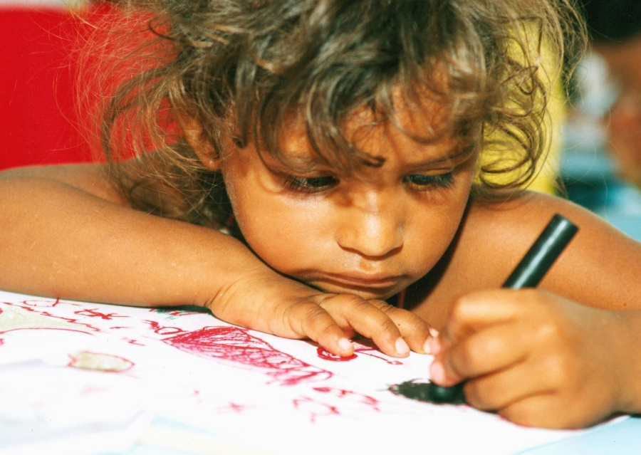
Extension  Play guessing games. Your child thinks of an animal, colour or food. They paint the first sound. Can you guess it?  Challenge your child to write familiar words that they know, including family names.  Try painting shapes such as spirals, wavy lines, zigzags and dots. | Questions to ask  Do you know to hold a pencil?  What happens if you paint with water on the patio?  What letters do you know how to write?  Can you write the sound which snake begins with?  Can you cover that paving stone with ‘e’s?  What letter could you write which has zigzags?

Activity 7 – Letter formation
Write letters and identifying them by ‘feel’

What to do  - Choose a letter and write it on your child’s non- dominant hand as they watch, using your finger like a pencil. What letter is it? Can they tell? You can identify it by the letter name or the sound it makes – either is fine.  - Ask your child to write the same letter on your hand. Praise their formation or help them if they are not forming the letter correctly (see below for guidance).  - Now for a trickier task. Say you are going to write a new letter and they will try to work out what it is just by feeling it. This time, ask your child to shut their eyes as you write. Can they guess it by feeling the formation?  - When they guess the letter, get them to try writing it on your hand. You can show them with their eyes open first. | What you need  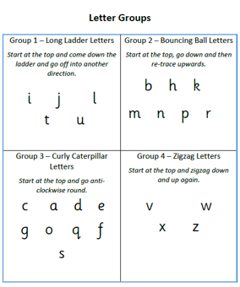  See below for Guidance for writing and Handwriting Letter Groups for formation help
Extension  Play the guessing game, taking turns to write a letter while the other guesses it through touch.  Try ‘sky-writing’ in the air with fingers or on backs. | Questions to ask  Can you see what letter I am writing?  What does it feel like? What if you close your eyes? Can you feel which letter it is?  Can you write on my hand? How/where does the letter start? Can you think of a new letter to write on my hand?

Activity 1 – Writing significant words and phrases
Writing names of family and or friends

What to do  - Set up a reason to make name cards – this could be place cards, door signs or name badges.  - Discuss which names your child knows how to write already, beginning with their own.  - Encourage your child as they write names carefully. Help them use their knowledge of sounds to write and praise letters formed the correct way. Don’t worry if you can’t read every word – the process is more important that the finished product.  - Encourage your child to try to spell their own name correctly but it is fine for other names to be spelt how they sound. | What you need  Paper, pens, pencils  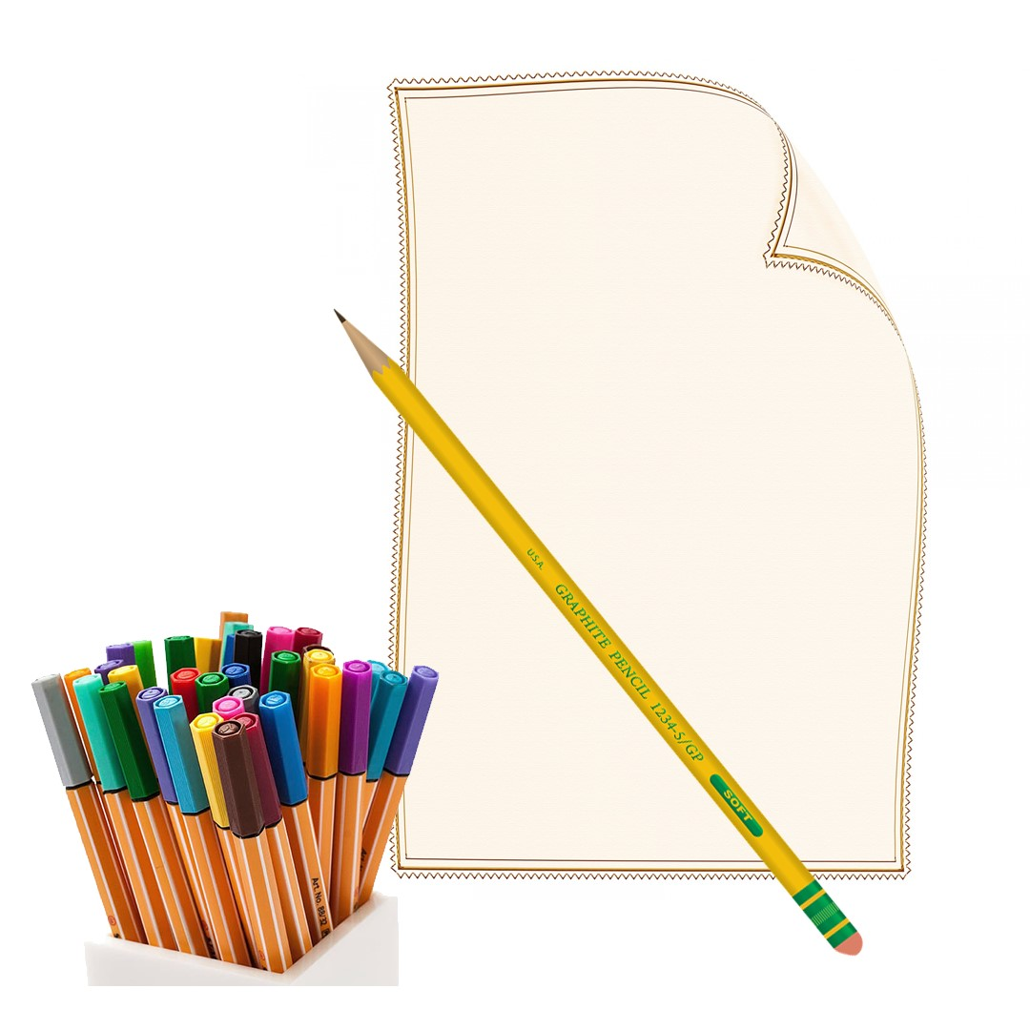
Extension  Present or display decorated name signs or badges.  Make a register using names of family, friends, pets and/or toys. Write each name and find out who is present.  Create a photo book by sticking photos of significant people onto folded paper and writing their names below. | Questions to ask  Which names will we write?  How do you spell your name?  Can you remember how to start writing that letter? Do we know a rhyme for the letter formation?  What sound does the name begin with?  Can we sound out the name?  What is the last sound?

Activity 2 – Writing significant words and phrases
Learn to write own address

What to do  - Talk about what an address is. If possible, look at the number on your front door and walk to where your road has its street name. Read the name together and notice if it ends in Street, Road, Close or something else. (If you are stuck inside, use Street View.)  - Now look at how your address appears on the post. Look at what comes at the top, the second line and so on.  - Explain that knowing your address is a useful skill. You need it to find where you live and so that people know where to send letters and parcels!  - Does your child think that they can remember any of their address? Let them have a go at saying it, giving clues and filling in to keep things fun.  - Together, practise writing your address, asking your child to dictate what they remember. Read it back together.  - Repeat the practise over several days, seeing what parts your child can write. | What you need  Paper, pencils, a photo of some post with your address on it (or write it out beforehand)  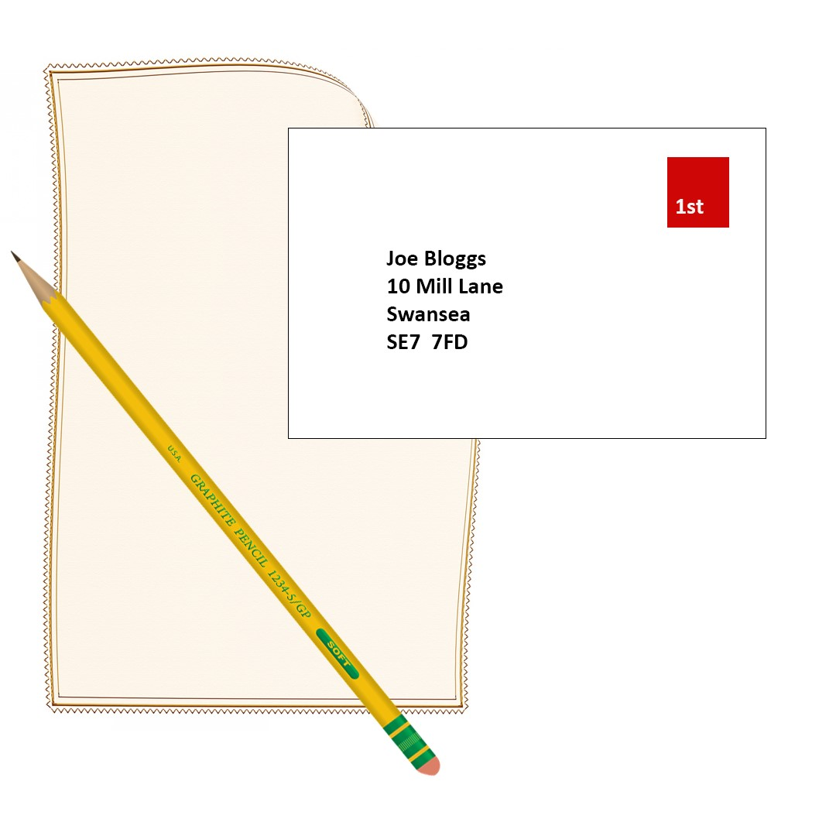
Extension  When post arrives (observing government guidelines) look at how the address is written.  Write your address on an envelope and cut it up to make a puzzle (keeping words intact). Increase the number of pieces by cutting them into smaller parts as confidence grows.  Provide your child with blank envelopes, pens and paper. They can write real and imaginary addresses and ‘post’ them.  Send a postcard to a someone at your address. | Questions to ask  Do you know what our house/flat number is?  What road do we live on? Does the name end in road, street, close or another word?  What goes after the street name? What is the name of our town/city?

Activity 3 – Writing to share ideas
Write a book

What to do  - Make paper books made by fixing sheets together (hole punch and string, staples, ribbon) or by folding – see the website below for step-by-step instructions.  - Show the blank book. Explain that this is a special book as you are going to write it together. Discuss what sort of book it might be? Share ideas. Will it be a story book or a book about trains or full of jokes or poems?  - Once you have decided, taking turns as to who will write, write the book together, your child dictating some of the words and writing others.  - When finished, share and enjoy the book together. Consider adding some illustrations. Make sure to give the book a title and write the authors names on the front cover. | What you need  Paper, pencils, pens  (optional) ribbon, tape, string, hole punch, stapler  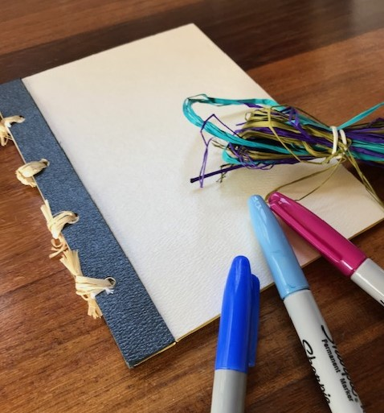
Extension  Provide blank books of different sizes and writing materials. Leave your child to independently explore and create their own books.  Write a book for a particular reader.  Build a library of made books by your child and other members of the house. Celebrate the variety and imagination which has gone into them. | Questions to ask  What could this book be about?  What books do you like?  Will it be a fact book or a fiction/story one?  Who will the authors be?  Will we need pictures/illustrations?  What will go on the front cover/first page?  How will we start the story?  What will the first page be about?  Who will enjoy our book?

Three ways to make a paper book with minimal resources:
https://www.wikihow.com/Make-a-Paper-Book
Activity 4 – Writing to share ideas
Write a letter or card

What to do  - Talk about the people you know who you haven’t seen for a while. Explain that we have lots of ways to communicate when we can’t visit people, but one lovely way is to send a letter or card. Who would love to hear from us/has a special day coming up?  - Spend some time talking about the person you are going to write to and the sorts of things they would like to read about.  - Write the letter or card together, taking turns to write. Don’t worry if your child only writes a few words; they can dictate more ideas for you to write for them.  - Read the letter together and talk about how the receiver will feel when they get the letter. | What you need  Pens and pencils  Paper or special writing set or card  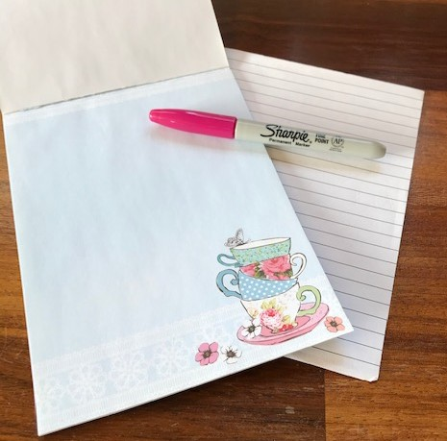
Extension  Post your card or letter, writing the address on and explaining what the stamp is for. (Photograph it before you send it if your child wants to ‘keep’ a copy.)  Write and send letters between people in your house or toys or pets. Appoint your child as the postman/lady.  Set up a letter-writing box, with paper, pens and envelopes for your child to play with and explore independently. | Questions to ask  Who could we send a letter or card to?  When do we get cards?  How will our letter get to them?  How do we start a letter/card?  What will they like to hear about? Can we put it in a sentence to hear what it sounds like?  What questions could we ask them?  Is there a greeting we should use?  How should we end the letter? Can you sign your name?

Activity 5 – Writing to share ideas
Write rules for my room

What to do  - Discuss the different rules we have in different situations: crossing the road, water safety, cooking, school rules. Why do we have rules? What are they for?  - Discuss rules in your home. These are sometimes less obvious as they are not usually written down like they might be in school or at the swimming pool.  - What rules does your child think they could have for their own bedroom? Do siblings borrow toys without asking or do parents throw away art projects?  - What about rules to make the bedroom a nice place to be? Could there be rules about dirty laundry, scrap paper or switching off lights.  - Create a list of rules together by saying them aloud to build each sentence verbally before writing each down together. You can number the rules and display them. | What you need  Paper, pens and pencils
Extension  Make some positive house rules, decorate and display them.  Make rules for story characters, dolls house people or cars in a garage.  Spot rules on posters and on manuals.  Make up silly rules which are impossible to follow. | Questions to ask  What rules are there in school/swimming/rainbows?  Why do we have rules?  Do we have any rules at home?  What rules would be good for your bedroom? What problems could they avoid?  Who should follow the rules?

Activity 6 – Writing to share ideas
Invisible writing

What to do  - Write some letters, words or sentences in white crayon on a sheet of paper without showing your child.  - Explain that you have written them an invisible message and show them the apparently blank sheet.  - Ask them to dip a brush in the paint and sweep it over the paper. Once they spot some lines made by the wax, they will brush more to reveal the message. Read it together.  - Show them your secret so they can have a try. They can then paint over to read their writing. Children will often want to try this many times. | What you need  White crayon or a white wax candle  Paper, mixed/water colour paint and a brush  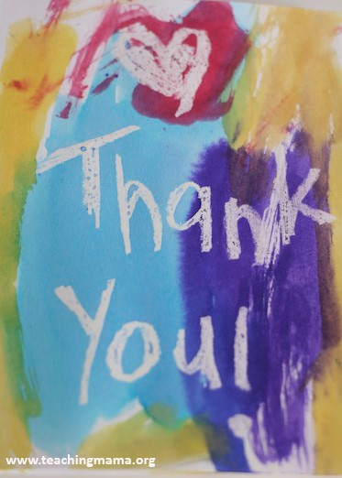
Extension  Use different coloured paints and display the dry messages with writing revealed.  Enjoy tricking another adult by giving them a ‘blank’ piece of paper and asking if they can read it? Allow your child to teach them the trick. | Questions to ask  What does invisible mean?  Can you see my invisible message?  Can you paint a line on the paper?  What can you see? How could you see more?  Can you read my writing now?  What will you write in invisible crayon?  How will we read it?

Guidance for writing – some dos and don’ts

- DO focus on letter formation. See sheet below. It’s really important that children get into the habit of writing letters correctly – this is not about how the finished letter looks, it’s all about how they write it – what direction they move the pencil or pen. Bad habits are almost impossible to break – if they form letters wrongly, the finished letter may look good BUT in the long run, they are much less likely to be able to write fluently.

- DON’T write a word or a line for them to copy. If they can’t remember how to write a letter, demonstrate, forming it correctly, so that they can imitate you.

- DO give loads of praise. Writing is so hard, and children get discouraged easily. It may be that they have just written one or two words, but if you praise them, it may be four words next time!

- DON’T do ‘dotty’ letters for them to trace. It is much better for children to form their own letters. We are teaching them to write not trace!

- DO write for them sometimes. It is important that young children can express their ideas in written form, and sometimes it is really good to write down what they say so that their ideas are expressed in writing on the page. Sometimes you can take turns to scribe. You write a bit, then they write a bit.



